Wednesday:

Daily Activities
​Whole-school event: Go to the Well-being Fortnight page for today’s activity!
Spellings: Learn spellings daily and write 3 of the words in interesting sentences.
Writing: Set a timer for 5 minutes and do some "free writing" or "free typing" on a topic of your choice.
Reading: Try to read for at least 15 minutes (or more if you can)!
Maths: Daily 10 Mental Maths Questions. Try level 1 or 2.
- Skip counting in 5s to 50 (0, 5, 10, 15, 20, 25, 30, 35, 40, 45, 50)
- Weekly tables 8+
- https://www.topmarks.co.uk/maths-games/hit-the-button. Click the link, go to halves and play halves to 10. Have fun!

1. English:
- Learn the next 4 spellings - pear, wear, swear, underwear.
*Challenge. Silly sentence! Write one silly sentence using as many <ear> words as you can! Here is one I wrote last week with <are> words.
‘The square hare had a scare in a nightmare but he didn’t care to share.’

- Complete the activity sheet below.
Last week we looked at prefixes.
Do you remember what a prefix is?
A prefix is a pair or group of letters added to the front of a root word.
The bottom part of this activity sheet asks you to add the correct prefix to the root words. The prefixes are tri- and tele-.
TIP:
Read the prefix and root word out loud to hear whether they make sense. If one doesn’t sound right, maybe try it with another prefix.
Use a dictionary to check your answers. Find a link to an online dictionary in today’s resources.

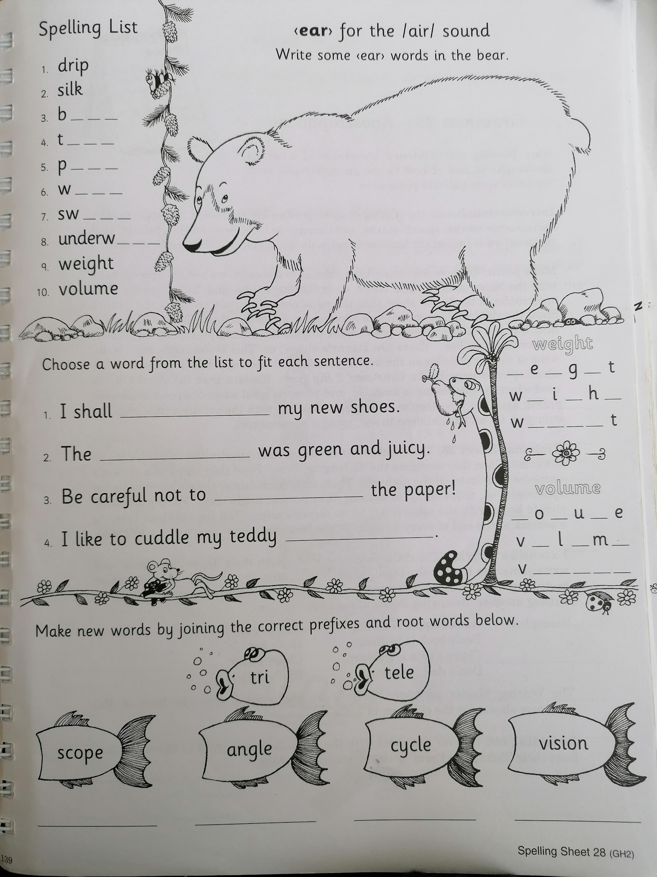
Maths

- We are looking at 3D shapes today.
- Can you think of what a 3D shape looks like? Is it flat or hollow?
- 3D shapes have sides, corners and edges. Can you think of some 3D shapes and identify how many sides, corners and edges they have?
- Complete this worksheet on 3D shapes.
*Challenge-Complete Wednesday on the problem-solving worksheet below.
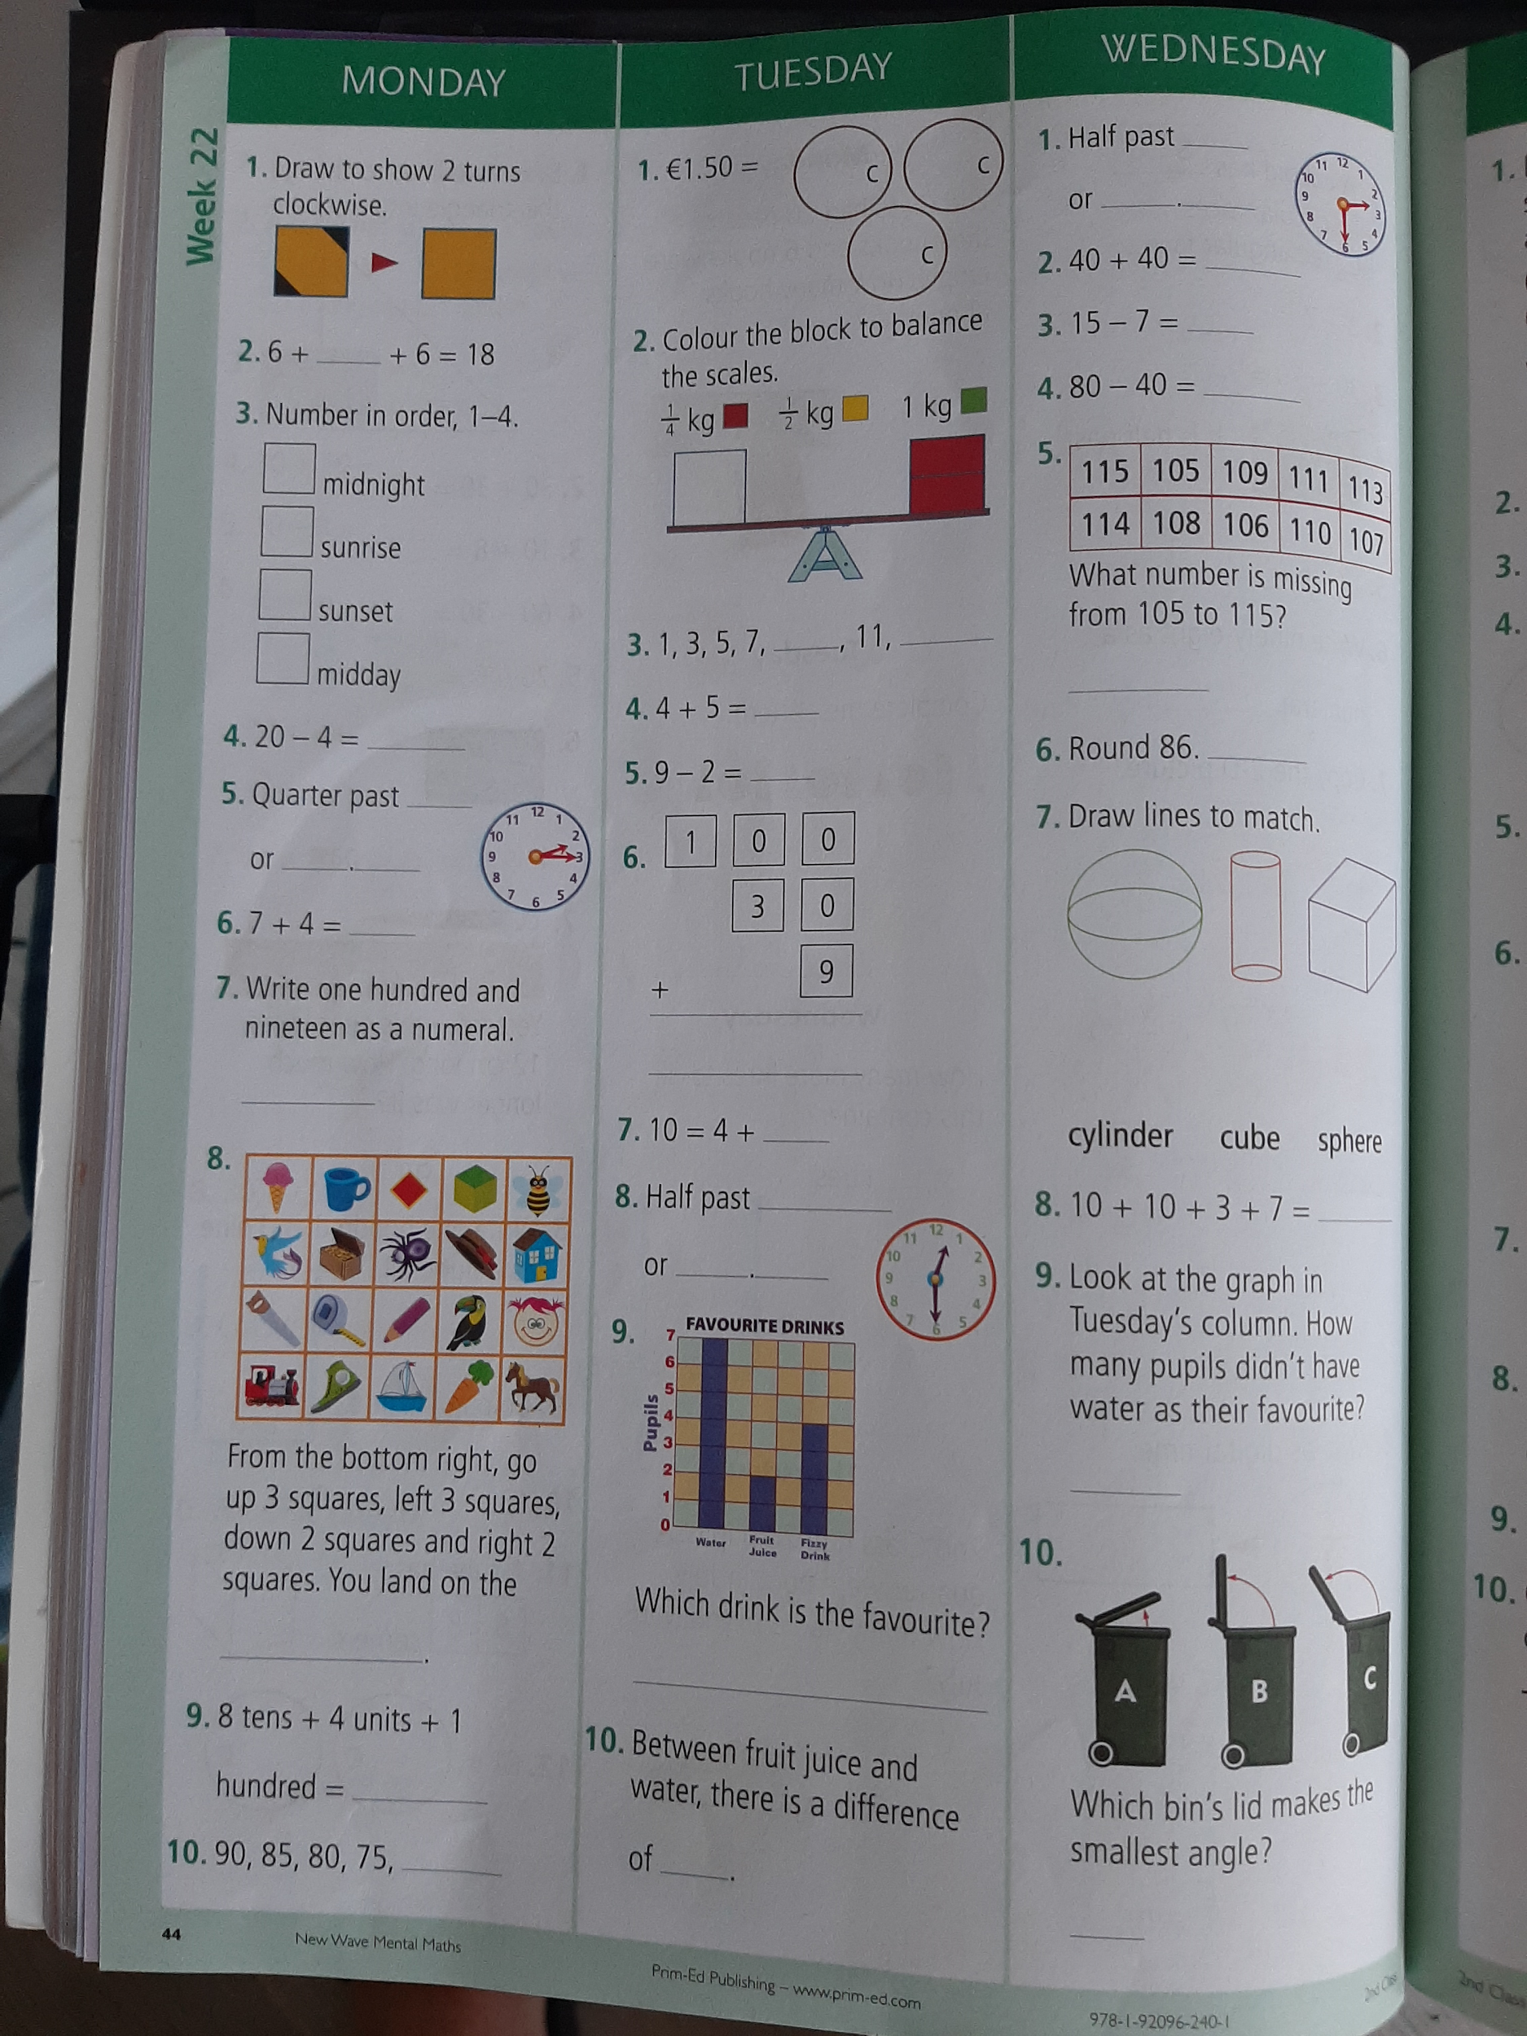

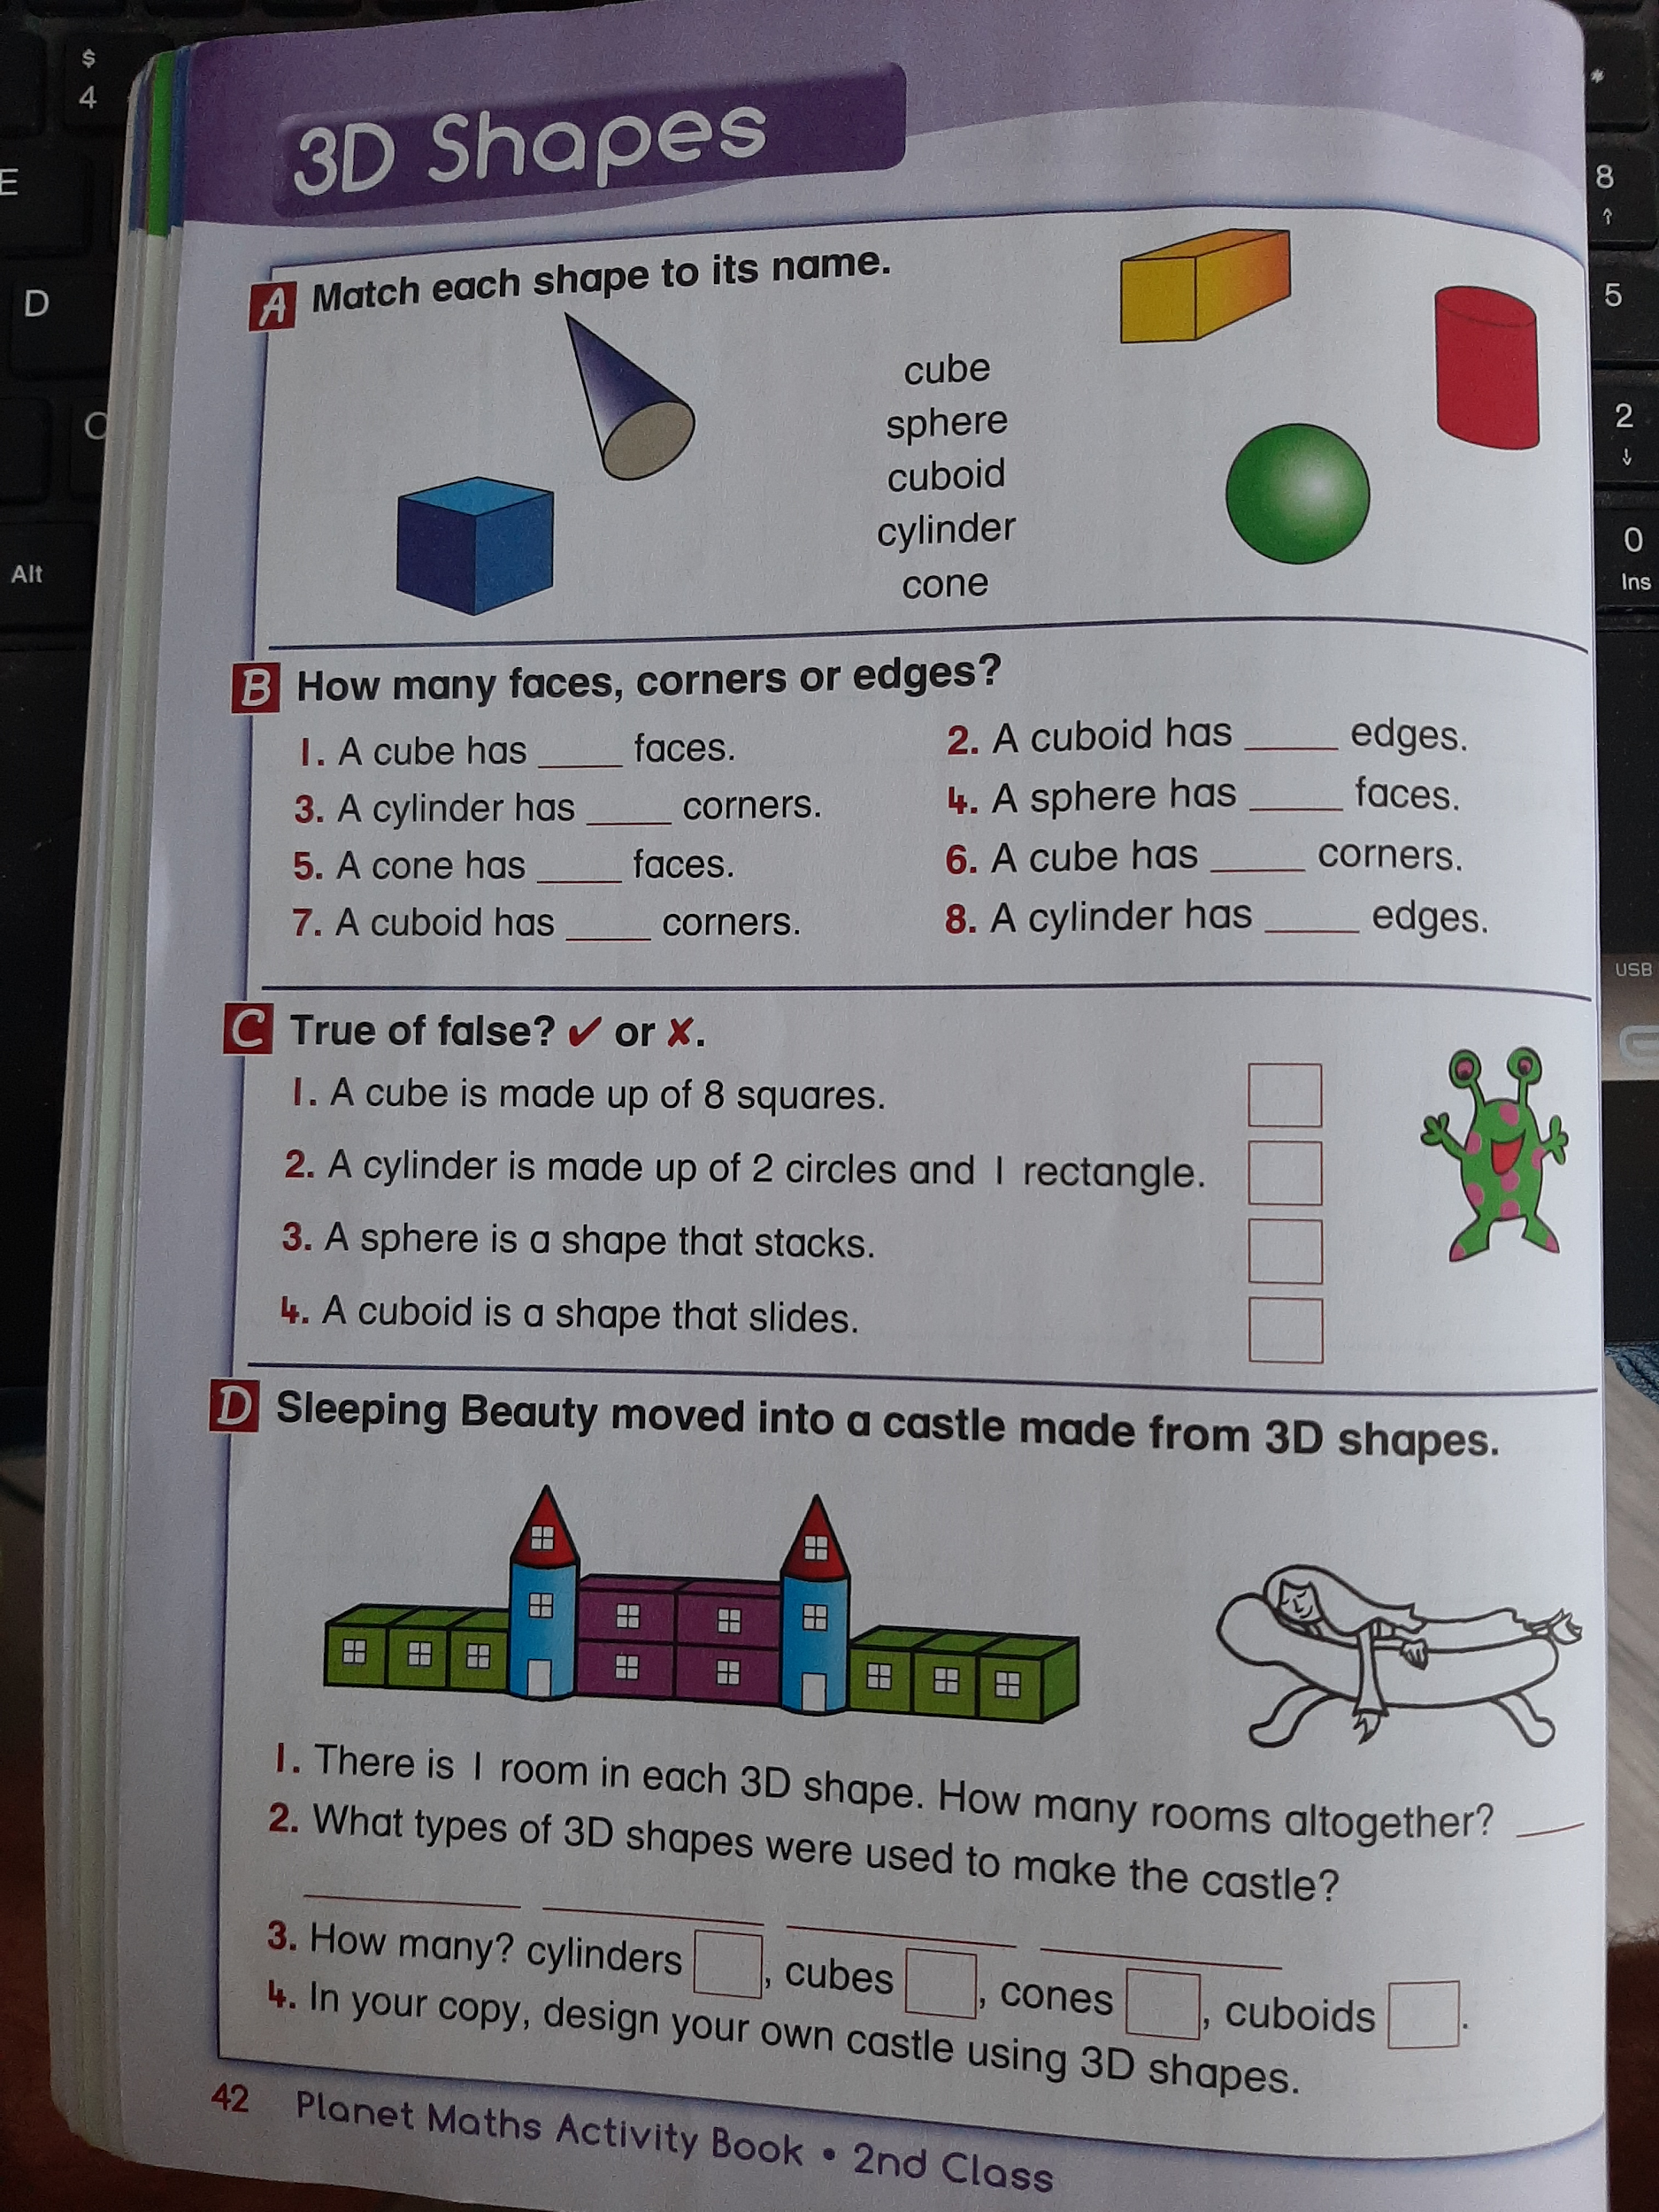

3. Gaeilge
- Look back on this week’s Home Learning page and click on the resources titled Na hAinmhithe. Watch this video from Bua na Cainte.
- Then complete this activity sheet. You can write your answers in a copy if you don’t have a printer at home.
