Tuesday:

Daily Activities
Whole-school event: Go to the Well-being Fortnight page for today’s activity!
​Spellings: Learn spellings daily and write 3 of the words in interesting sentences.
Writing: Set a timer for 5 minutes and do some "free writing" or "free typing" on a topic of your choice.
Reading: Try to read for at least 15 minutes (or more if you can)!
Maths: Daily 10 Mental Maths Questions. Try level 1 or 2.
- Skip counting in 5s to 50 (0, 5, 10, 15, 20, 25, 30, 35, 40, 45, 50)
- Weekly tables 8+
8+ Tables

8+0=8
8+1=9
8+2=10
8+3=11
8+4=12
8+5=13
8+6=14
8+7=15
8+8=16
8+9=17
8+10=18

- https://www.topmarks.co.uk/maths-games/hit-the-button. Click the link, go to halves and play halves to 10. Have fun!

Seesaw: Log on to the Seesaw app. Here you will see that we have assigned an activity called ‘Introduction to Seesaw tools’. We want you to give it a go!

1. English: Find spelling list below.
This week most of your spellings “end in” <ear> and make an /air/ sound.
Check on Anita’s teaching clip to help you on the home learning page. Also look at the “Look, Say, Cover, Write, Check” poster below.
- Underline the /air/ sound in 6 of these words.
- Write each word in an interesting sentence.
-Check each sentence. Make sure that it makes sense and that you have a capital letter, finger spaces and full stops.
- Learn the first 4 spellings - drip, silk, bear, tear
*Challenge: 6 of these words rhyme. Can you write a rhyming poem using them?

Spelling list:
drip,
silk,
bear,
tear,
pear,
wear,
swear,
underwear,
weight,
volume

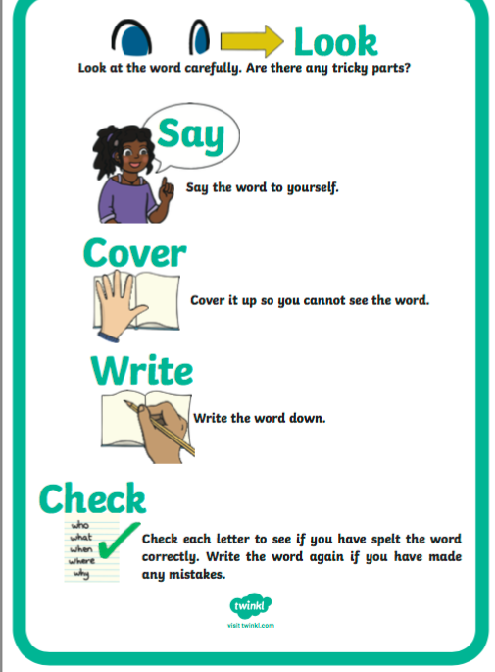

3. Gaeilge:
This week we will listen to a story about the circus from Bua na Cainte.
Look back on this week’s Home Learning page and click on the resources titled Sceal-An Sorcas. Watch this video.
An Sorcas - Cuir na pictuir in ord. Watch this video also.

Find the activity sheet below.
- Practice reading the story.
- Dathaigh an pictúir agus líon na bearnaí (colour the picture and fill in the gaps).
If you cannot print this page, tarraing pictiúr de fearr grinn agus scríobh na lipéad - ‘Fearr grinn, rón, srón, liathróid, hata,’ air nó uirthi. (Draw a picture of a clown and write the labels on him or her.)
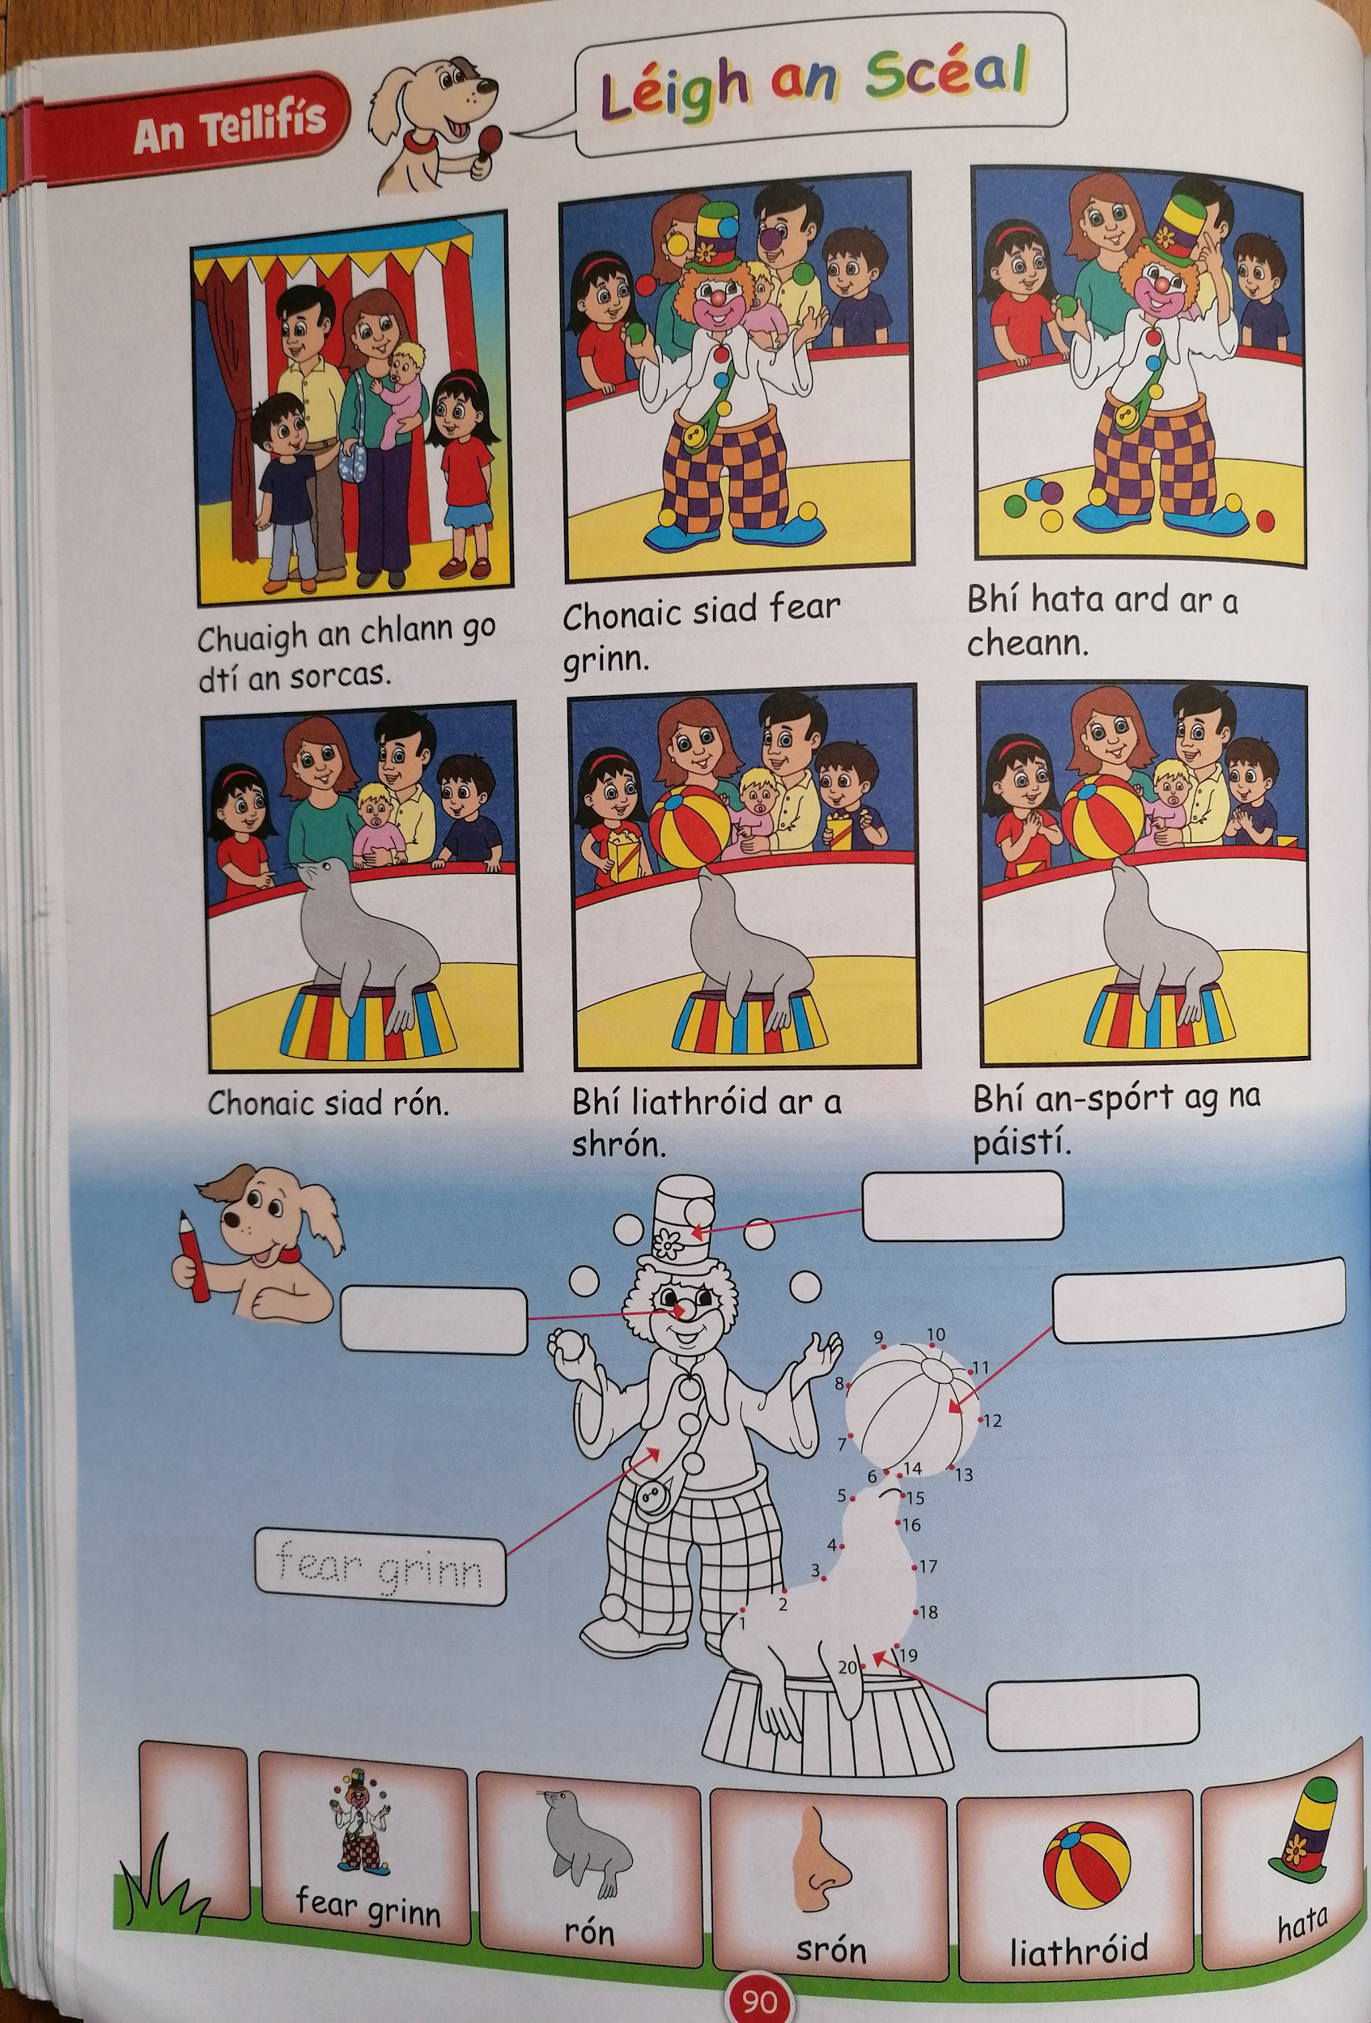

4. Maths

- We are looking at 3D shapes today.
- Can you think of the different 3D shapes? There are 5 of them that we look at in 2nd class.
- Can you think of the different characteristics of 3D shapes?
A face is the big, flat side of a shape.
An edge is where two faces meet.
A vertex (plural: vertices) is another word for a corner...the pointy bits of a shape.

Can you look around home and identify any 3D shapes? In my kitchen I found a box of pringles, which is a cylinder.You might find different 3D shapes in your kitchen.
- Now, in your copy or on a piece of paper, write down some 3D shapes that you find at home. Aim to find at least 1 of each of the 5 different 3D shapes that we look at in 2nd class.
- Complete this worksheet on 3D shapes. There is 1 extra 3D shape on the worksheet, can you find the name of it?
*Challenge-Complete Tuesday on the problem solving worksheet below.
