Thursday:

Daily Activities
Whole-school event: Go to the Well-being Fortnight page for today’s activity!
​Spellings: Learn spellings daily and write 3 of the words in interesting sentences.
Writing: Set a timer for 5 minutes and do some "free writing" or "free typing" on a topic of your choice.
Reading: Try to read for at least 15 minutes (or more if you can)!
Maths: Daily 10 Mental Maths Questions. Try level 1 or 2.
- Skip counting in 5s to 50 (0, 5, 10, 15, 20, 25, 30, 35, 40, 45, 50)
- Weekly tables 8+
- https://www.topmarks.co.uk/maths-games/hit-the-button. Click the link, go to halves and play halves to 10. Have fun!

1. English:
- You have 2 new words to learn today: weight, volume.
Use a dictionary to find their meaning. Find a link to an online dictionary in today’s resources.
- Practise spelling your words for your test tomorrow.

- Today we will look at apostrophes. Do you know what these are?
- An apostrophe <’s> shows that something belongs to someone.
For example: Amy’s jumper. Shane’s ball. Anita’s coffee.

- Go back to the website and click on the “Apostrophe <’s>” resource to learn more.
- Complete the English activity sheet below.

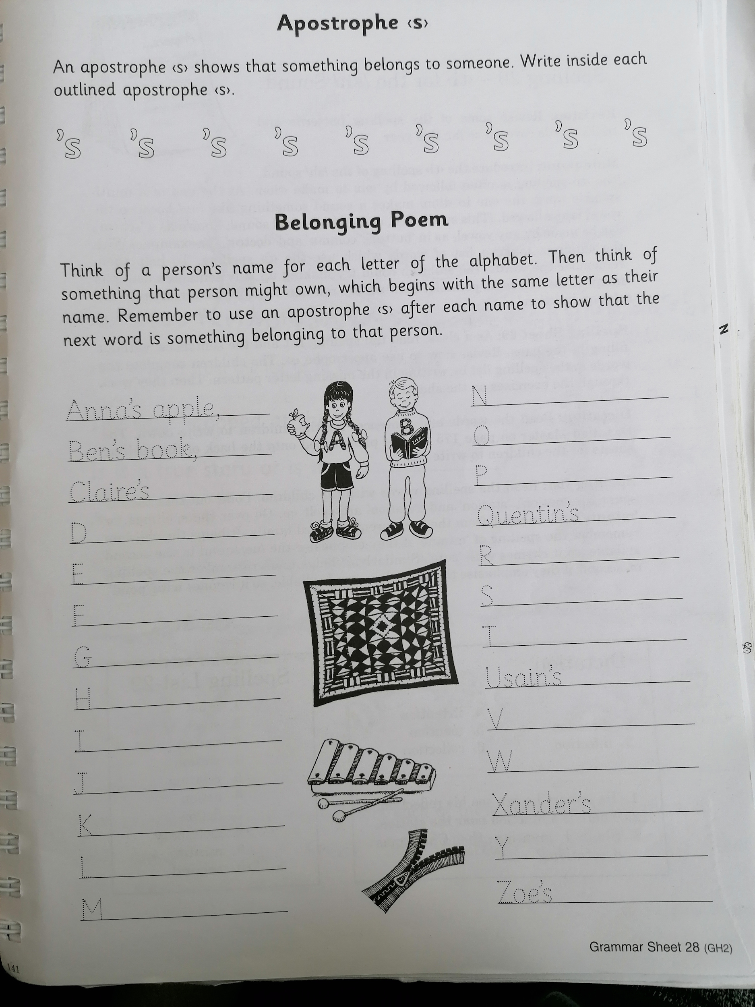

2. Maths:
- We are looking at 3D shapes again today. Let's do a quick recap.
- Which 3D shape or shapes do you think rolls?
- Which 3D shape or shapes do you think stack?
- Which 3D shape or shapes do you think slide?
- Now, in your copy write down which 3D shapes roll, stack and slide. You might like to use some 3D shapes that you find at home to help, it's fun!
- Complete this worksheet on 3D shapes.
*Challenge-Complete Thursday on the problem-solving worksheet.

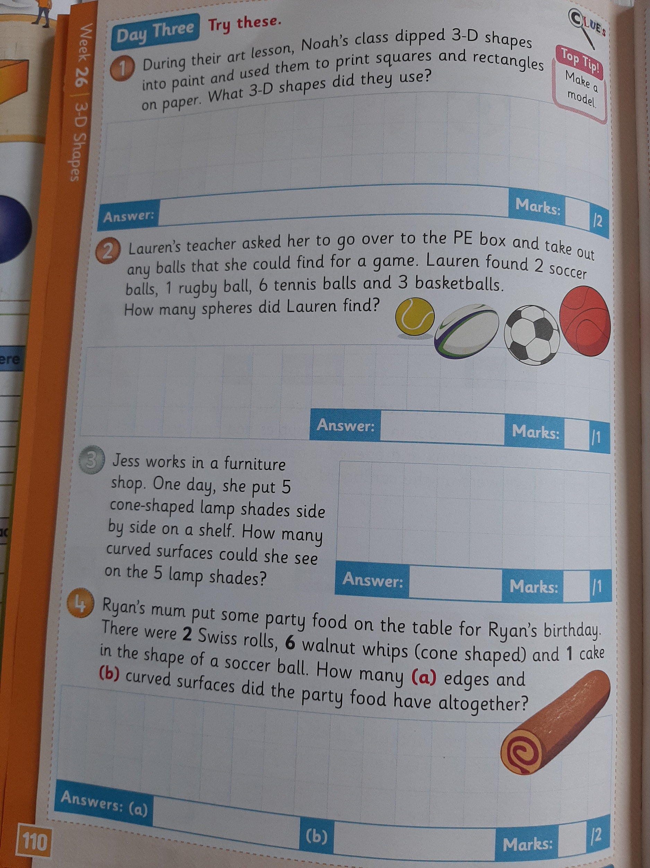

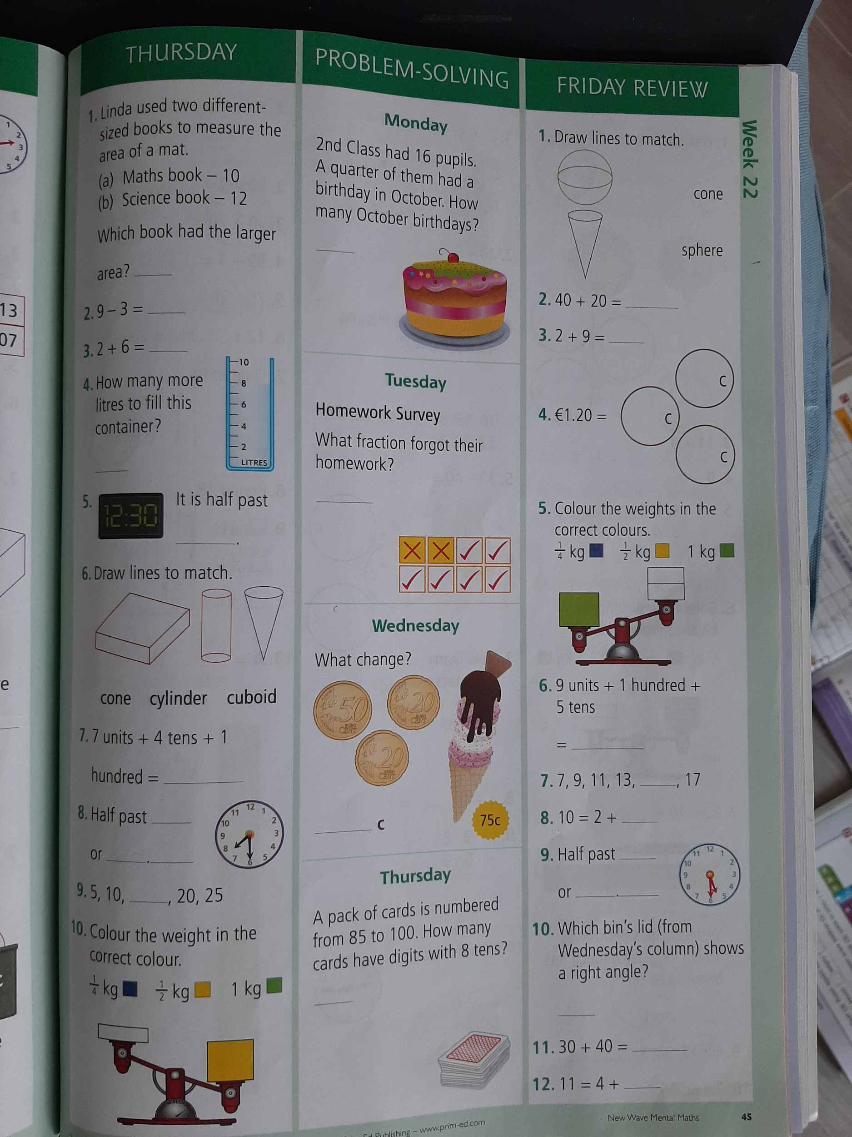

3. Gaeilge:
In class we usually begin each Gaeilge lesson with An Nuacht.
- Cén lá atá ann inniu?
- Cén sórt aimsir atá ann inniu?

Look back on this week’s Home Learning page and click on the resource titled
An Nuacht . Féach ar an físéan seo (watch this video).
- Complete the activity sheet below from Bua na Cainte. Líon na bearnaí (fill in the blanks). There are words on both sides of the page for you to choose from.
*If you cannot print this page you could write An Nuacht onto a page
Have fun! :)

*Bonus Gaeilge Activity. Just for fun!
Aimsigh na difríochtai - Tá 6 rud.

