Thursday:
Daily Activities
Morning Meeting: Check out Seesaw each morning!
​Spellings: Learn spellings daily.
Writing: Set a timer for 5 minutes and do some "free writing" or "free typing" on a topic of your choice.
Reading: Try to read for at least 15 minutes (or more if you can)!
Maths: Daily 10 Mental Maths Questions. Try level 1 or 2.
.Skip counting: in 2s backwards from 30. (30, 28, 26, 24, 22, 20, 18, 16, 14, 12, 10, 8, 6, 4, 2, 0)
Tables: Practice 10+ tables.
Whole-school event: Go to the Mother Language and Multi-Language Fortnight page for today’s activity.

1.English:
Spellings.
Practise spelling all of your words for your test tomorrow.

Writing.
A preposition is a word that tells us where a noun or pronoun is in relation to another. Eg. ‘beside’, ‘under’.
Check out Seesaw for this week’s activity on prepositions. Have fun!!

2. Maths:

- Today we are looking at area again.
- Remember, area is a measure of how much space there is on a flat surface.
- We have looked at different ways to understand the area of spaces and we have made comparisons. I hope that you enjoyed comparing different objects that we find in our classroom, our school and at home. Hopefully it was fun!
- Today we are looking at some problem solving questions on area.
- Here are 2 problem solving questions to get you warmed up before you take on the worksheet, have fun! Do them in your copy or a piece of paper.
- Colm, his sister and his Dad were making handprints on an A4 sheet of paper. Will the three handprints cover more than or less than half of the sheet of paper?
- Michelle was at the zoo and she saw hoof prints. She counted 16 giraffe hooves, 8 camel hooves and 4 elephant hooves. Which of these do you think covered the biggest area?

- Complete the worksheet below on Area
*Challenge- Open the resource titled ‘Maths challenge 2’ and complete Thursday

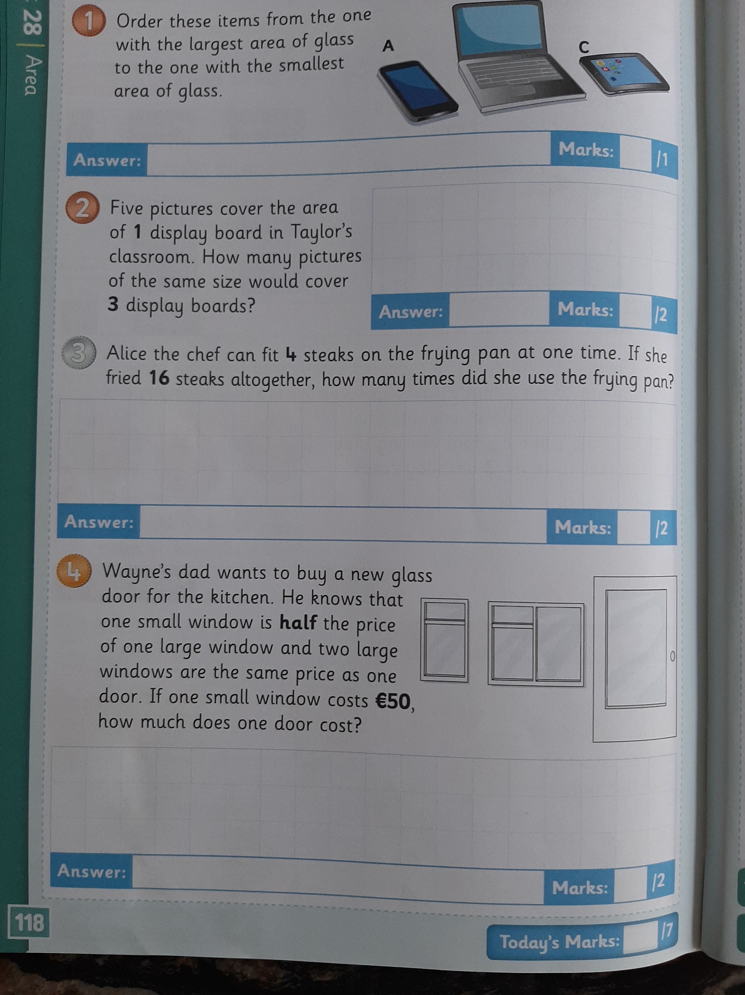

3. SESE:

- We are looking at sharks today, I hope that you enjoyed the shark activities from Tuesday.
- Open the resource titled ‘Sharks’ on the homepage.
- Read the fun facts below about Sharks and answer the questions, the questions are based on the powerpoint and fun facts, enjoy!!

Here are 5 fun facts about sharks.
- A shark's sense of smell is 10,000 times better than a human's.
- Sharks have a skeleton of cartilage but no bones.
- A baby shark is called a pup.
- Sharks can detect electrical impulses, including another animal's beating heart.
- Sharks have been on earth for more than 420 million years.

Now, answer the following questions in your copy or a piece of paper. Have fun!

- What is a baby shark called?
- Name another animal that has pups.
- How many years have sharks been on earth?
- How long is the Greenland shark?
- Why are Greenland sharks also called sleeper sharks?

