Friday:

Daily Activities
Morning Meeting
​Spellings: Learn spellings daily.
Writing: Set a timer for 5 minutes
and do some "free writing" or "free typing" on a topic of
your choice.
Reading: Try to read for at least 15
minutes (or more if you can)!
Maths: Daily 10 Mental Maths Questions. Try level 1 or 2.
Skip counting: in 10s. (10, 20, 30, 40, 50,
60, 70, 80, 90, 100)
Tables: Practice 9+ tables.
Whole-school event: Go to the Well-being Fortnight page for today’s activity.

1. Tests:
- Spellings: ask an adult to test you on your spellings for this week.
Adults- please call out each spelling and ask your child to write their answer. Go through corrections together.
- Maths: ask an adult to test you on your 9+ times table. Write down your answers and have an adult check them for you. Go through corrections together.
*Note for adults: Ask your child to write out and answer ten “9+ “ sums.
E.g. 9+5= ?, 9+11= ?
Please do not go beyond 9+20= ? (unless your child is fully confident with that).

2. English
- Find the template below. You are going to create a narrative story of your own, based on the picture on this template.
- Have a look at the picture below. Discuss it with someone in your home (if you can).

Beneath the picture there are 5 prompts. Answer these.
- Who? - Who is in the picture? What are their names?
- Where? - Where is the story set? Where are the characters? Does this place have a name?
- What was the problem? - All narrative stories have a problem that needs to be resolved. What kind of problem did your characters encounter?
- How was it solved? - Problems are usually resolved in a narrative story. How was the problem resolved in this story? Did the main character do something to fix it? Did another character join the story and help?
- The end. - How does the story end? How are the characters feeling? Do they all live happily ever after?

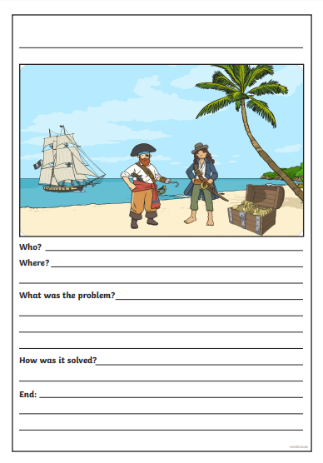
3. Maths:
- We are looking at place value again today.
- Try these few activities in your copy or a piece of paper just to get you warmed up and ready!
- How many hundredths, tens and units are in the following.
- 26
- 46
- 68
- 126
- 132
- 145
- Today’s activity is a fun problem solving sheet so I hope you have fun solving them, try your best and enjoy them! Find the activity sheet below.
*Challenge- Open the resource titled ‘Maths challenge 2’ and complete Friday.

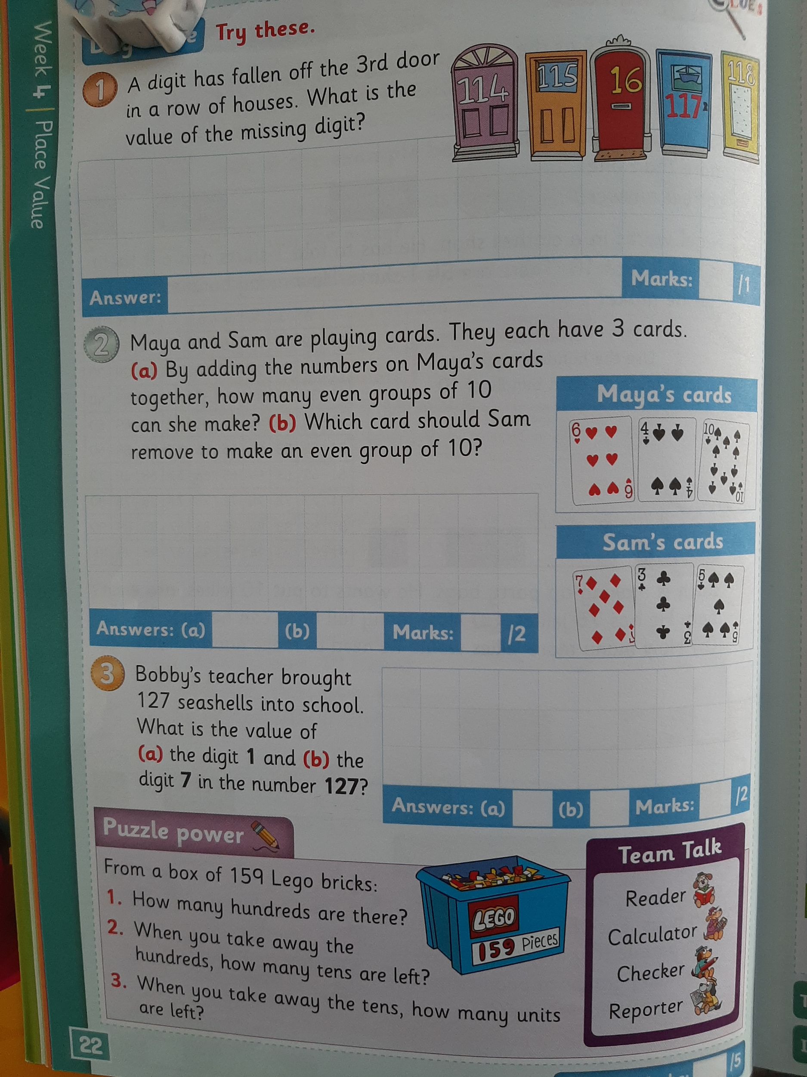

4. SPHE
A rainbow moment is a positive moment in your week.
Check out this poster to learn more.
For example :
My rainbow moments were learning all about our new Seesaw app and I was also on a nature hunt in a forest near my house. I saw grey squirrels and deer in the forest (Shane).
My rainbow moments were being able to spend time outside and enjoy the lovely weather. I went on a long walk to my local park and I saw so many dandelions growing. We know all about dandelions! (Amy).

- Think of three rainbow moments that you had this week and write about them. You can share these with others in your house and ask them if they had any rainbow moments this week.

Have a super weekend.
Amy, Shane and Anita.

