Thursday:
Daily Activities
Morning Meeting: Check out Seesaw each morning!
​Spellings: Learn spellings daily.
Writing: Set a timer for 5 minutes and do some "free writing" or "free typing" on a topic of your choice.
Reading: Try to read for at least 15 minutes (or more if you can)!
Maths: Daily 10 Mental Maths Questions. Try level 1 or 2.
.Skip counting: in 3s backwards from 30. (30, 27, 24, 21, 18, 15, 12, 9, 6, 3, 0)
Tables: Practice -5 tables.
Whole-school event: Go to the Mother Language and Multi-Language Fortnight page for today’s activity.

1.English:
Spellings.
Practise spelling all of your words for your test tomorrow.

Writing.
Homophones are words that sound the same but have a different spelling and meaning. For example; ‘their’ and ‘there’. ‘Our’ and ‘are’.
Check out Seesaw for this week’s activity on homophones. Have fun!!

2. Maths: Addition

- Today we are looking at the topic of Addition again.
- Remember, addition is adding something to something else.
- During addition sums, we have tens and units. We always start with the units!
- We have already looked at lots of sums this week so today we are going to have some fun with problem solving. Here are some examples that you can do just to get warmed up! Use a copy or a piece of paper to help you.

- In a football match, Kevin scored 16 goals, Lisa scored 11 goals and Jane scored 18 goals. How many goals did they score altogether?
- A farmer has 29 sheep and 16 lambs. How many animals does the farmer have altogether?

- Complete the worksheet below on addition. No need to print the worksheet, just write the answers in your copy or a piece of paper.
*Challenge- Open the resource titled ‘Maths challenge 1’ and complete Thursday

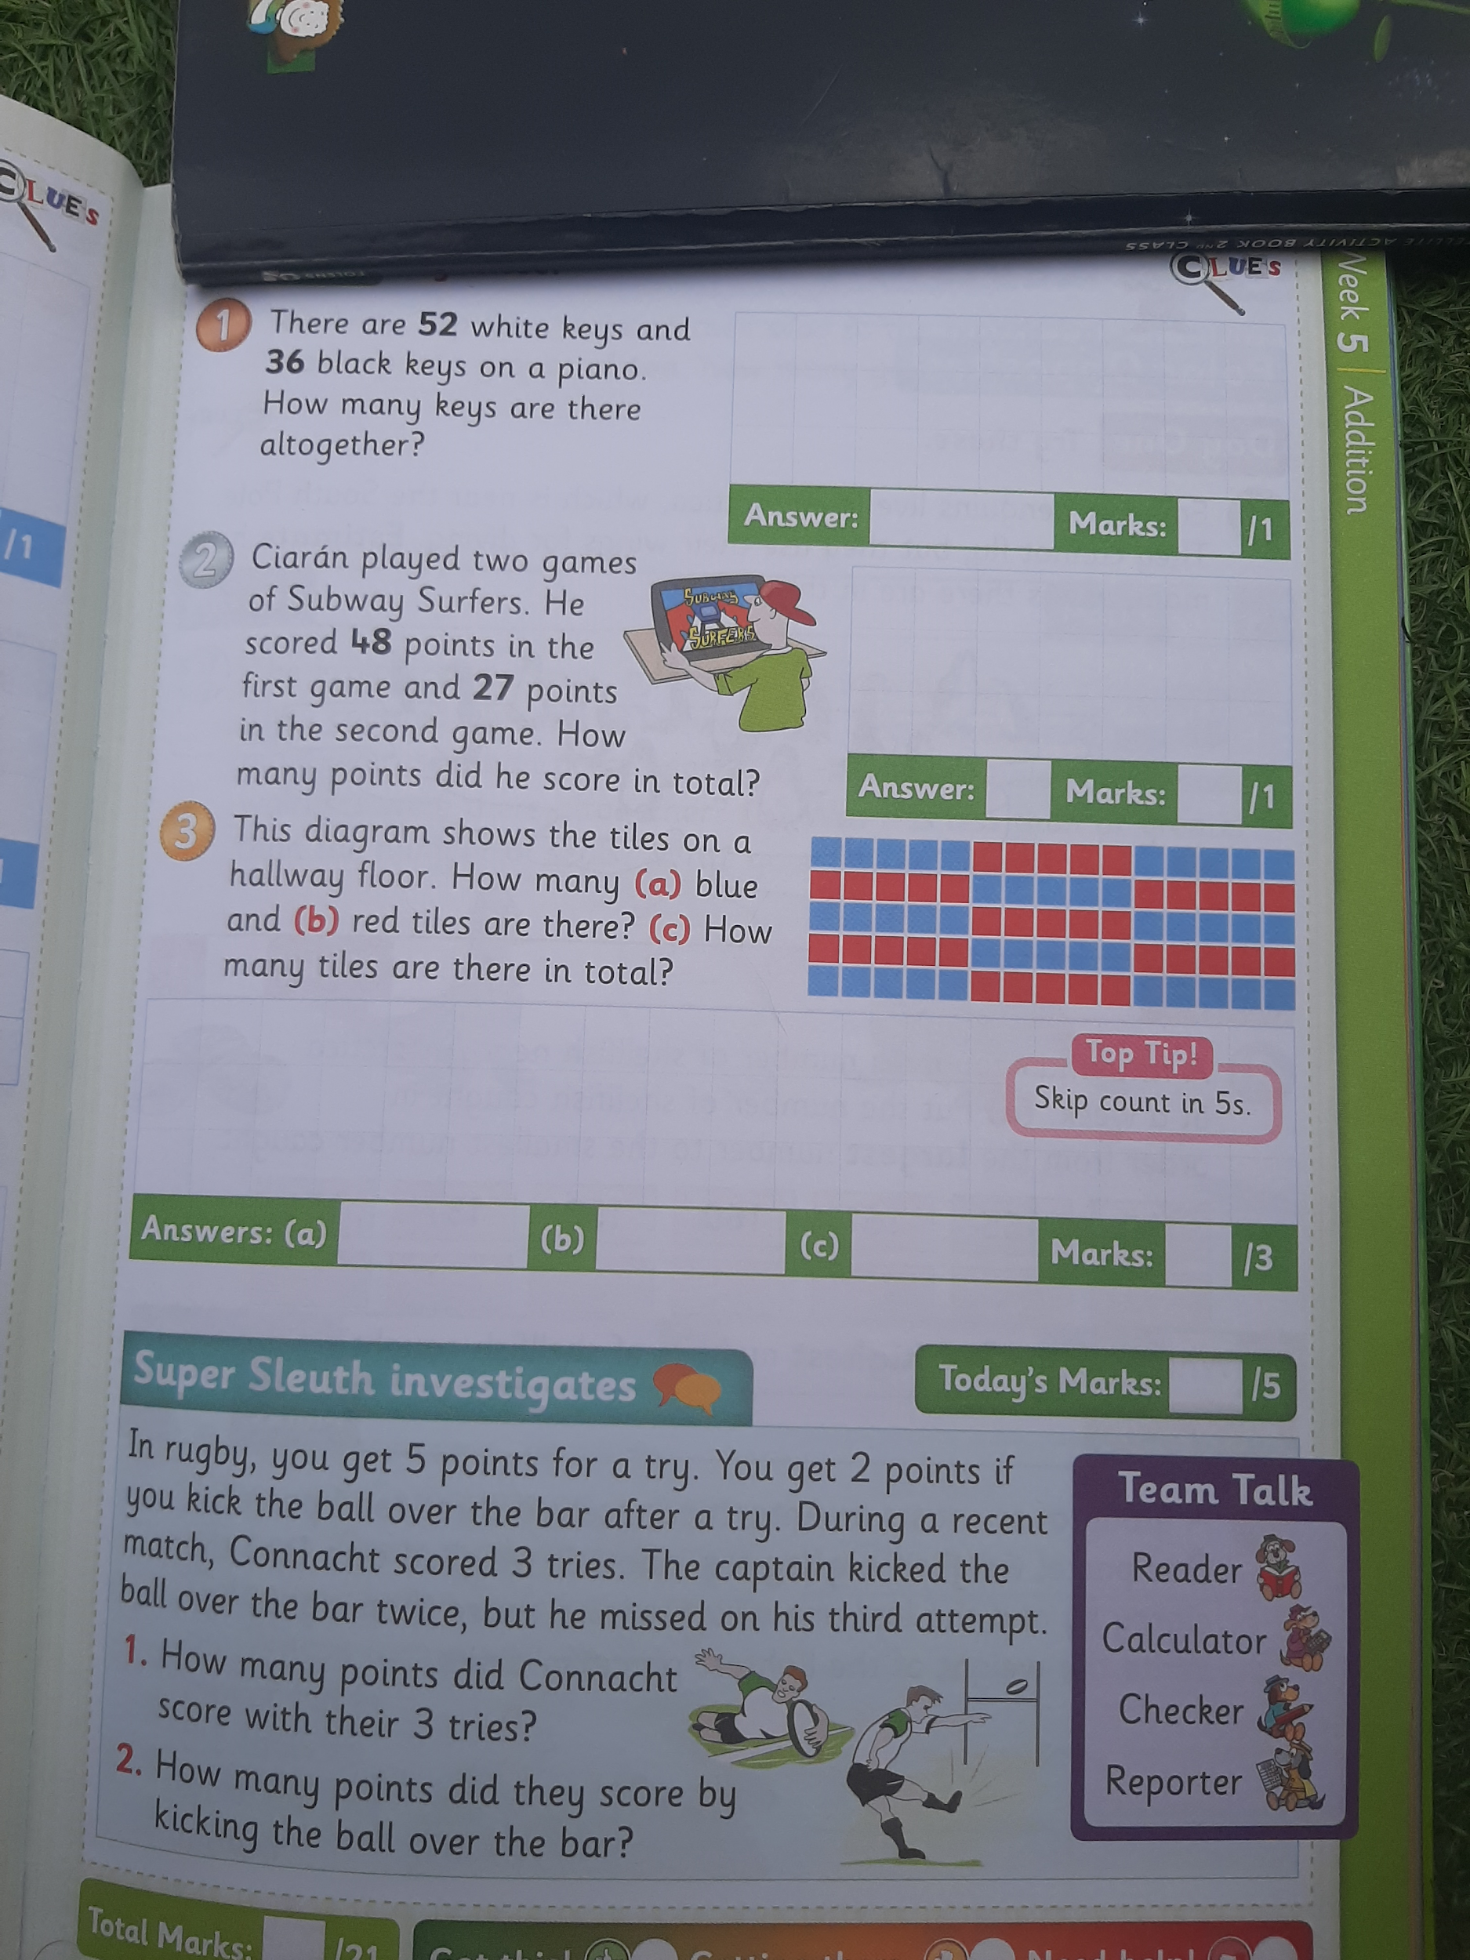

3. SESE:

- We are looking at the Sun again today, I hope that you enjoyed the sun activity from Tuesday.
- Maybe you now know some new facts about the Sun!
- Can you name 3 new facts that you know now? No need to write them down, just say them in your head or tell someone at home.
- Open the resource titled ‘The Sun ppt”’ on the homepage.
- Here you will find a powerpoint presentation about the Sun and some more interesting facts.
- Answer the following questions based on the powerpoint, enjoy!
- What is the Sun?
- Why is the Sun hot?
- What is the Sun?
- How big is the Sun?
- Why do the planets orbit the Sun?
- How far away is the Sun?

