Wednesday:

Daily Activities
Morning Meeting: Check out Seesaw each morning!
​Spellings: Learn spellings daily.
Writing: Set a timer for 5 minutes and do some "free writing" or "free typing" on a topic of your choice.
Reading: Try to read for at least 15 minutes (or more if you can)!
Maths: Daily 10 Mental Maths Questions. Try level 1 or 2.
Skip counting: in 4s backwards from 40. (40, 36, 32, 28, 24, 20, 16, 12, 8, 4, 0)
Tables: Practice -6 tables.
Whole-school event: *Find the link for Diversity Fortnight on the home page

1. English:
Spellings
- Learn the next 4 spellings - front, dozen, monkey, somebody
Remember your spelling strategy: “Look, Say, Cover, Write, Check.”

Writing
- Complete worksheet ‘Spelling Sheet 32’.
- Log in to Seesaw to listen to the instructions for this.

- We will look at persuasive writing again today.
Find today’s activity on Seesaw.

2. Gaeilge
Éadaí + dathanna revision.

Find videos and instructions on Seesaw.
Complete pages 126 and 127 in Bua na Cainte.

3. Maths:

- Today we are looking at subtraction again.
- We are going to look at regrouping.
- Remember the rhyme “More on top no need to stop, more on the floor go next door and get ten more.
- We always start with the units first, then we do the tens.
- Check Seesaw for a video to explain regrouping for the problems below.
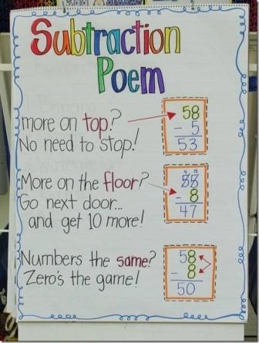
T U T U
5 4 6 3
- 2 8 -3 8

- Complete the worksheet below on Subtraction with regrouping. No need to print the worksheet, just write the sums in your copy or a piece of paper.
*Challenge- Open the resource titled ‘Maths challenge 1’ and complete Wednesday.

