Wednesday:
Empower Tools - have compassion
Spellings
Tables ÷6 ÷7
Maths - Decimals
Gaeilge - Éadaí - story and vocab
English - Comprehension

Empower Tools
Have Compassion
- Spellings: extravagant, participant, valiant, triumphant, insignificant, flamboyant.
Sentences: Put 3 of these spellings into a sentence each.

2. Maths:
- Revise ÷6 ÷7 tables- play the game linked for Monday or the game linked for Tuesday to help
- Today's goal: Write whole numbers as decimals and multiply decimals
- Go to page 111 in Planet Maths and answer questions A&B. Try the Challenge question in the green box if you can.
- *There are extra maths worksheets for those who would like a challenge under Fridays work*

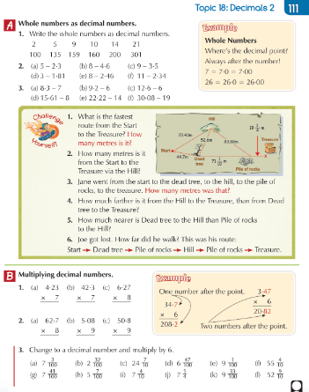

3. Gaeilge (see Gaeilge support document for translations)
Póstaer 15: An Chulaith Nua (The new outfit)
- Look at this story on Folens online - listen to it and try your best to understand what is happening. https://content.folensonline.ie/programmes/AbairLiom/4th_class/resources/Poster/AL_4C_ACT_POS_CH11_009/index.html
- Complete the ‘Foclóir’ (vocabulary) activity here
https://content.folensonline.ie/programmes/AbairLiom/4th_class/resources/Poster/AL_4C_ACT_POS_CH11_009/index.html

Wednesday

Story Translation

An chulaith nua – The new suit

Tá Mamaí, Daidí agus na páistí i siopa éadaí – Mum, Dad and the children are in the clothes shop

Tá éadaí de gach sórt ann. – There are clothes of every type there

Ba mhaith le Daidí culaith nua a cheannach – Dad wanted to buy a new suit

Tá sé ag caitheamh culaith ghalánta anois. – He is wearing a fancy suit now

Ceapann Daidí go bhfuil sé an-fhaiseanta – Dad thinks he is very fashionable

Is maith le Mamaí agus Síofra an chulaith seo – Mam and Síofra like this suit

Ní maith le Mamaí na cultacha eile. – Mam didn’t like the other suits

Bhí ceann amháin róbheag agus ceann eile rómhór. – One was too small and another too big

Bhí culaith eile rógheal agus ceann eile róbhuí! - Another outfit was too bright and one too yellow!

Tá Seán ag feachaint ar chulaith atá ar mhaincín – Seán is looking at a suit on a mannequin

Ceapann sé go bhfuil an chulaith sin an-daor – He thinks this suit is very expensive

Tá go leor carbhat geal ar an gcuntar agus tá bróga ildaite faoin gcuntar
There are lots of bright ties on the counter and colourful shoes under the counter

Foclóir (Vocab)
https://content.folensonline.ie/programmes/AbairLiom/4th_class/resources/Poster/AL_4C_ACT_POS_CH11_009/index.html
(These will be in random order)

Éist leis an bhfocal agus cliceáil ar an bpictiúr ceart – Listen to the word and pick the right picture

Bríste – Trousers
Ciarsúr – handkerchief
Mainicín – mannequin
Culaith ghalánta – Fancy suit
Bróga faiseanta – fashionable shoes
Léine – Shirt
Seaicéad - Jacket
Hata art – top hat
Spéaclaí – Glasses
Carbhat geal – Bright tie

4. English
Read the news article on the Oxpecker Bird and answer the questions

