Wednesday:

Suggested Daily Schedule

Spellings: Practice your spellings each day
Maths: Practice Big Maths Beat That each day
Reading: read a book for 30 mins each day
Language: complete your activity for each day (https://www.citywestetns.ie/language-fortnight.html)

Spellings: previously, predecessor, prearrange, preliminary, presumption, precautionary
Sentences: Put 3 of these spellings into a sentence each.

Maths:
Go to Seesaw and complete the ‘Geoboard’ activity.

Go to page 135 in Planet Maths and complete A&B. (you will need a ruler to complete this activity)

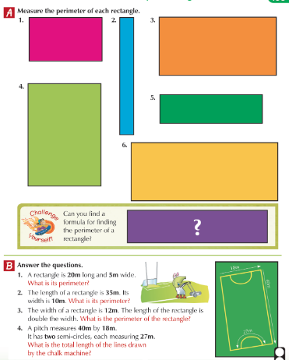

English

Today, we will be writing a recipe poem - see the video by Lisa on the home learning page .

See home learning page for word mat.

Gaeilge

Leigh an scéal “An cluiche ríomhaire nua” agus freagair na ceisteanna. Tá físeán ann chun cabhrú leat.
(Read the story “The new computer game” and answer the questions. There is a video to help you on the home learning page.)

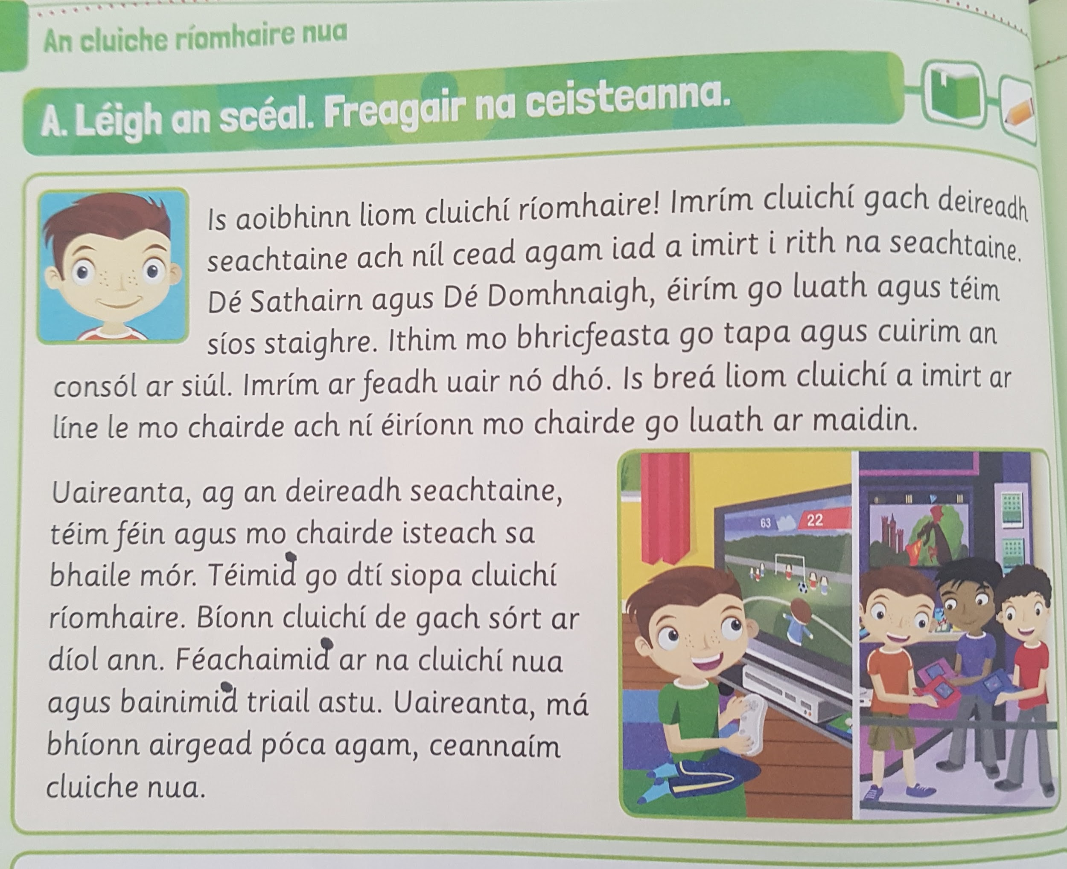

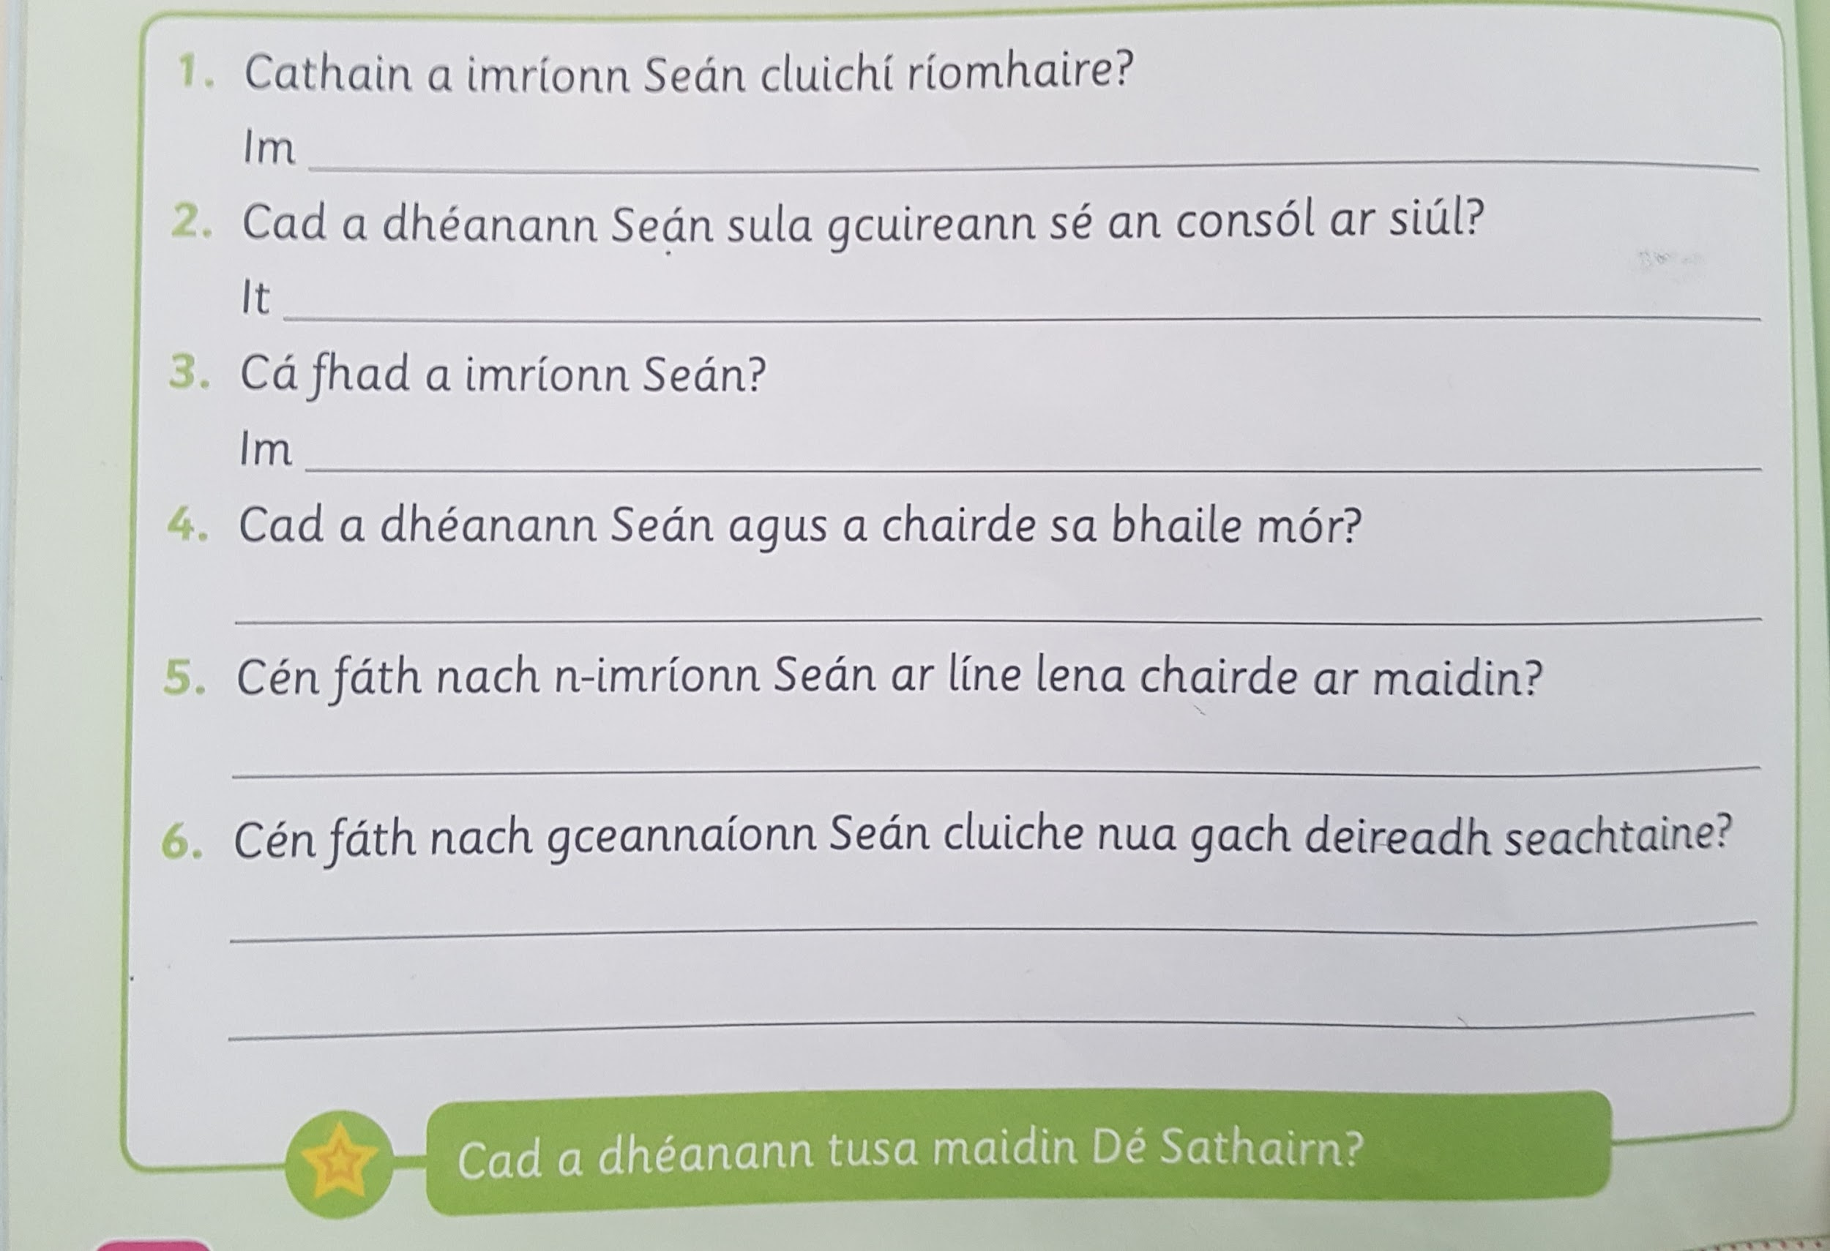

Language Fortnight
Complete activity for today

