Wednesday

Suggested Daily Schedule

Spellings: learn 6 spellings each day
Maths: Practice Big Maths Beat That each day
Reading: read a book for 30 mins each day
Wellbeing: complete your activity for each day

Bonus activity - Try out a GoNoodle activity

Spellings: guitarist, scientist, linguist, tourist, journalist, therapist
Sentences: Put 3 of these spellings into a sentence each.

- Maths:
- Watch the PowerPoint Presentation with Trisha on number patterns
- Go to page 130 in Planet Maths. Complete A&B. (You can try C too for an extra challenge if you want).
- I have linked some games on the home learning page for this week so have a look there for some games to help you.
- https://ie.mathgames.com/skill/4.88-increasing-growth-patterns
- https://mathsframe.co.uk/en/resources/resource/42/sequences
- https://www.abcya.com/games/number_patterns

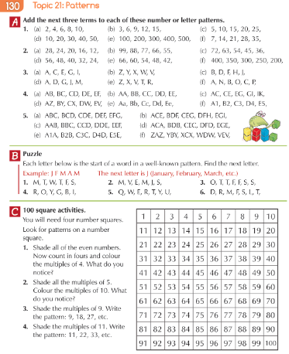

- English- Poetry

Summer Colour Poem- Watch video by Lisa link to be added later

Example poem:
Title : What’s my colour?
It is the salty chips I eat on the promenade
It is the red hot sand beneath my feet
It is the greedy seagull’s open beak
It is the happy sunflower, swaying in the breeze
It is the melting ice cream, running down my chin
It is my bright raincoat, keeping me dry on wet summer days
It is the delicious and salty corn on the cob, yum!

My colour is yellow!

Ideas to help with your writing

Red: sandals, sunburn, tomatoes, peppers, cherries, ladybird, poppies, England flag when the world cup is on/Welsh flag, apple, strawberries, inside of a watermelon, lobster (cooked), striped lighthouse, cricket ball
Orange: the sun, ice lollies, oranges, orange juice, monarch butterfly, apricot, fire (while camping), tent, flowers, sunset, sunrise, crab, battered fish, lighthouse light, seaweed, starfish, Nemo, beans (while camping)
Yellow: bumblebee, wasp, sunflower, banana, lemon, the sun, sand, ice lollies, buttercup, raincoat, corn on the cob, dandelions, stars, chick, grapefruit, butterfly, ice cream, sandcastle, chips, jacket potato (round the campfire)
Green: grass, grass stains, salad, countryside, trees (for climbing), apple, caterpillar, frog, lawn, lime, grapes, watermelon, mushy peas, cricket pitch, palm tree
Blue: the sea/ocean, blueberries, bluebells, forget-me-nots, butterfly, the sky, fish, bluebird, peacock, dolphin, whale, Dory fish (from Finding Nemo), flags from other countries you have been to on holiday?

- Gaeilge

Déan cur síos ar na carachtair (Describe the characters).

Tá foclóir ar líne anseo chun cabhrú leat. (There is an online dictionary here to help you.)
https://www.focloir.ie/

