Wednesday:
Spellings: transitory, transfusion, transparent, translation, transferable, transformation
Sentences: Put 3 of these spellings into a sentence each.

Maths

Today you will be making 3-D shapes using nets. You can print and make or draw and make your nets. I will include some templates here if you would like to print them off. (Tip - if you want to colour your shape in, do that before you make it)

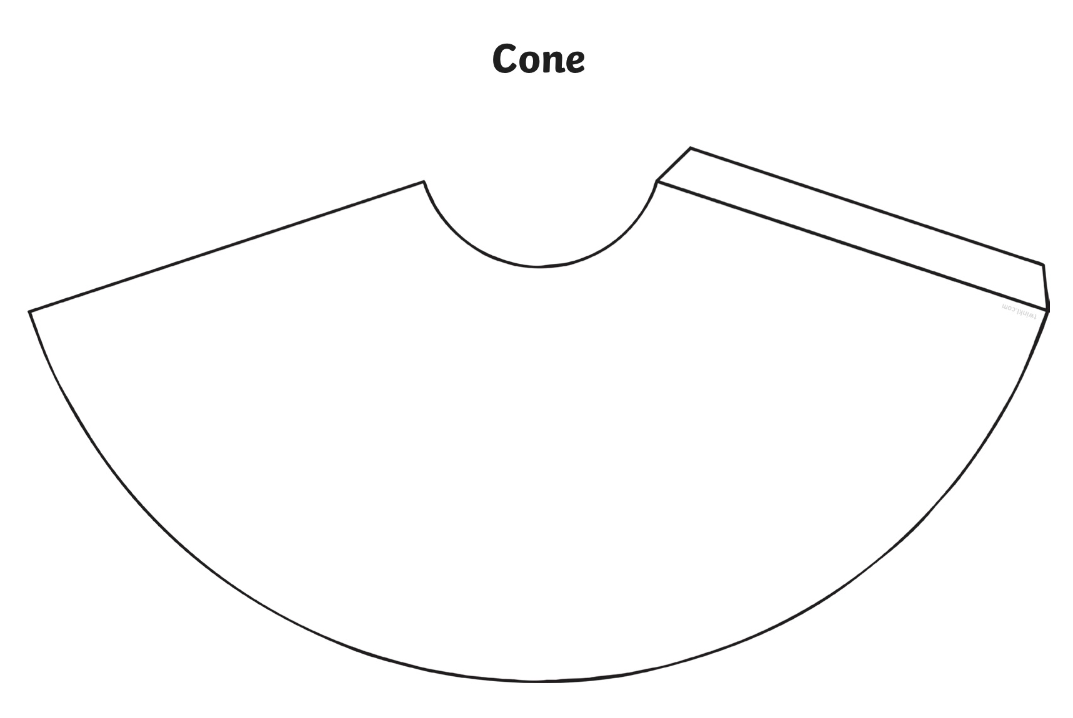

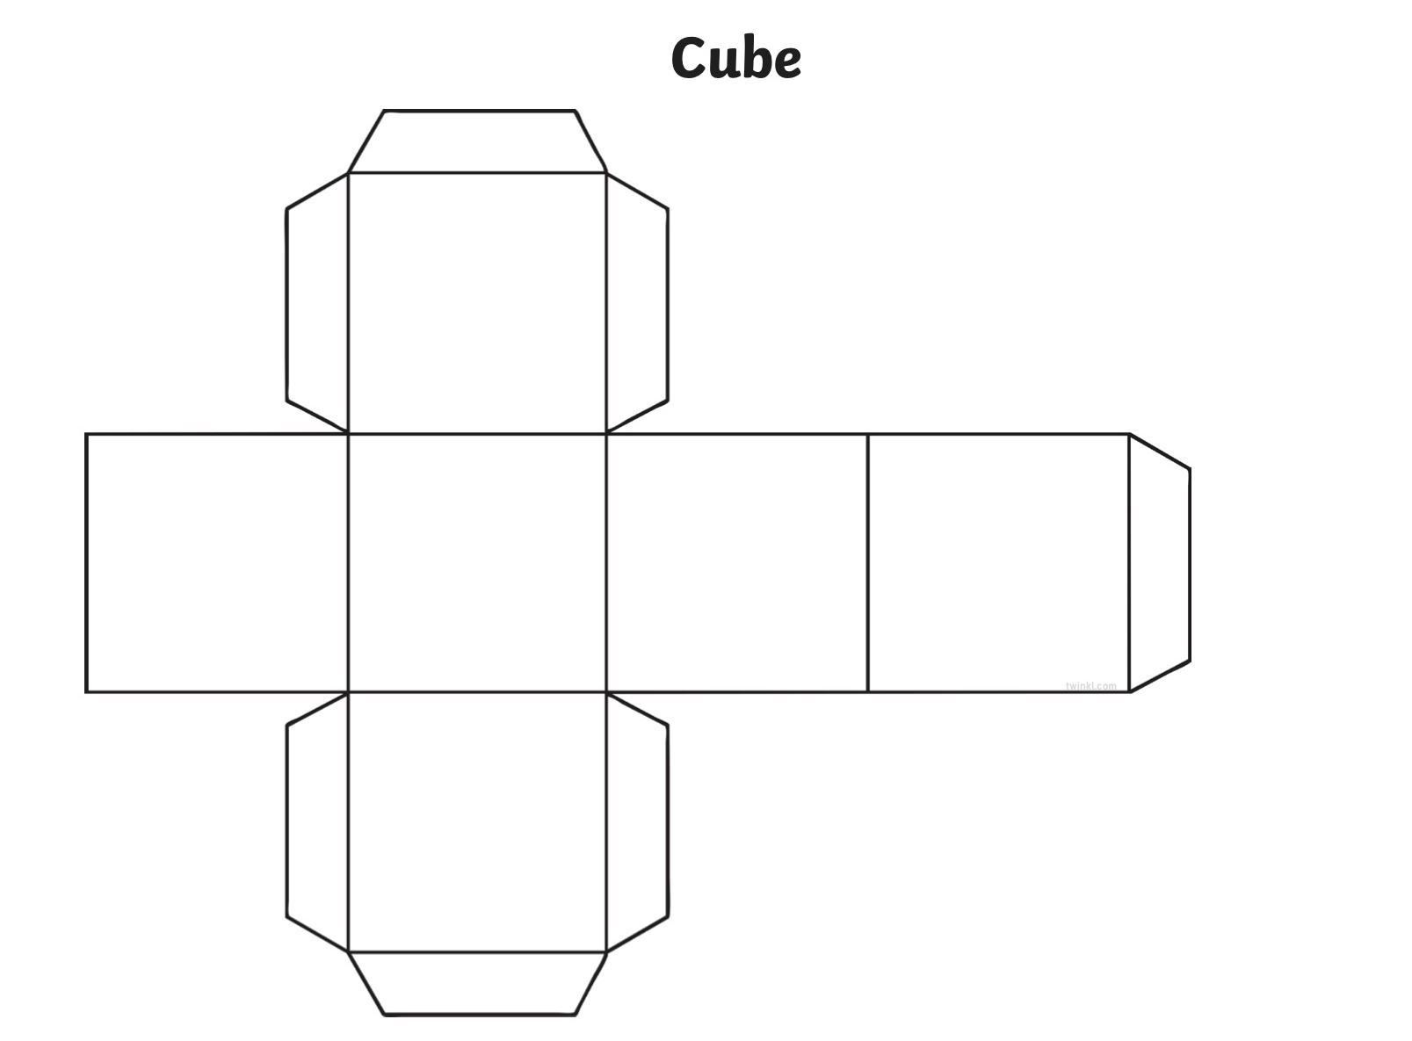

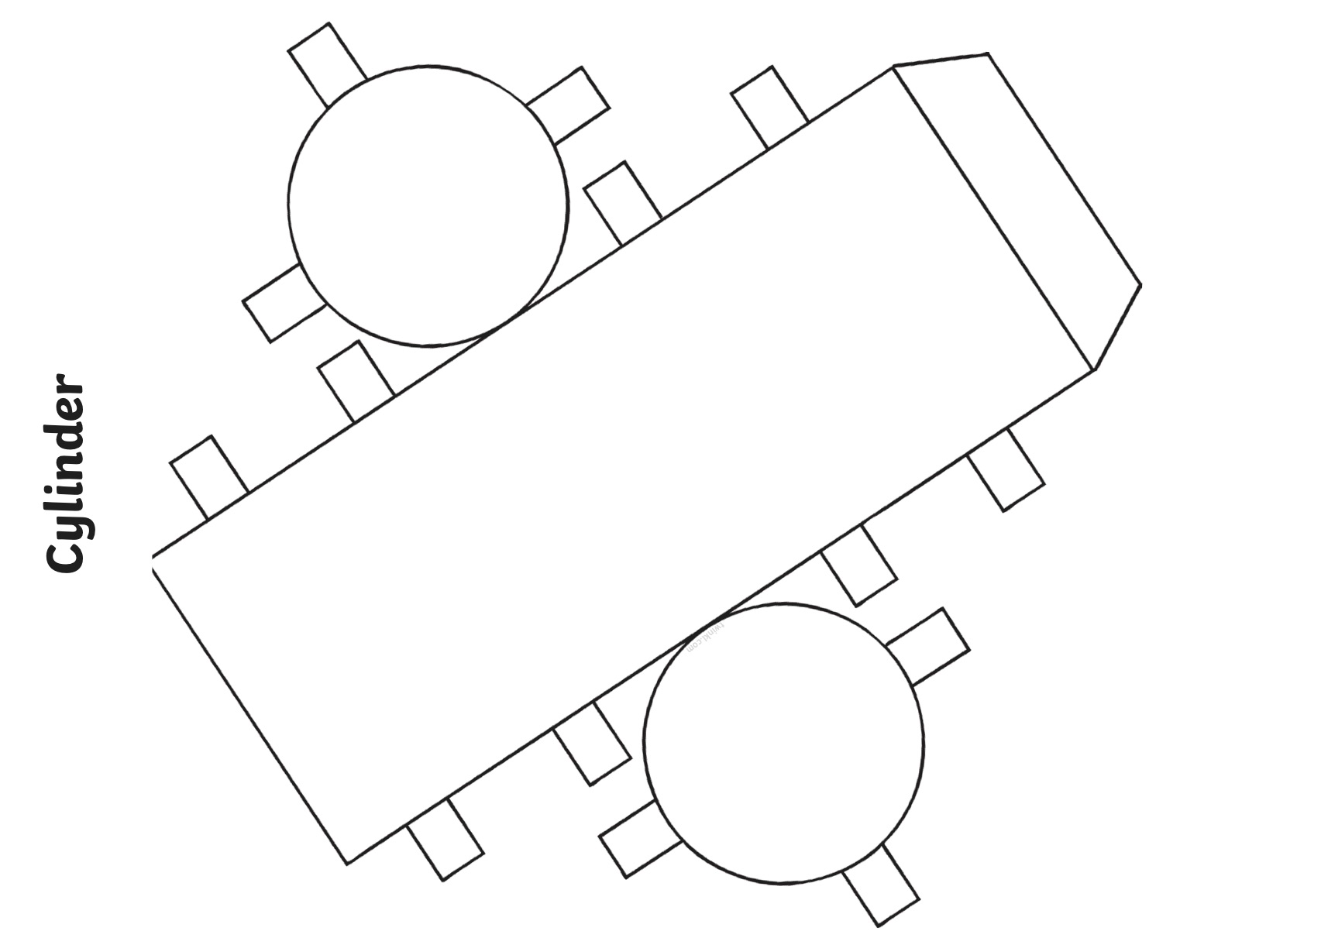

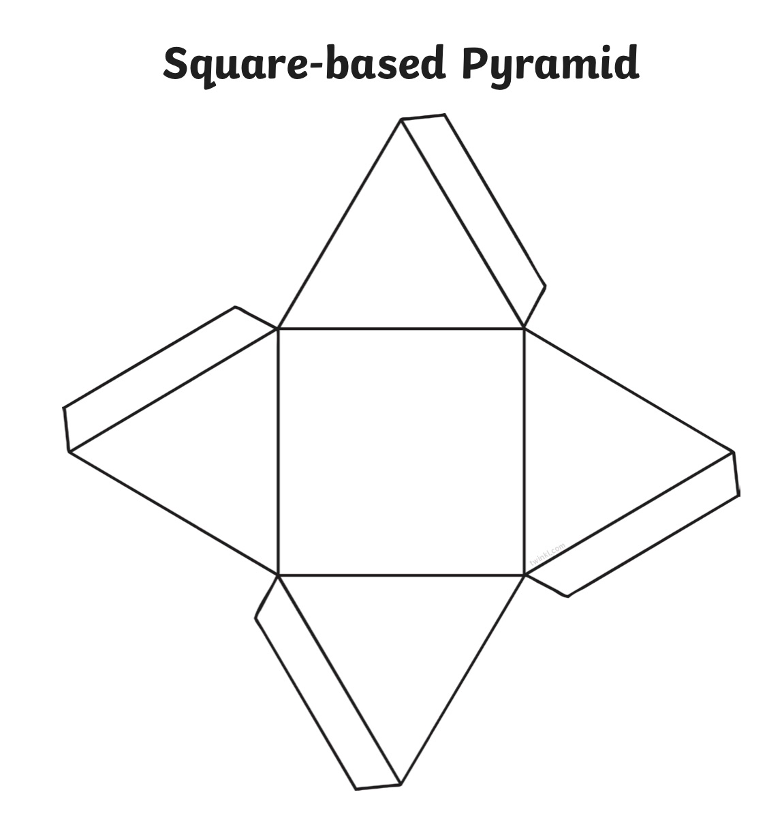

Gaeilge
Abair Liom- lch 128- Ábhar éisteachta a ghabhann leis an téacsleabhair Listening activity that goes alongside the textbook
Éist agus tarraing nó scríobh ( Listen and draw or write)
https://content.folensonline.ie/programmes/AbairLiom/4th_class/resources/Listening/AL_4C_AUD_CH15_001.mp3

English

