Home Learning
Week beginning: 2nd June 2020
Here are our learning topics for this week!

Maths: Time
Gaeilge - An Aimsir agus na séasúir
English - Persuasive writing
Science - Electricity
Music - Listening and responding
Diversity Fortnight

Don't forget you can access some great resources on our 'extra resources' page or by clicking here

Your Spelling List is: (anti-war, anti-hero, antibody, antidote, antiseptic, antimatter, antifreeze, antisocial, antipathy, anticlimax, anticyclone, anti-aircraft, anti-dandruff, antibiotic, antithesis, antioxidant, antibacterial, anti-perspirant)

Below you will find a suggested daily schedule! Please note that this outline is only a suggestion. We are aware that there are lots of things happening at home so please do what you feel is manageable. For those of you who want some extra challenges, please take a look at Lisa’s page, the bonus activity page and Citywest ETNS Book Club.

Suggested Daily Schedule

Spellings: Practice your spellings each day
Maths: Practice Big Maths Beat That each day
Reading: read a book for 30 mins each day
Diversity: complete your activity for each day (https://www.citywestetns.ie/diversity-fortnight.html)

Tuesday:
Spellings: anti-war, anti-hero, antibody, antidote, antiseptic, antimatter,
Sentences: Put 3 of these spellings into a sentence each.

Big Maths Beat That! : Give yourself 1 minute to do your big maths beat that sheet - note how many questions you answered correctly.

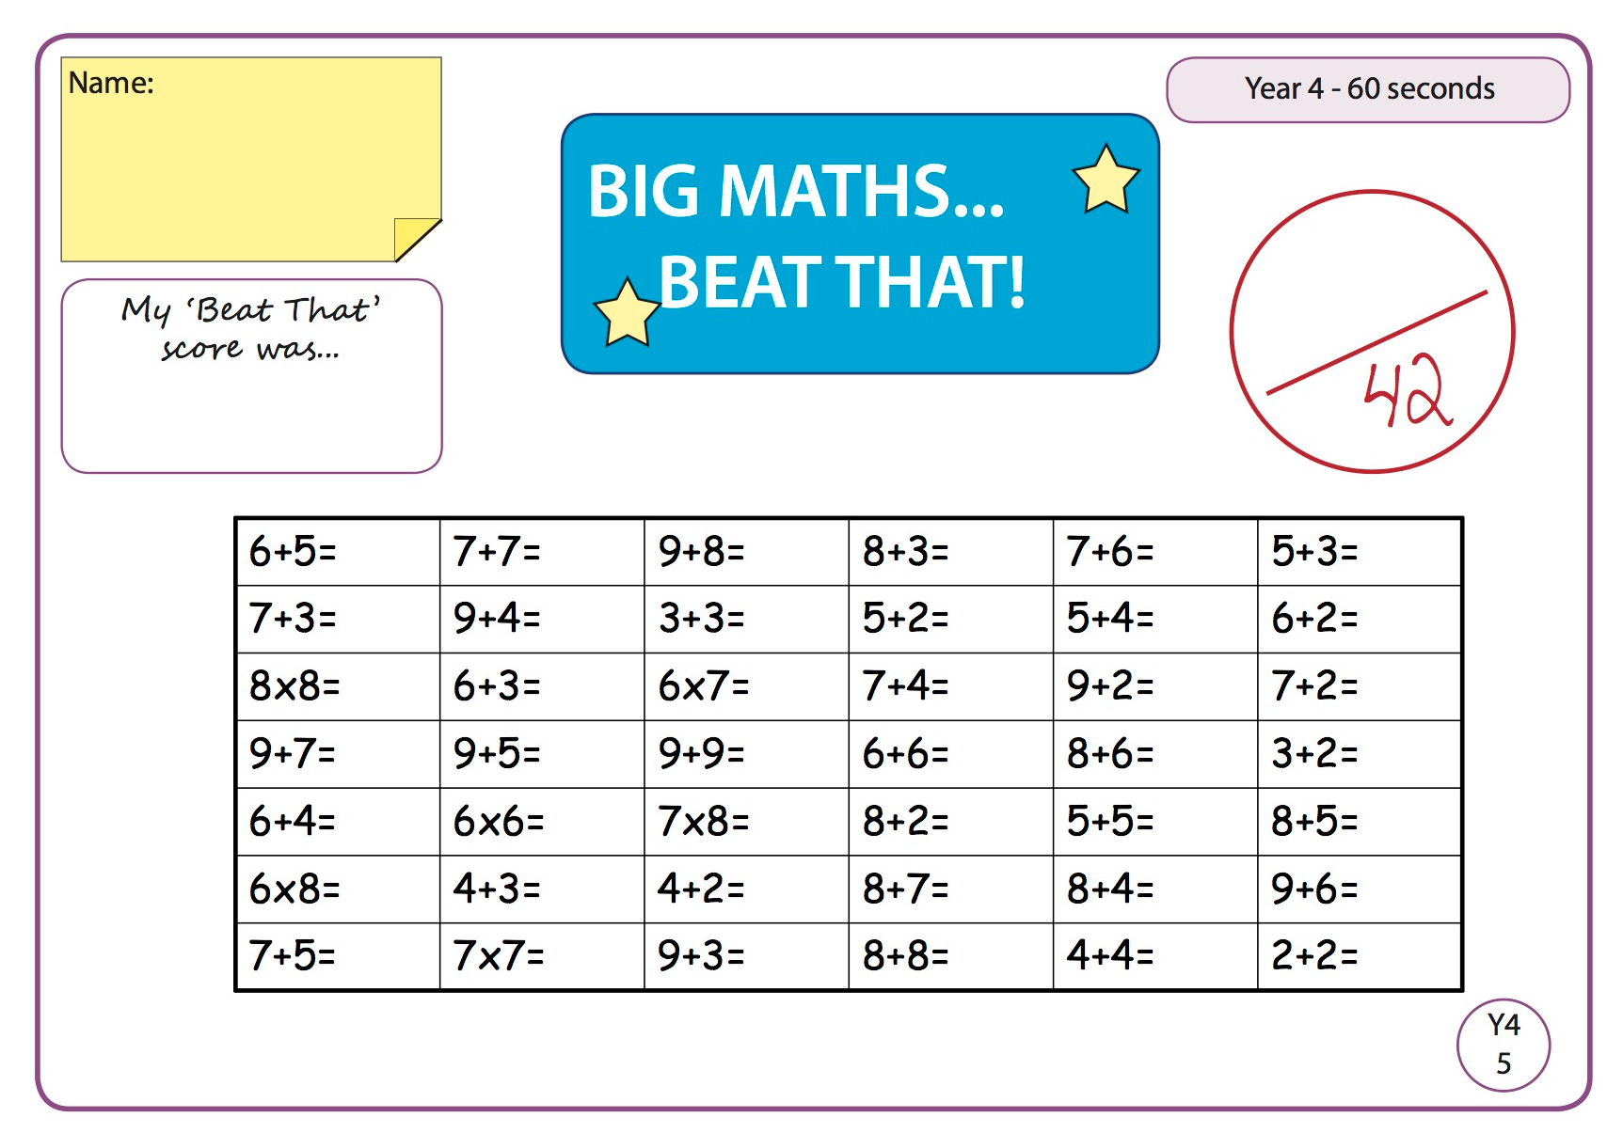

Answers

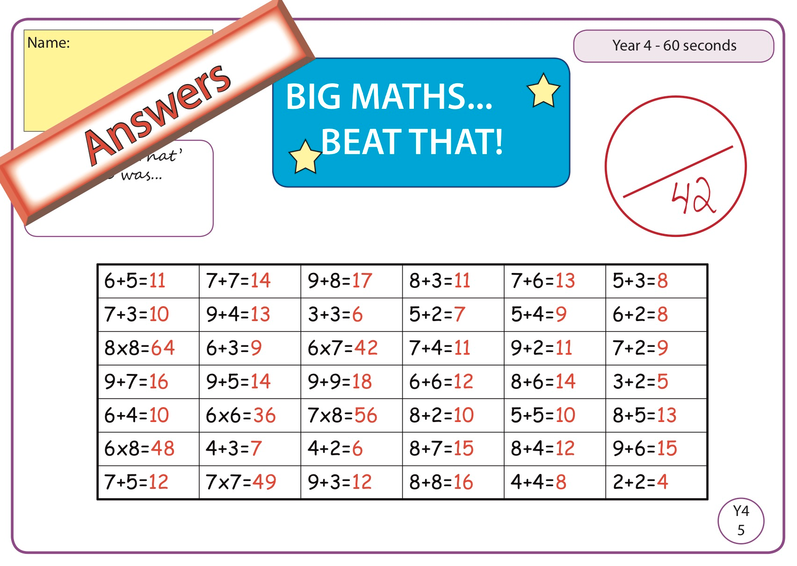

Maths

Play the game linked on the home learning page to revise telling the time. (Use the analogue clock)
https://www.abcya.com/games/telling_time

We are revising telling the time on an analogue clock today - Go to Seesaw and complete the two tasks set for today

Gaeilge

1.-Físeán bunaithe ar an aimsir agus na séasúir le Lisa ( video to be uploaded on the weather and the seasons by Lisa.
-Féach ar Seesaw ( Look on Seesaw )

2. Tá gníomhaíocht ann a dhéanamh ar Seesaw ( There is an activity on Seesaw to do)

- Dúshlán Breise
Extra Challenge
-http://www.nicurriculum.org.uk/microsite/pl/irish/whatever_the_weather/game/index.asp

English

