Thursday:
Empower Tools - own your power
Spellings
Tables ÷8 ÷9 ÷10
Maths - Decimals
English - Monkeys Comprehension
PE - with Lisa

Empower Tools
Own your power

1. Spellings: Revise all 18 spellings - put them into alphabetical order
Sentences: Put 3 of these spellings into a sentence each - spellings you haven’t put into sentences already this week.

2. Maths:
- Revise ÷8 ÷9 ÷10 tables
- Today’s goal: Divide decimals
- Go to page 112 in Planet Maths -Try part A. If you feel confident with division you can try B&C too!
- *There are extra maths worksheets for those who would like a challenge under Fridays work*

3. Physical education
See Lisa’s page for a video on different exercises today. Click on this page.

4.. English - Read the article on Monkeys

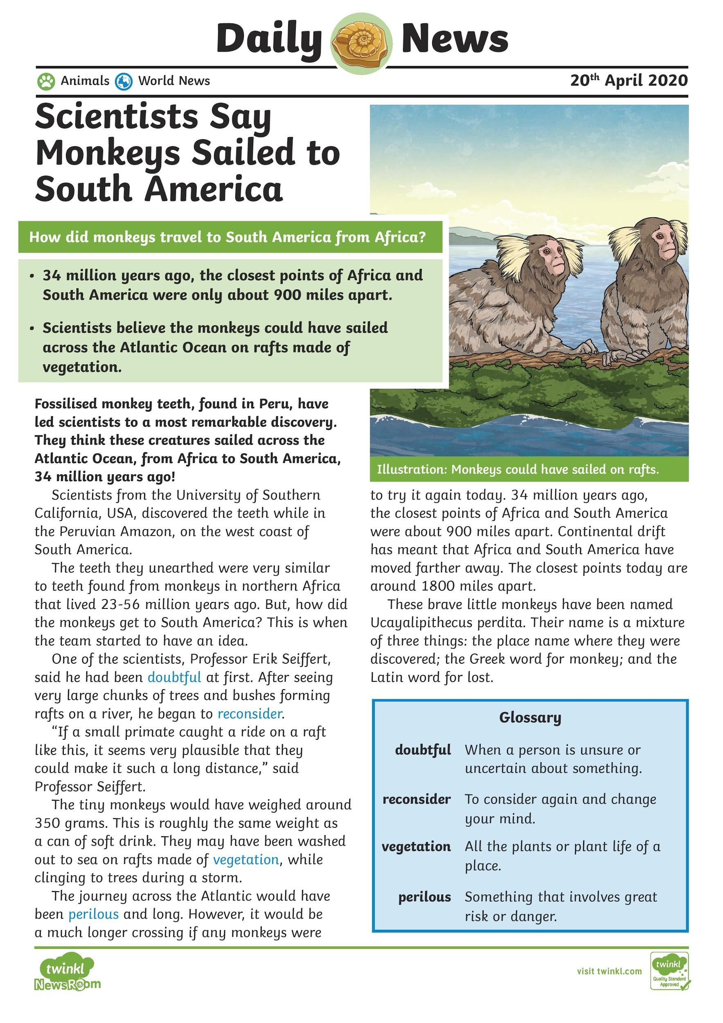

Answer the questions
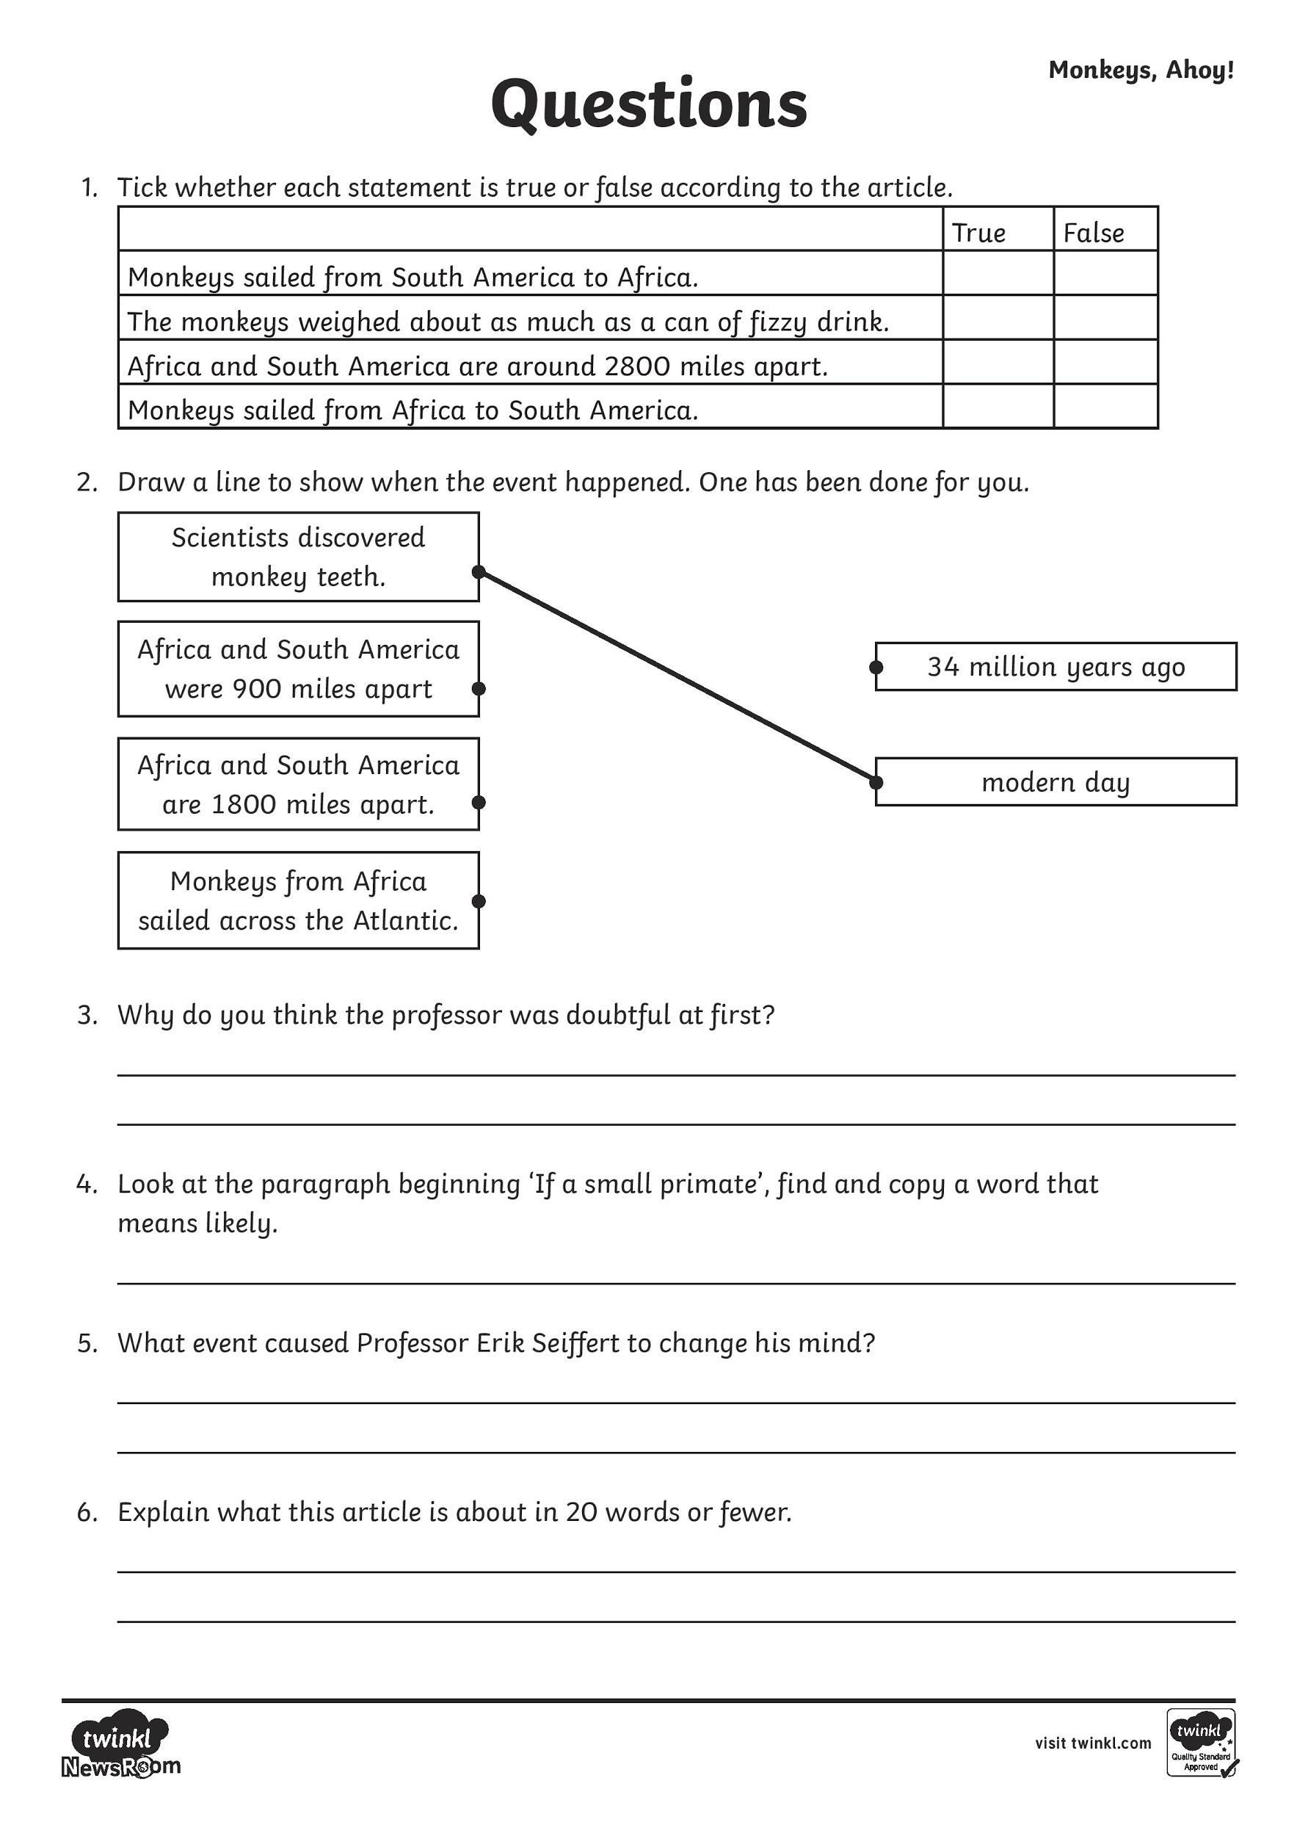

Do the activities on the task sheet.

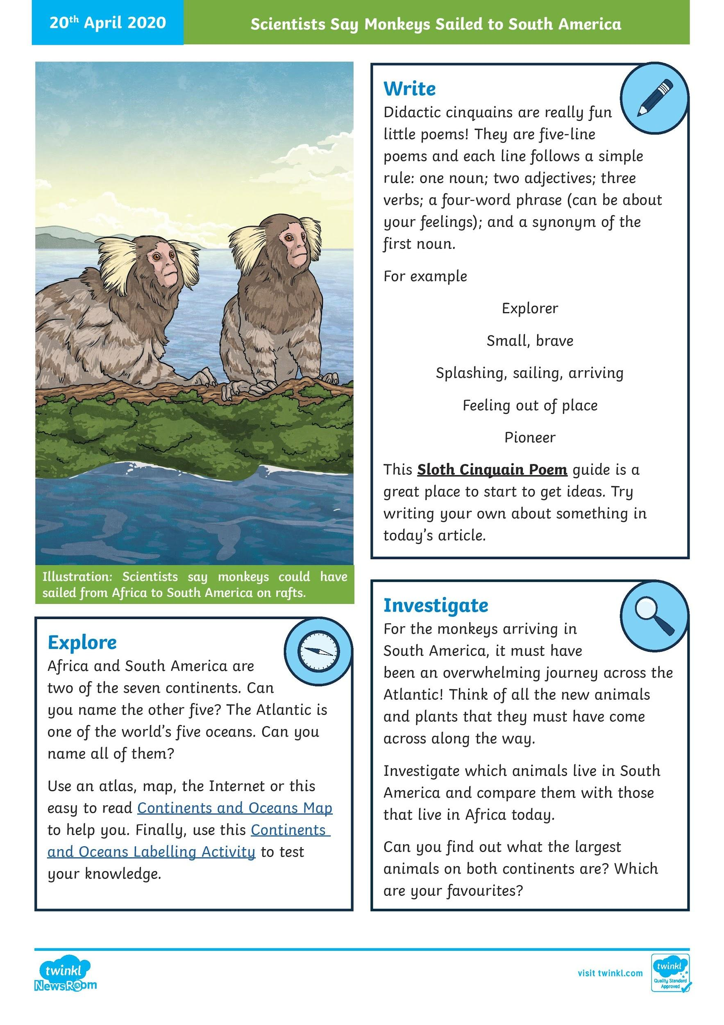

Cinquain Poems -

First look at the powerpoint presentation on Cinquain Poems.
Then look at this video Cinquain Poems

After do this sheet looking at a Cinqain poem about a sloth.

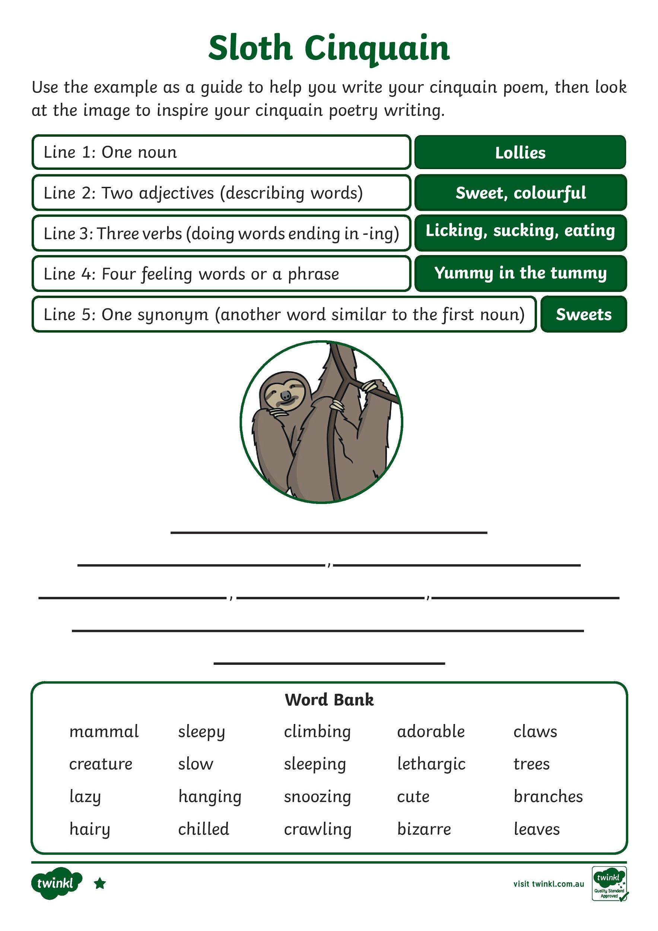

Then look at doing your own Cinquain poem. You can use this poster to remind you about the structure, you can use this sheet to check that you have included all the elements. There are a list of possible topics to choose from at the end if you are stuck.

