Thursday:

Suggested Daily Schedule

Spellings: Practice your spellings each day
Maths: Practice Big Maths Beat That each day
Reading: read a book for 30 mins each day
Language: complete your activity for each day (https://www.citywestetns.ie/language-fortnight.html)

Spellings: Revise all spellings. Put three more into a sentence.

Maths:
Watch Trisha’s video on the home learning page to help you with today’s work.

Go to page 136 in Planet Maths and do A&B.

Go to Seesaw and complete the ‘Perimeter Grid Puzzles’ activity.

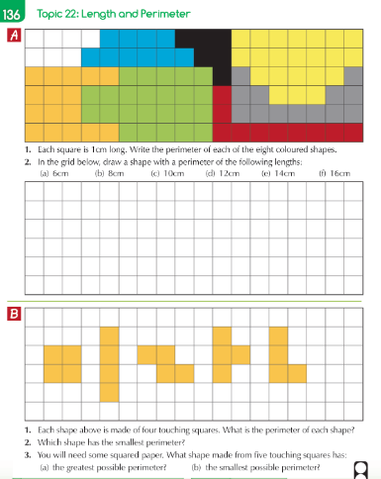

English

Persuasive writing

See activity on Seesaw. Use the OREO approach to write a strong piece of persuasive writing.

See video from Tuesday if you are unsure about this approach.

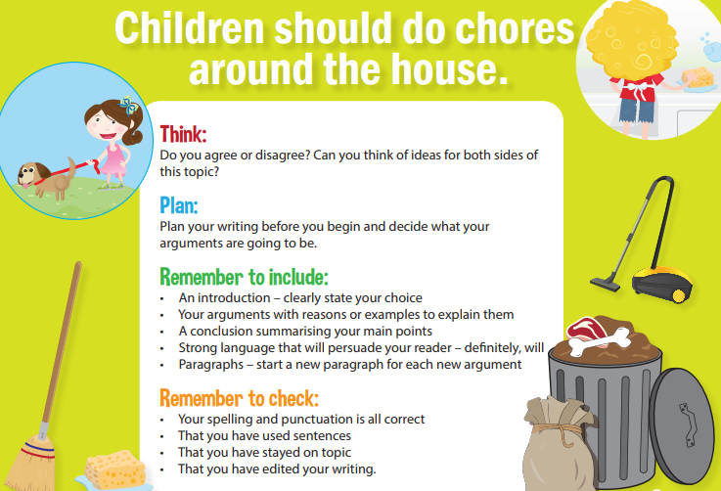

Use the template here to help you use strong language to persuade your readers.
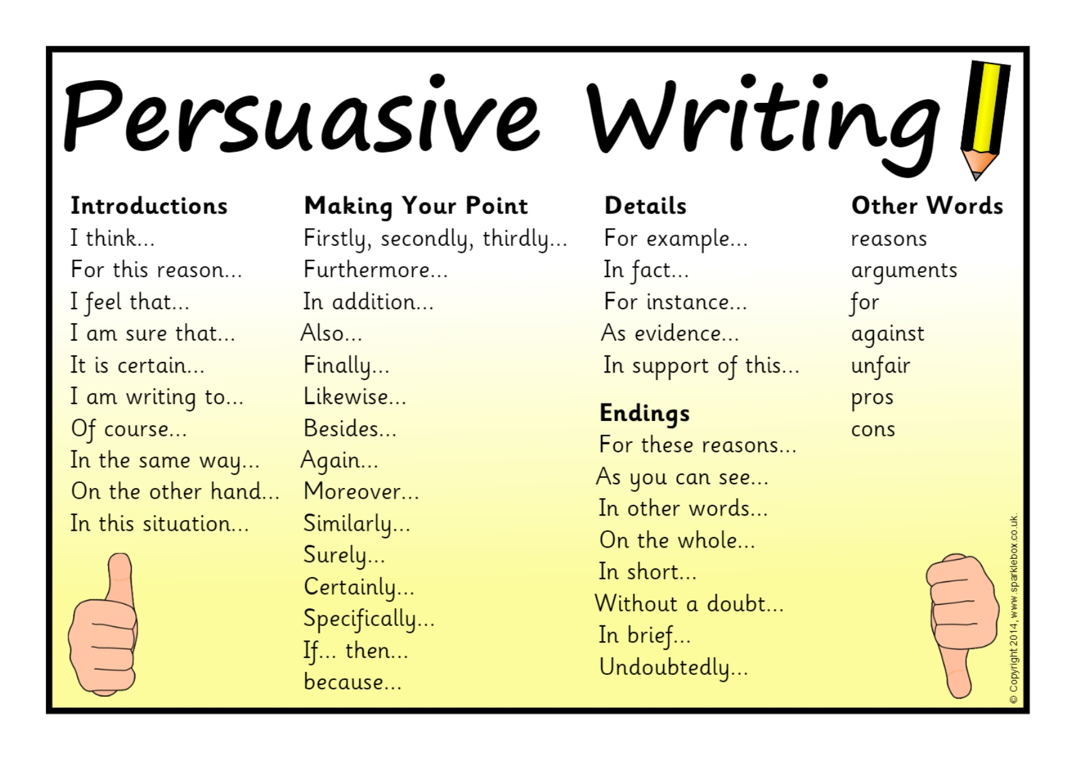

Science - Magnetism
Watch the video on magnetism and complete the activities on Seesaw

Language Fortnight
Complete activity for today

