Monday:
Spellings: transport, transfer, transmit, transept, transit, translate,
Sentences: Put 3 of these spellings into a sentence each.

Big Maths Beat That! : Give yourself 1 minute to do your big maths beat that sheet - note how many questions you answered correctly.

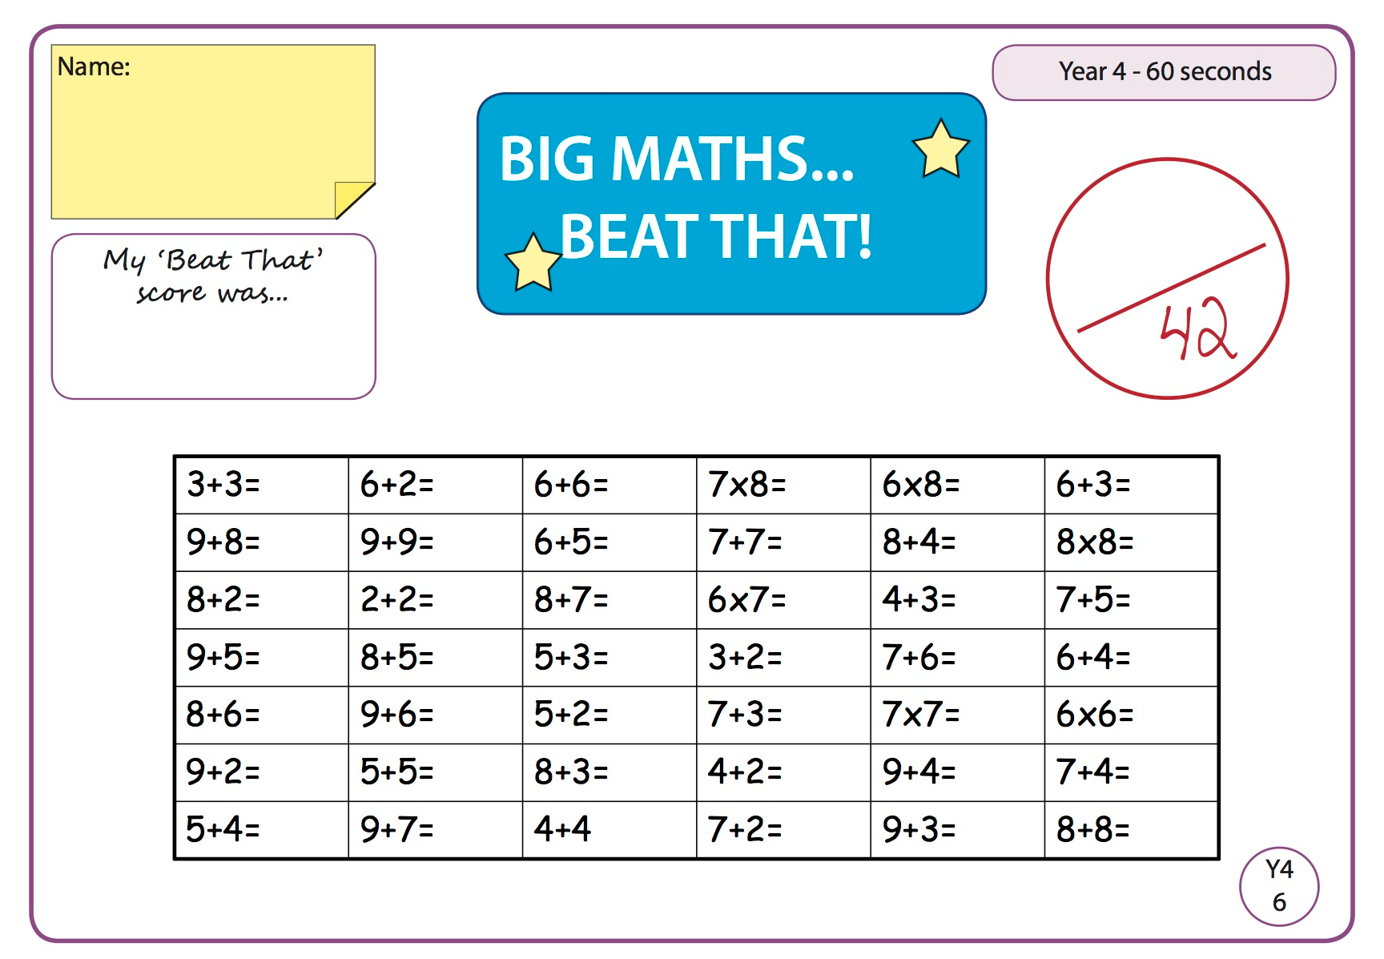

Answers:

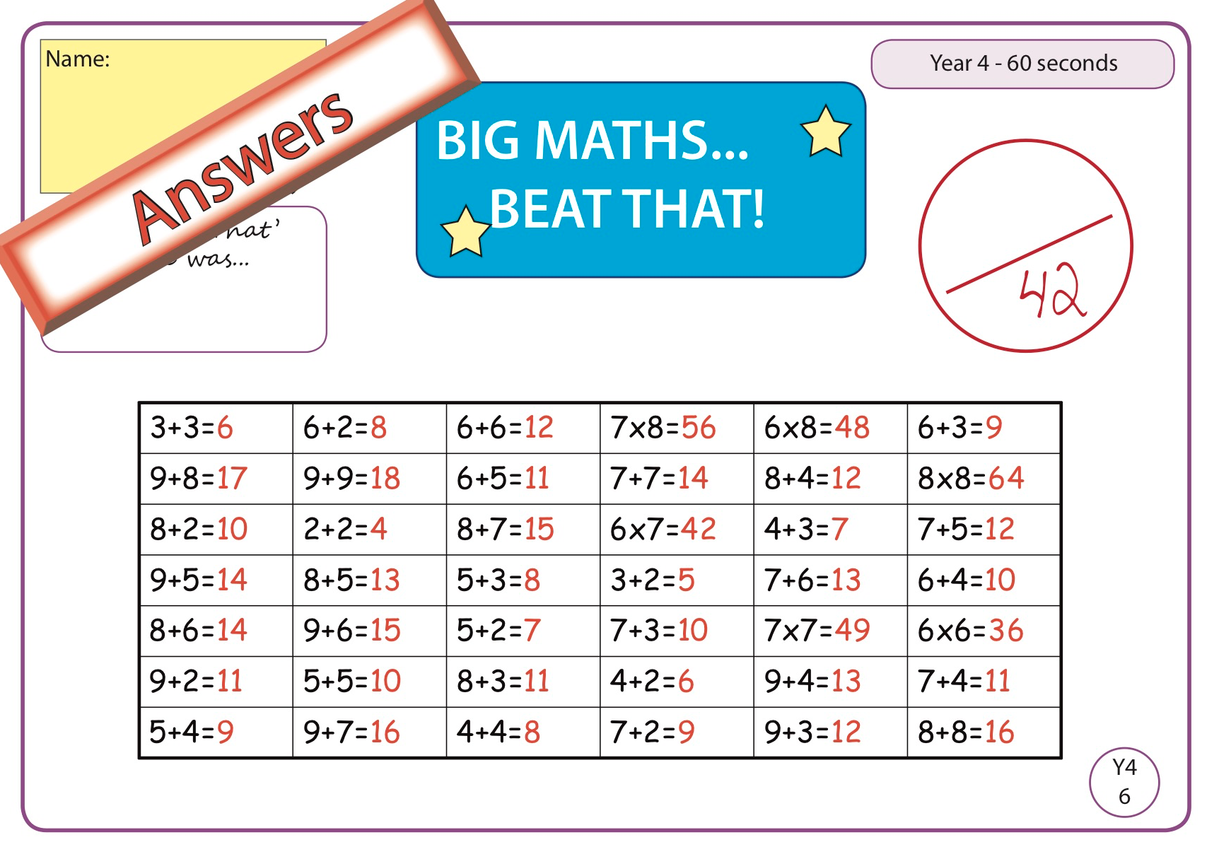

Maths

Watch the video linked on the home learning page to revise 3-D shapes. https://www.youtube.com/watch?v=ZnZYK83utu0

Go to Seesaw and complete the two 3D shapes activities for today.

English

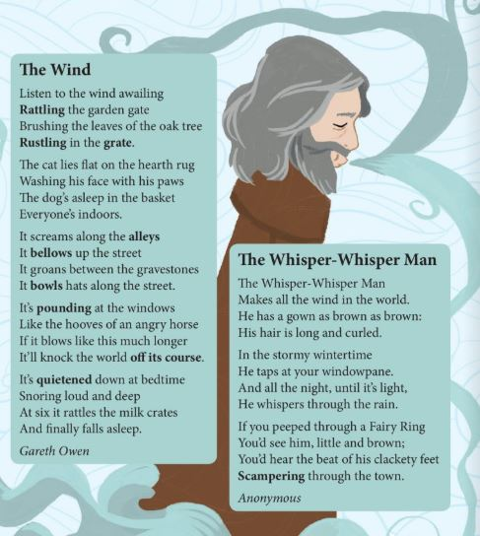
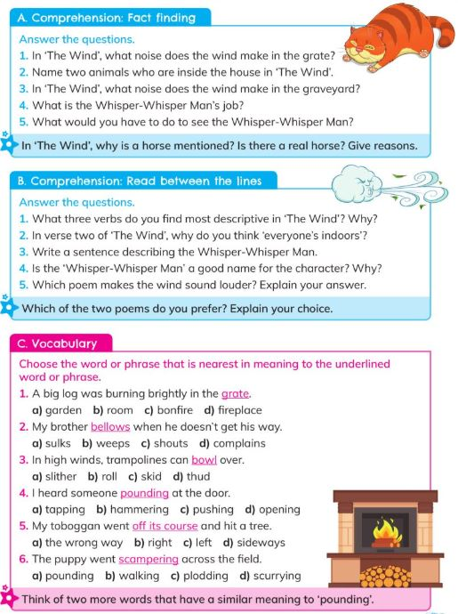

SPHE/Educate Together

1.Mindfulness activity on Seesaw.

2. Bucket List activity- Check activity on Seesaw.

A bucket list is a list of challenges, opportunities and ambitions you would like to do over your life. Some things that are on my bucket list are:

-To climb Carrauntoohil Mountain
- To complete 5 5k runs in June
-to volunteer abroad to help a less fortunate community during a summer
- to perform a song on my ukulele
- to paint my kitchen
-to explore and travel around Asia

What will go into your bucket? What hopes and dreams do you have?
Can you put into place steps to help you complete one?

