Monday:

Suggested Daily Schedule

Spellings: Practice your spellings each day
Maths: Practice Big Maths Beat That each day
Reading: read a book for 30 mins each day
Language: complete your activity for each day (https://www.citywestetns.ie/language-fortnight.html)
Spellings: prepare, prevent, prefix, prevail, preview, predict.
Sentences: Put 3 of these spellings into a sentence each.

Big Maths Beat That! : Give yourself 1 minute to do your big maths beat that sheet - note how many questions you answered correctly.

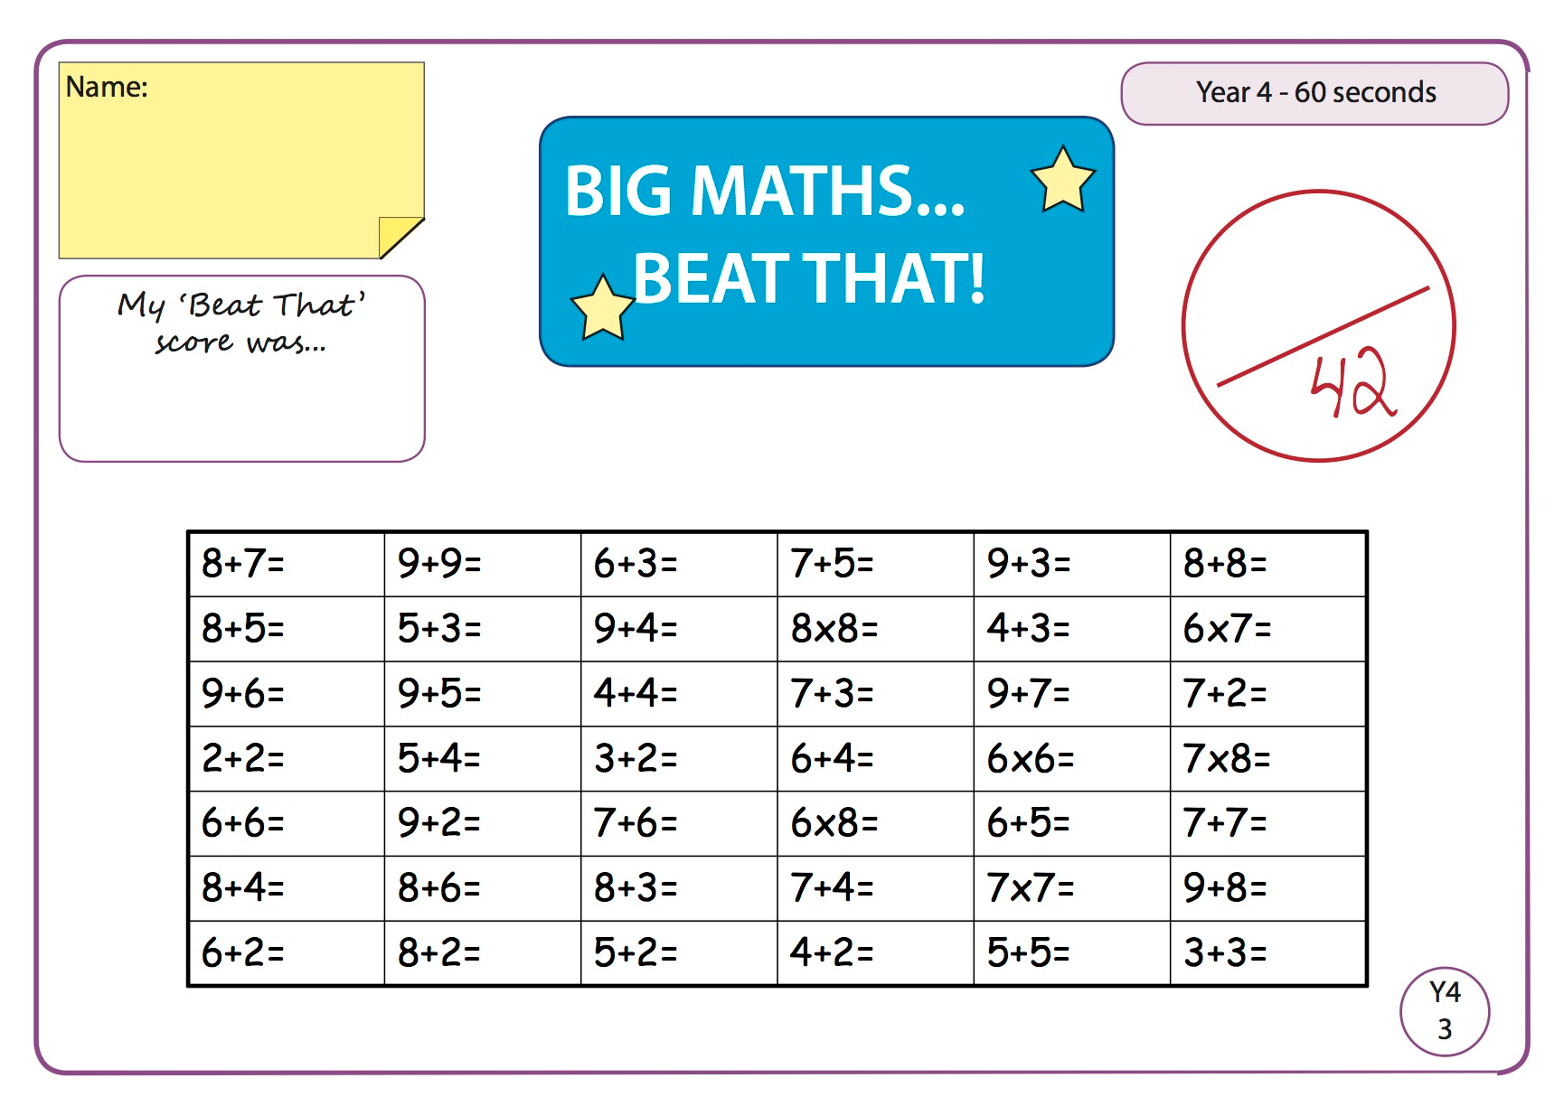

Answers

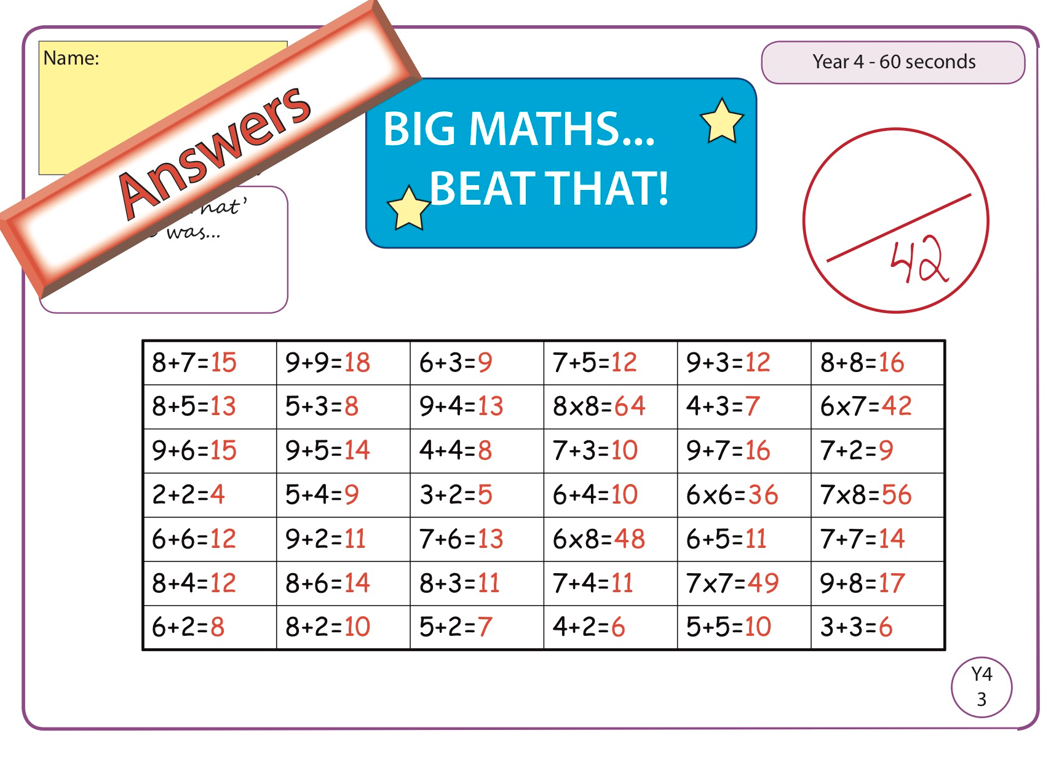

Maths

Perimeter: Perimeter is the measure of the outside of a shape. This diagram will help you remember the difference between perimeter and area (we will cover area next week).

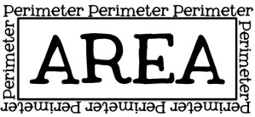

If you need help understanding or remembering what the perimeter is check out the video linked on the home learning page to help you! https://www.youtube.com/watch?v=6mopAgqjkVM
Complete the below worksheet (if you can't print just write the answers in your copy)

Example - the first square has 4 sides each measuring 10cm. I add each side up so 10cm+10cm+10cm+10cm = 40cm. So the perimeter of that square is 40cm.

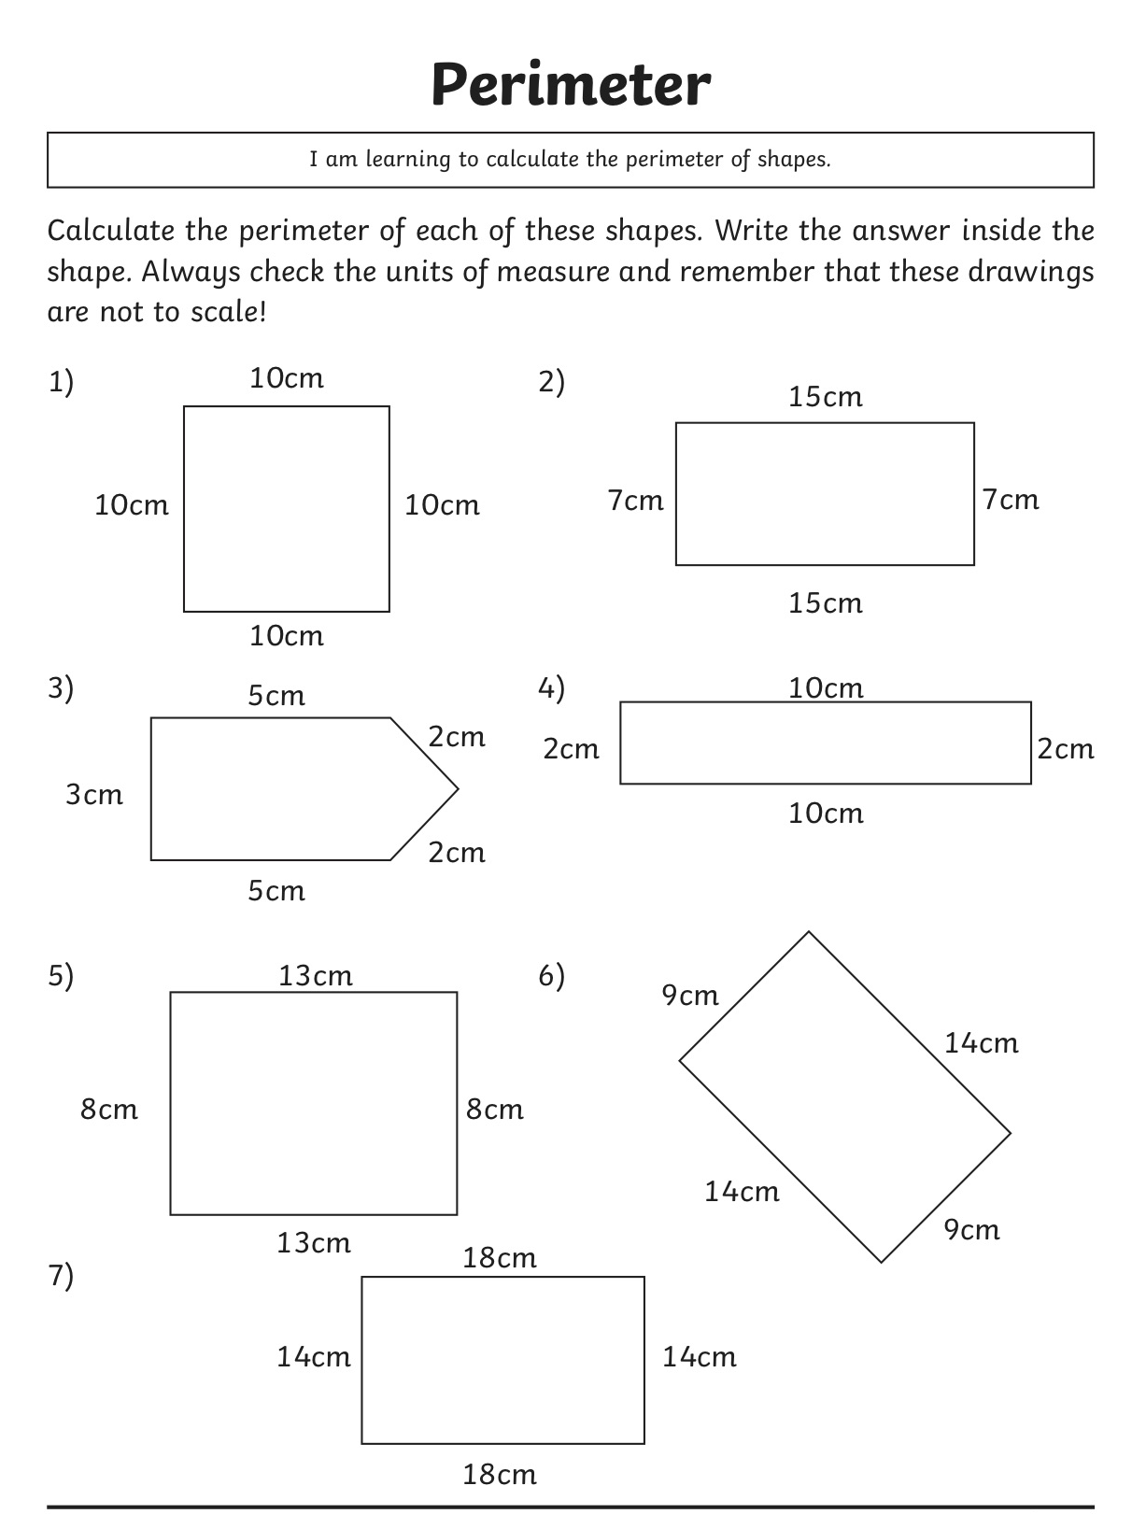

English

Today, we will be learning more about persuasive writing and how to create a good piece of persuasive writing.
Video to remind us of what we learnt last week. Click here
Take a look at the video, where Orla will be talking us through each of the steps. You will see some examples.
- If you would like to hear it explained in a different (and slightly more advanced) way, why not take a look at Sharon’s explanation on the 5th Class page - scroll down to Thursday to see it!
- Complete the OREO template provided below or do it in your copy, based on the statement ‘Summer is the best season’. It is up to you to decide whether you are for or against the statement, but you will follow the same steps as shown in the video. You might also want to use the ‘List of Phrases’ document, as they might be useful for you.

OREO Template
Use this template to help you to write to practice how to create a piece of persuasive writing.
O – Opinion | I think…
R – Reason | Reason 1:  Reason 2:  Reason 3:
E – Example | An example of why this is important is….
O – Opinion  (Give your opinion again, so the reader remembers!) | I really think that…

Gaeilge

Leigh an scéal “Séimí ar Strae” agus freagair na ceisteanna. Tá físeán ann chun cabhrú leat.
(Read the story “Séimí’s missing” and answer the questions. There is a video there to help you.)

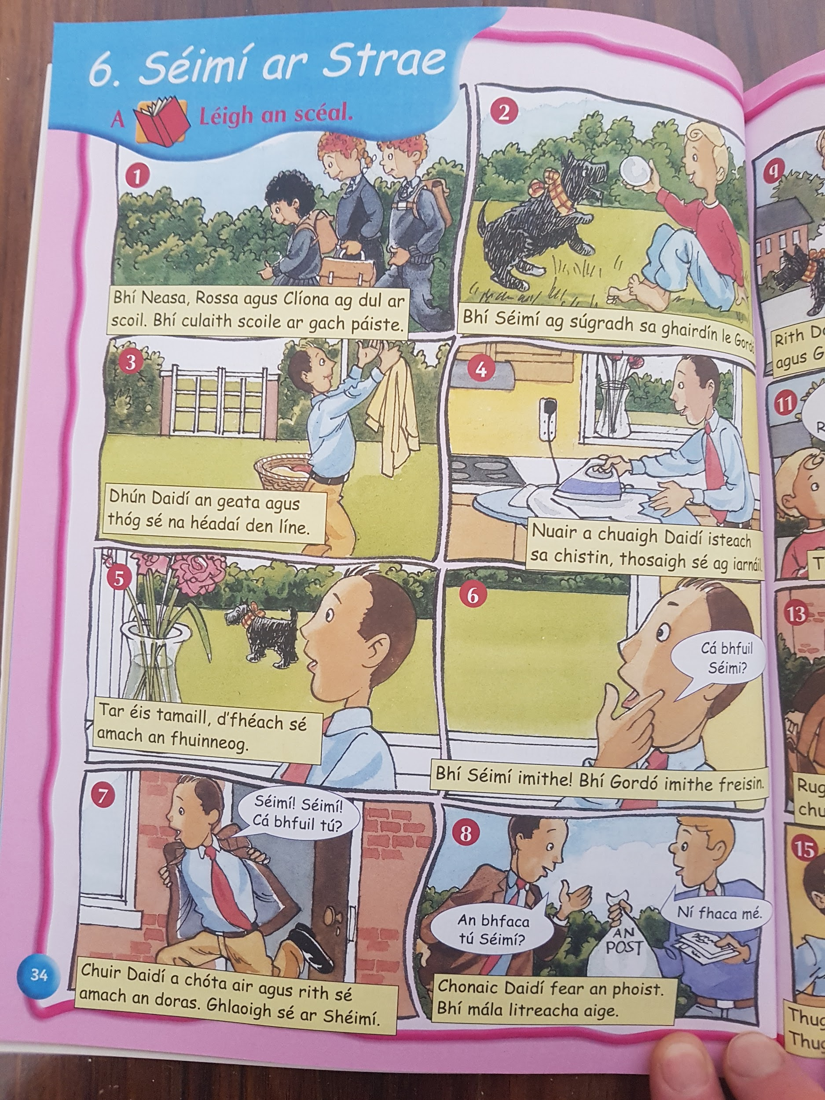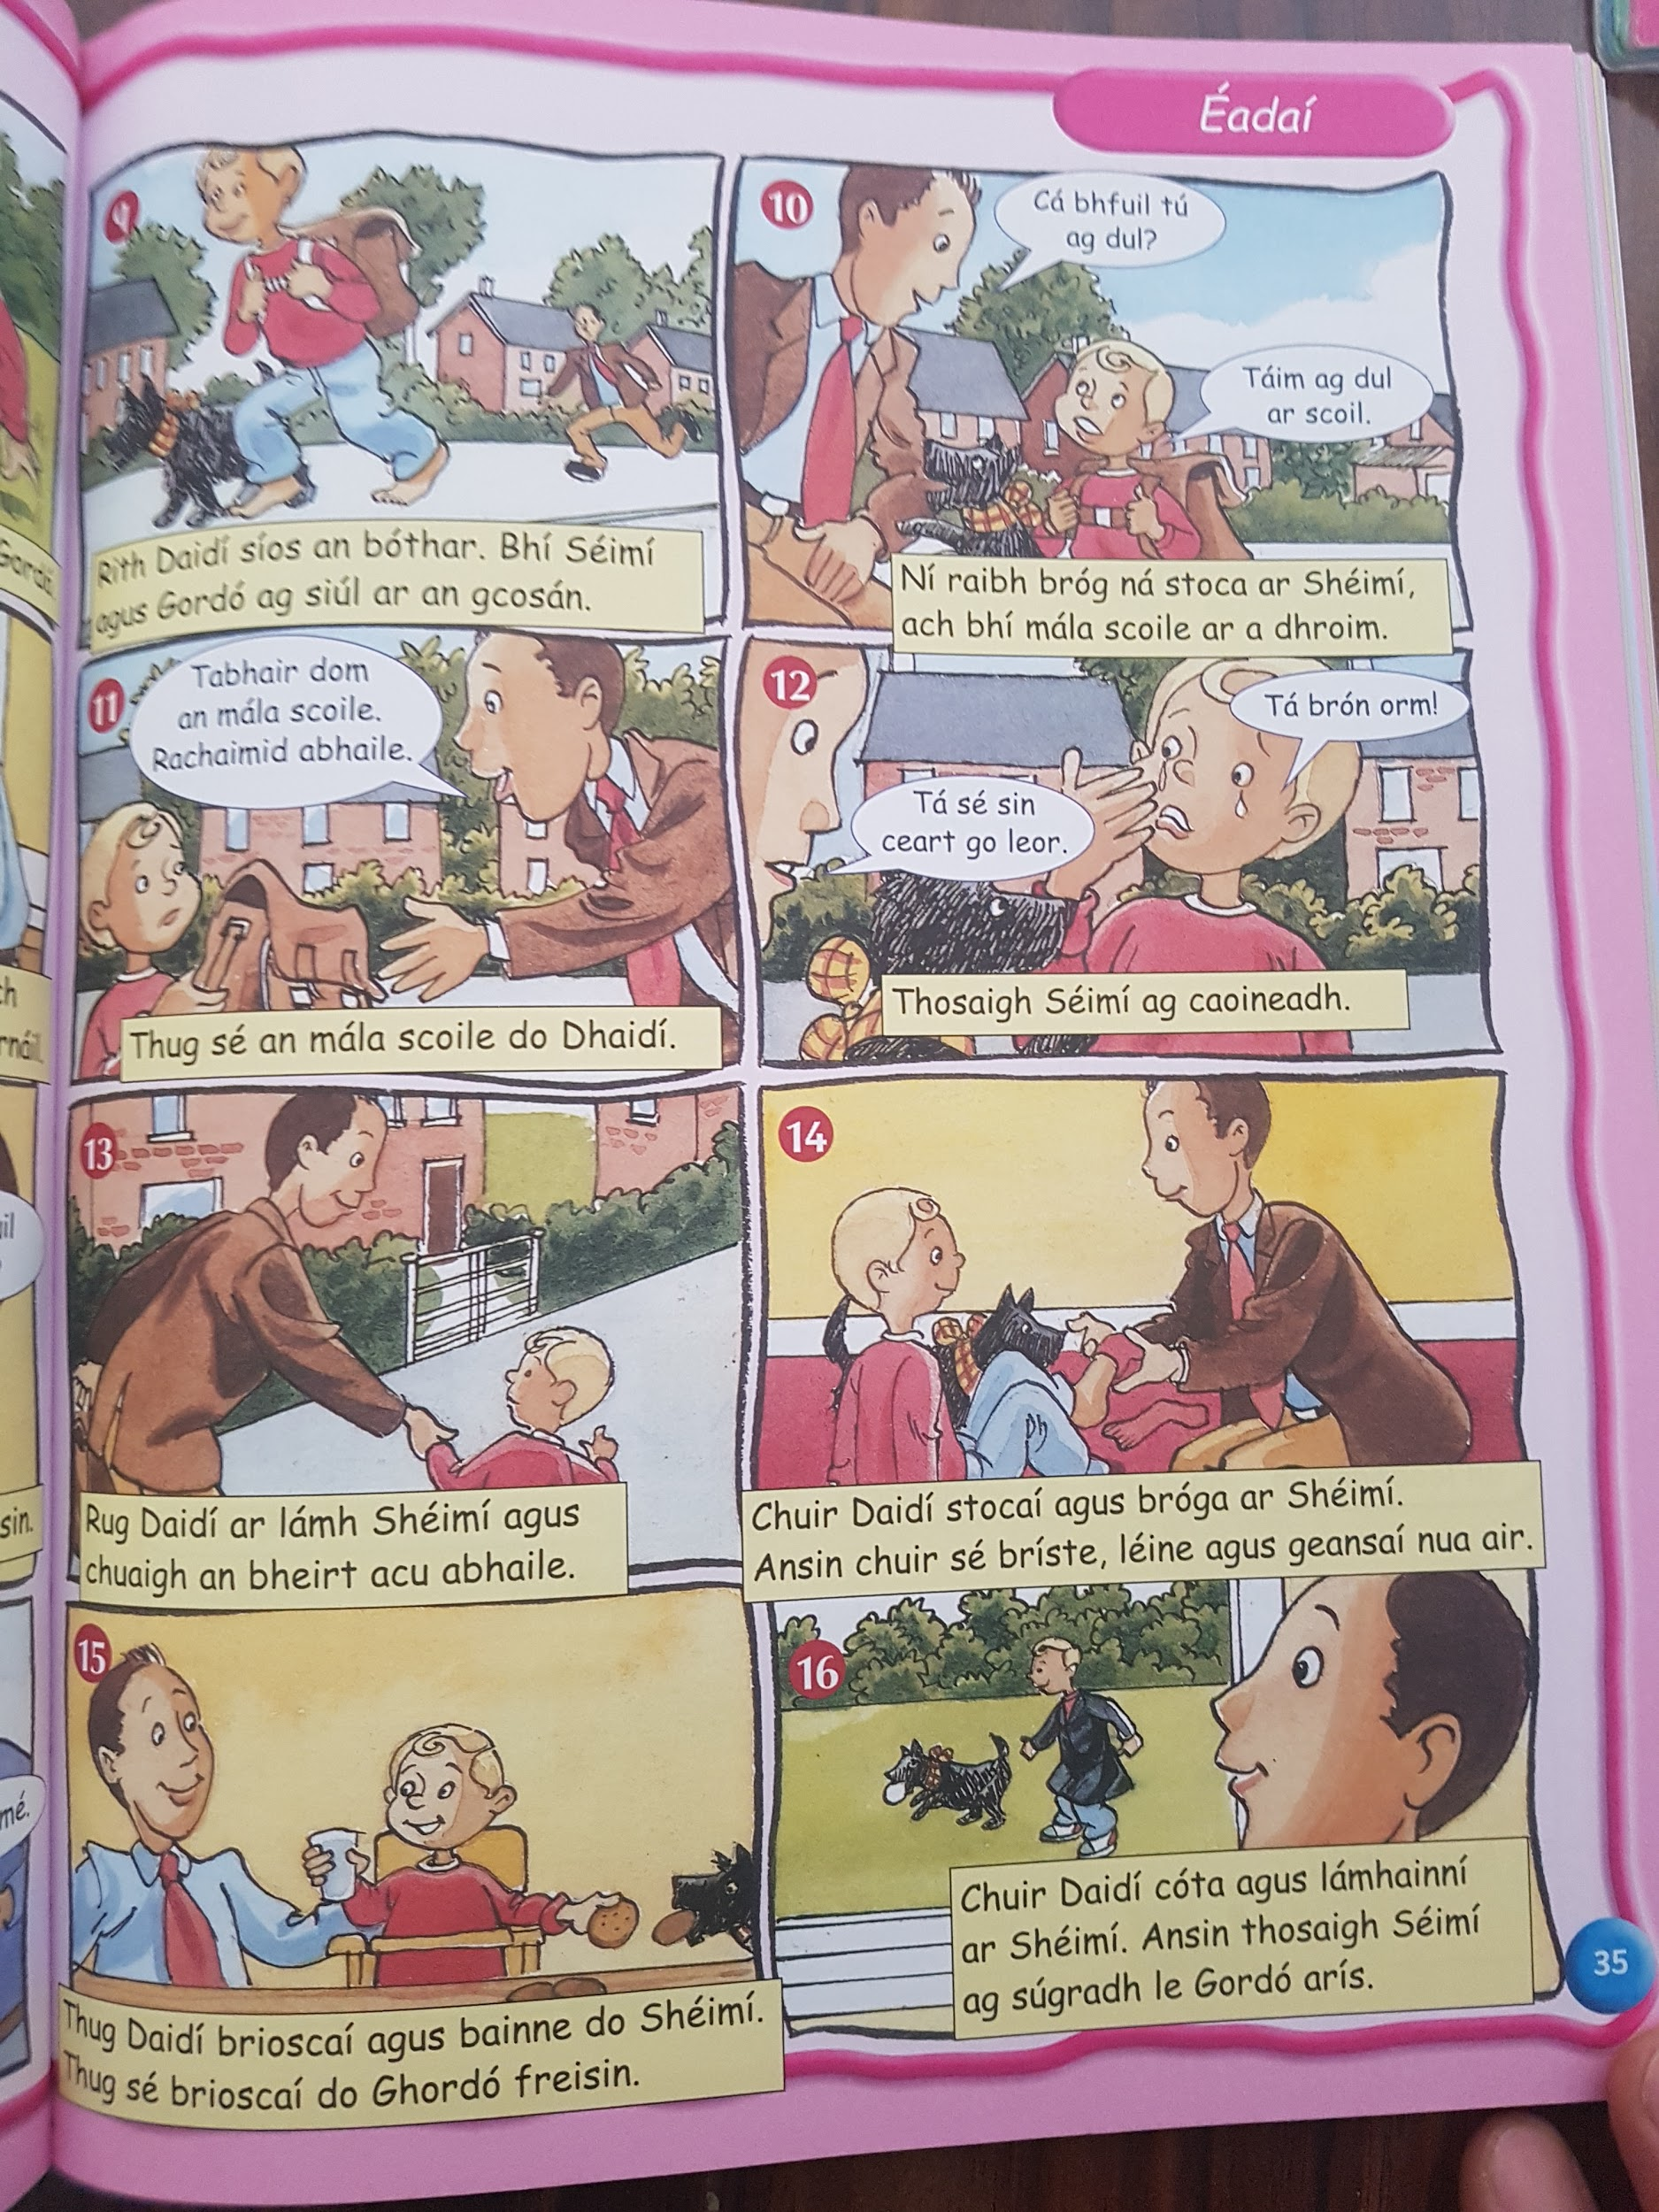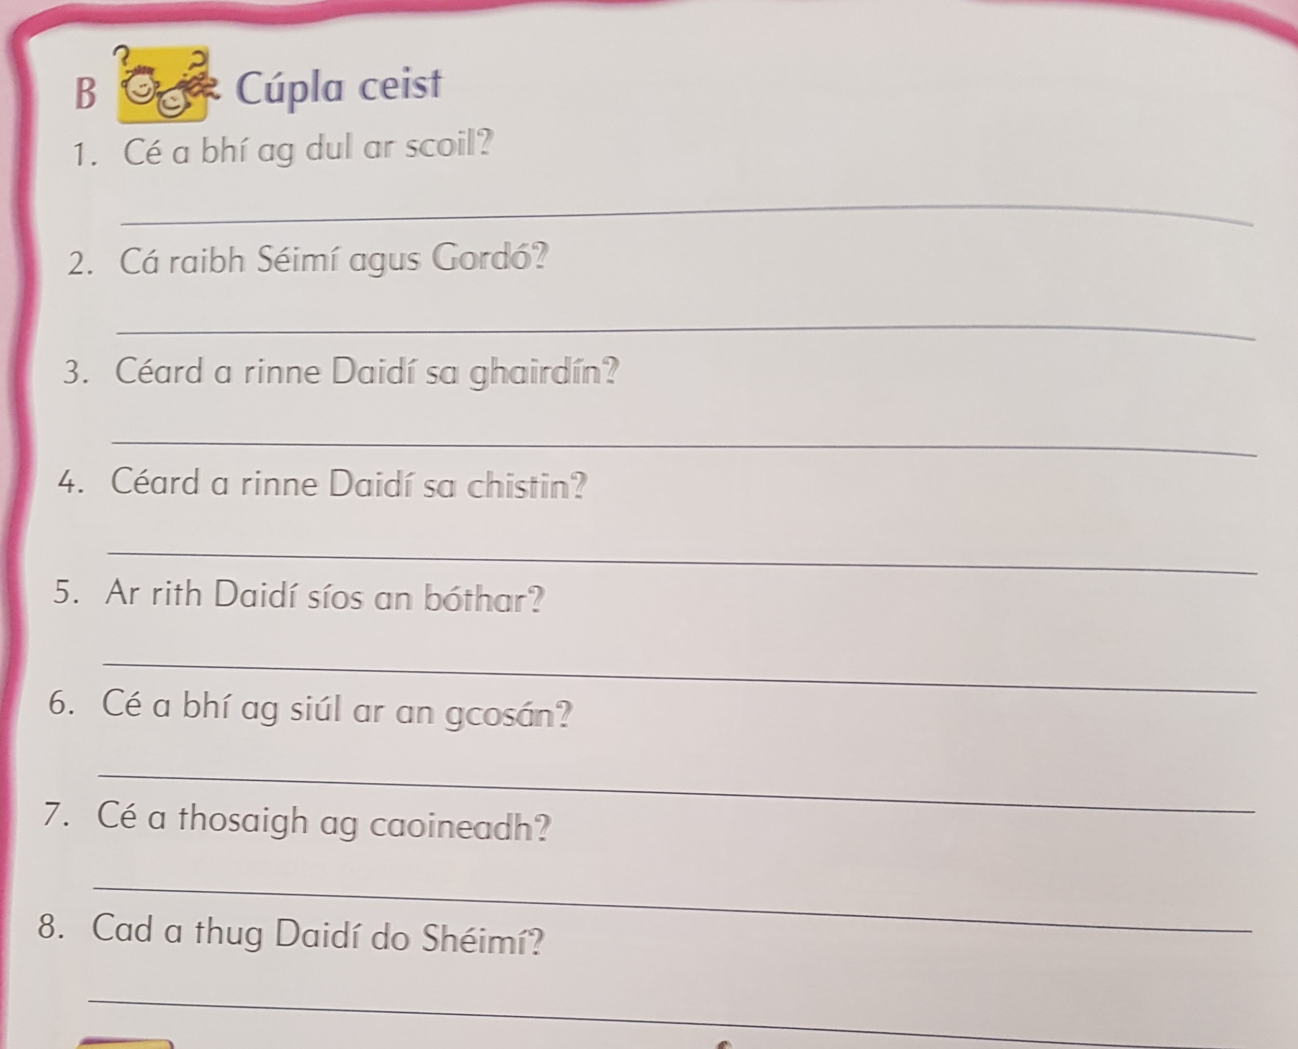

Language Fortnight
Complete activity for today

