Monday

Suggested Daily Schedule

Spellings: learn 6 spellings each day
Maths: Practice Big Maths Beat That each day
Reading: read a book for 30 mins each day
Wellbeing: complete your activity for each day

Bonus activity- Check out Lisa’s page for your weekly challenge!

Spellings: exist, resist, twist, insist, artist, consist
Sentences: Put 3 of these spellings into a sentence each.

Maths

Big Maths Beat That! : Give yourself 1 minute to do your big maths beat that sheet - note how many questions you answered correctly.

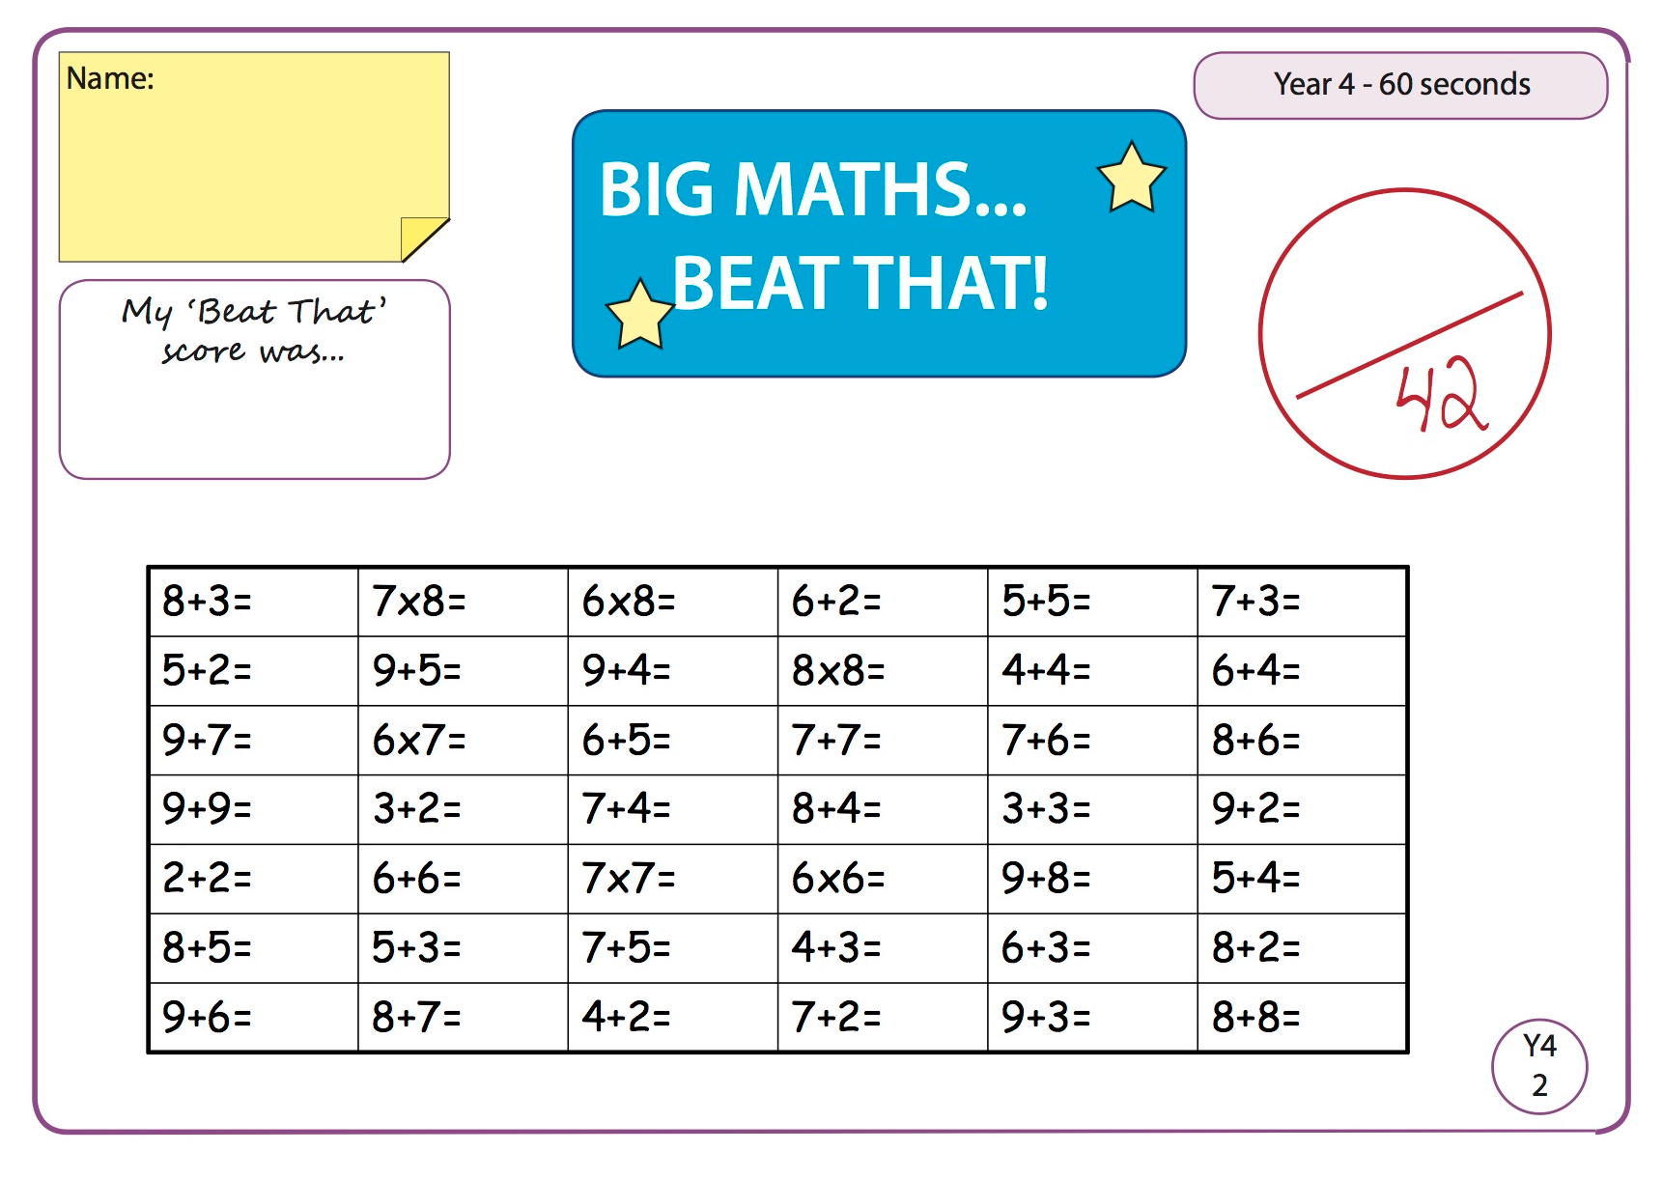

Here are the answers to correct.

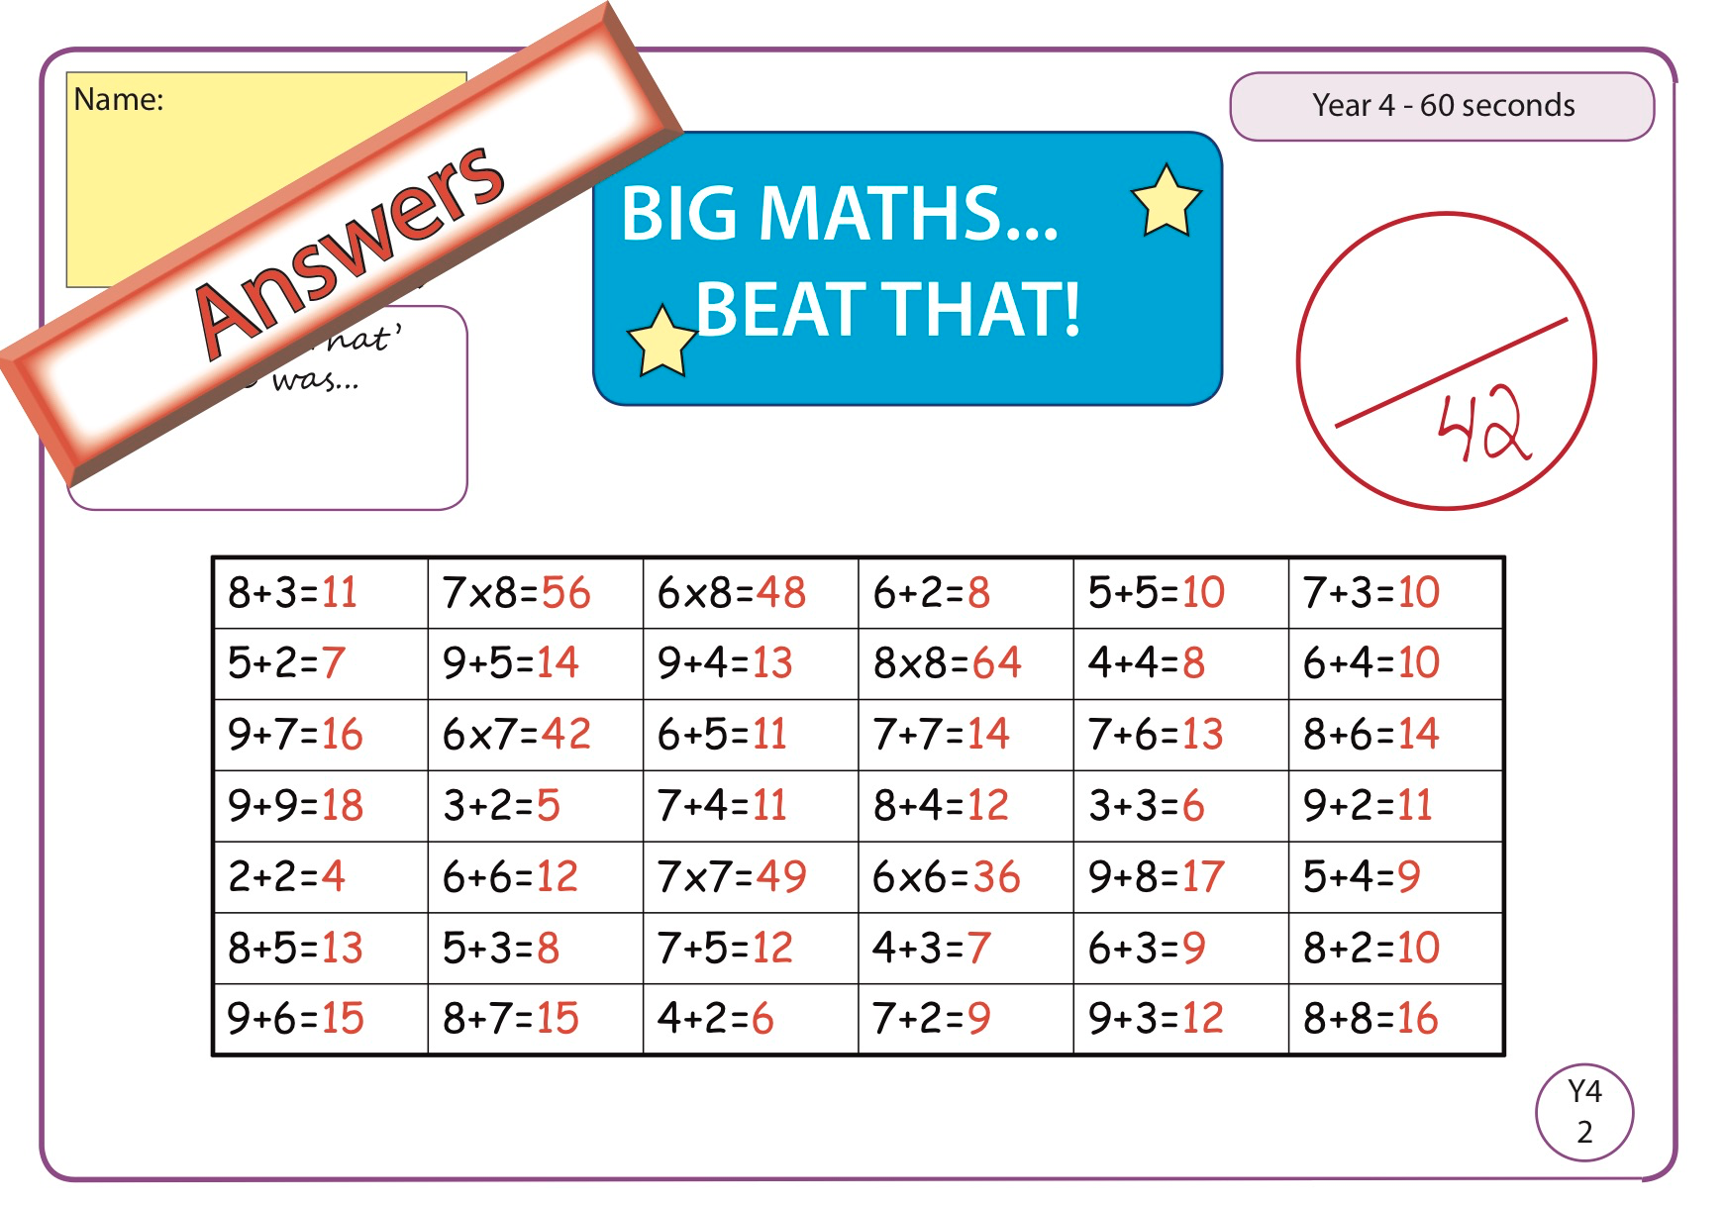

- Maths:
- Go to Seesaw and complete the ‘Patterns Everywhere’ activity.

- Gaeilge

Leigh an scéal “An Culaith Nua” agus freagair na ceisteanna. Tá físeán ann chun cabhrú leat.
(Read the story “The new suit” and answer the questions. There is a video there to help you.)

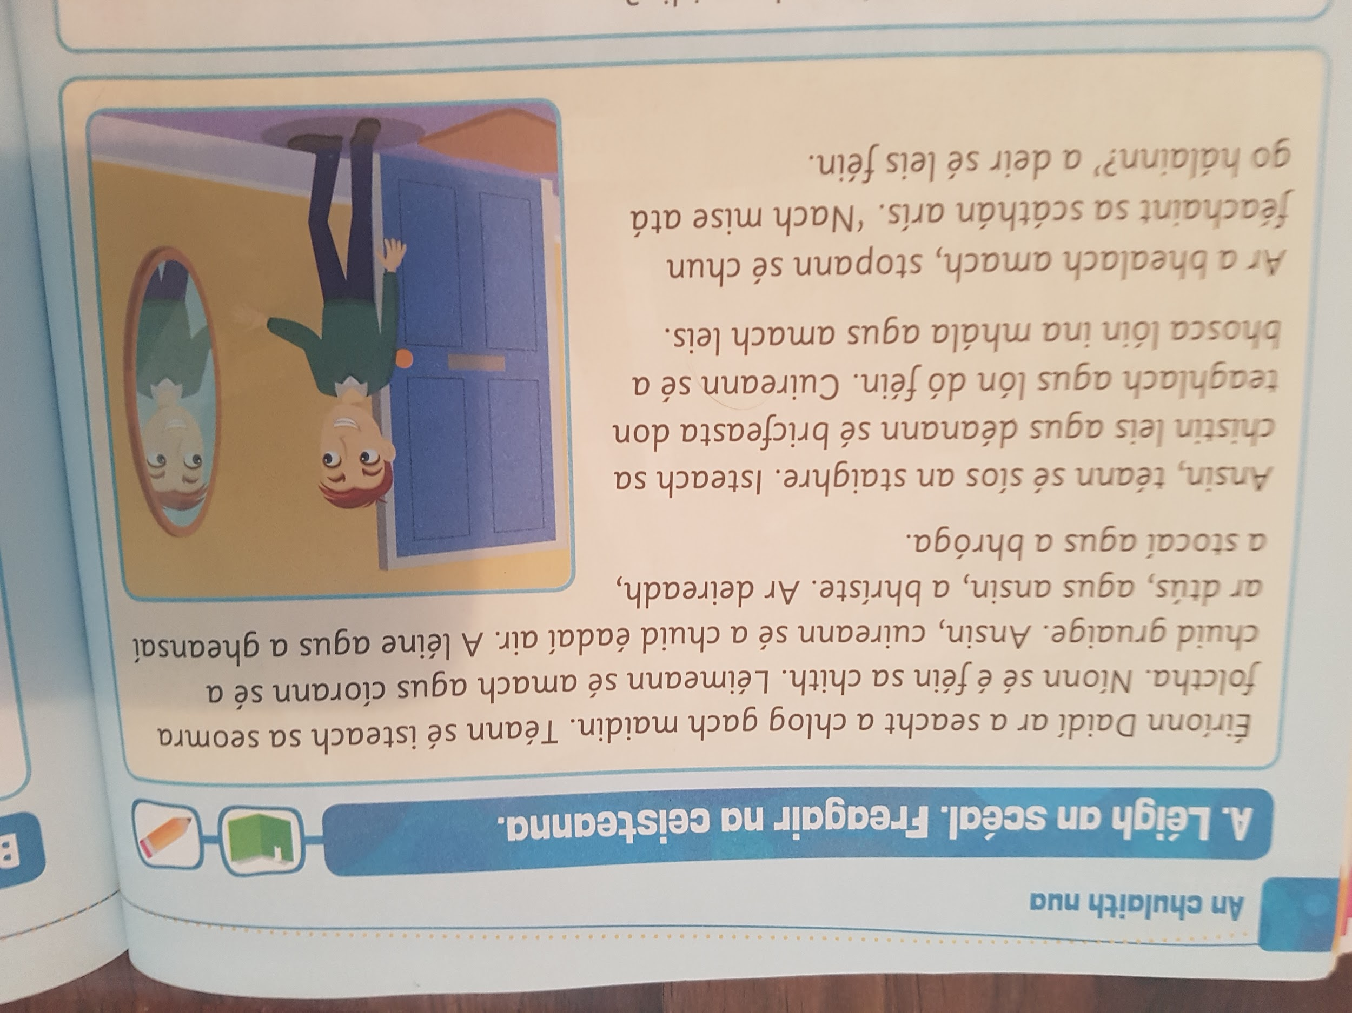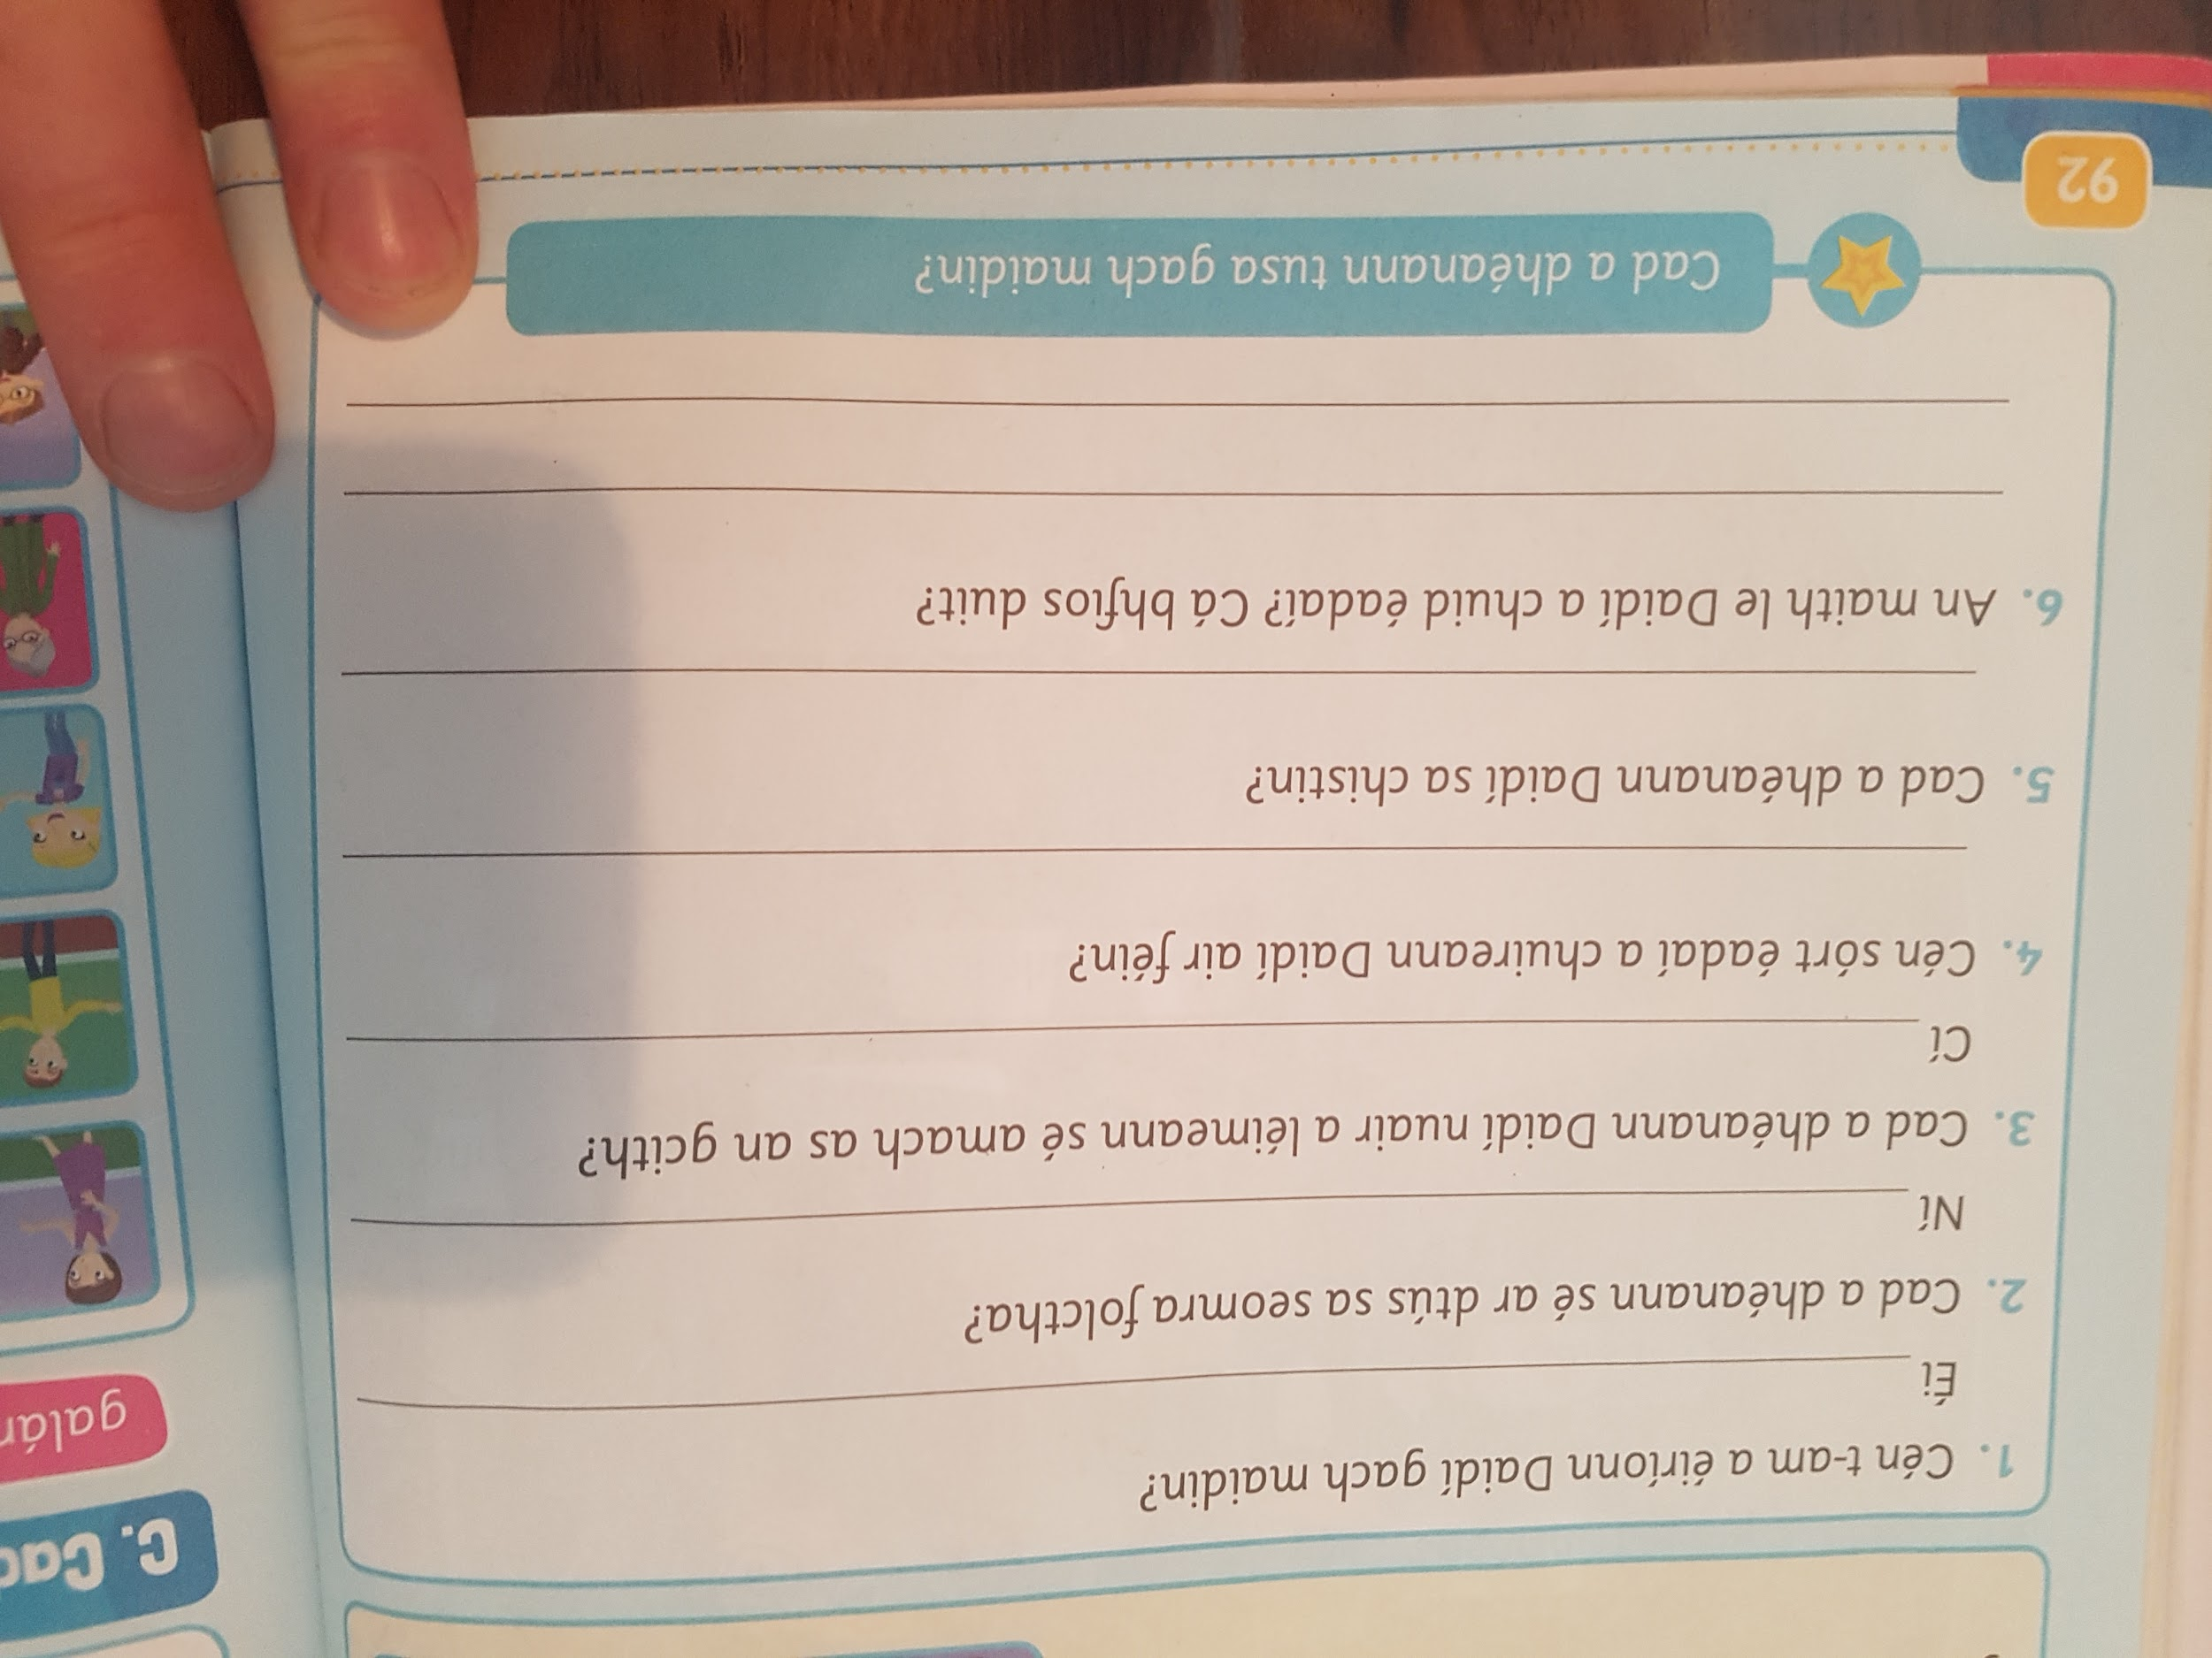

- English

Be the teacher !

Take a look at the below sheet- Horrid Henry has rushed his writing and has made an awful lot of mistakes. Be the teacher and check carefully through his writing for punctuation errors, grammar errors and even some spelling mistakes. Do your best to be the teacher and show him where the errors are. Make sure you then correct them too. Good luck!

Here is a link to the sheet.

----------------------------------------------------------------------------------------------------------------------------

English homework - Horrid Henry

On saturday, to boys happly skippd down the dusty road to his visit their friend ben. ( 5 mistakes)

They spended the day in the garden looking at the flours for a school project (3 mistakes)

It wasnt a lot of fun (2 mistakes)

At ate o’clock it was time for dinner. Bens mum sally was a grate cook (5 mistakes)

they had steak and a delicious salad, it had tomatoes lettuce onions peppers and corn in it (4 mistakes)

after they’re meal they sat and watchd spain and germany play they’re replay match (7 mistakes)

the match was being playd in dublin in the aviva stadium (5 mistakes)

The referee was a irish man calld jim o’neill (7 mistakes)

he was known for being a fare cind and decent man (5 mistakes)

They really enjoyd watchng the game (3 mistakes)

ben screamd when i grow up i want to be a footballer. (6 mistakes)

it was a fun they. (2 mistakes)

--------------------------------------------------------------------------------

