Friday:
Test: Test yourself on your spellings from the week. (Maybe 10 spellings and 10-15 sums). If you don’t have anyone to help you could test yourself - or why not make a wordsearch or crossword with all of your spellings!
Test yourself on Big Maths Beat that too, see if you can beat your score from the start of the week!

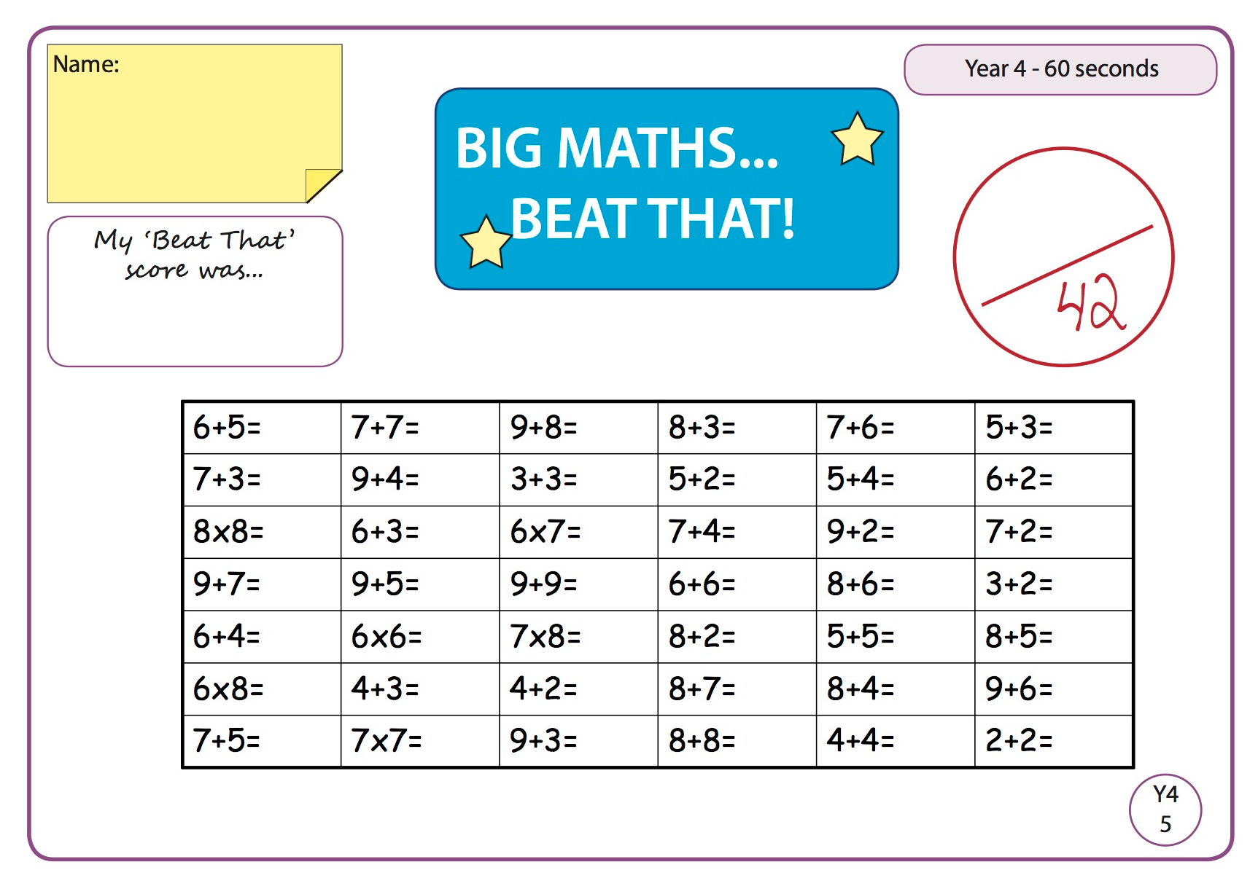

Maths

Go to Planet Maths and complete page 144 on Adding hours and minutes. You should have your book by now but if not I will attach a screenshot of the page here.

You could take a picture of your work and upload it to Seesaw.

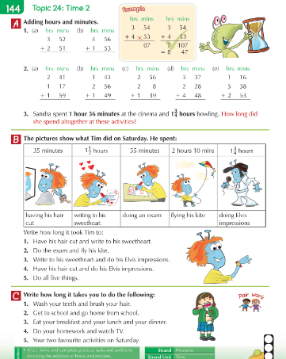

Science- Electricity
We are beginning a new science topic, Electricity. Before you log onto Seesaw. Write down everything you know about electricity. Write down what you would like to find out about also. What questions do you have?

See activity on Seesaw.

English

