Friday:
Daily activities​
Spellings- Test
Maths - Decimals revision and extra challenge
English - Comprehension and planning of creative story planning

- Test: Test yourself on your spellings from the week. If your adult is able to, they could test you on some of your tables too. (Maybe 10 spellings and 10-15 sums). If you don’t have anyone to help you could test yourself - or why not make a wordsearch or crossword with all of your spellings!

2. Maths:
- You can do the ‘Check up’ on page 113 to revise all the work you did this week. You can also do these worksheets as an extra challenge.

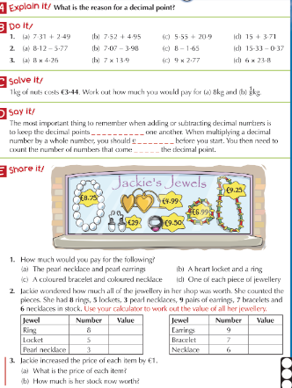
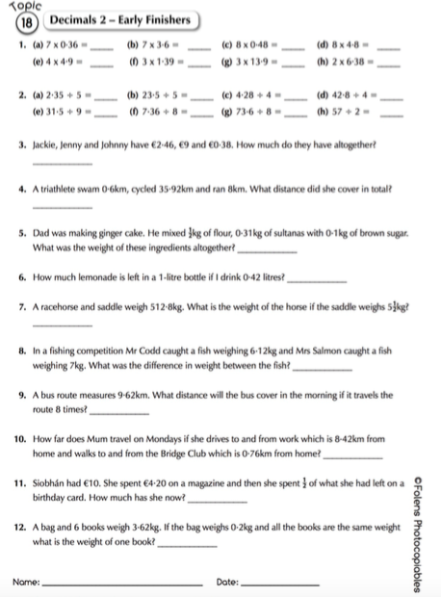

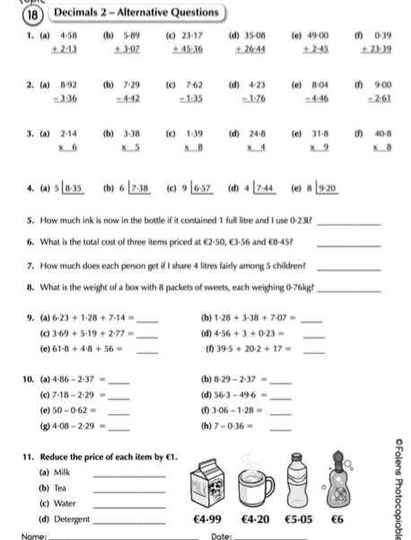

3. English

Read the article on the Cheetah Brothers and answer the questions.

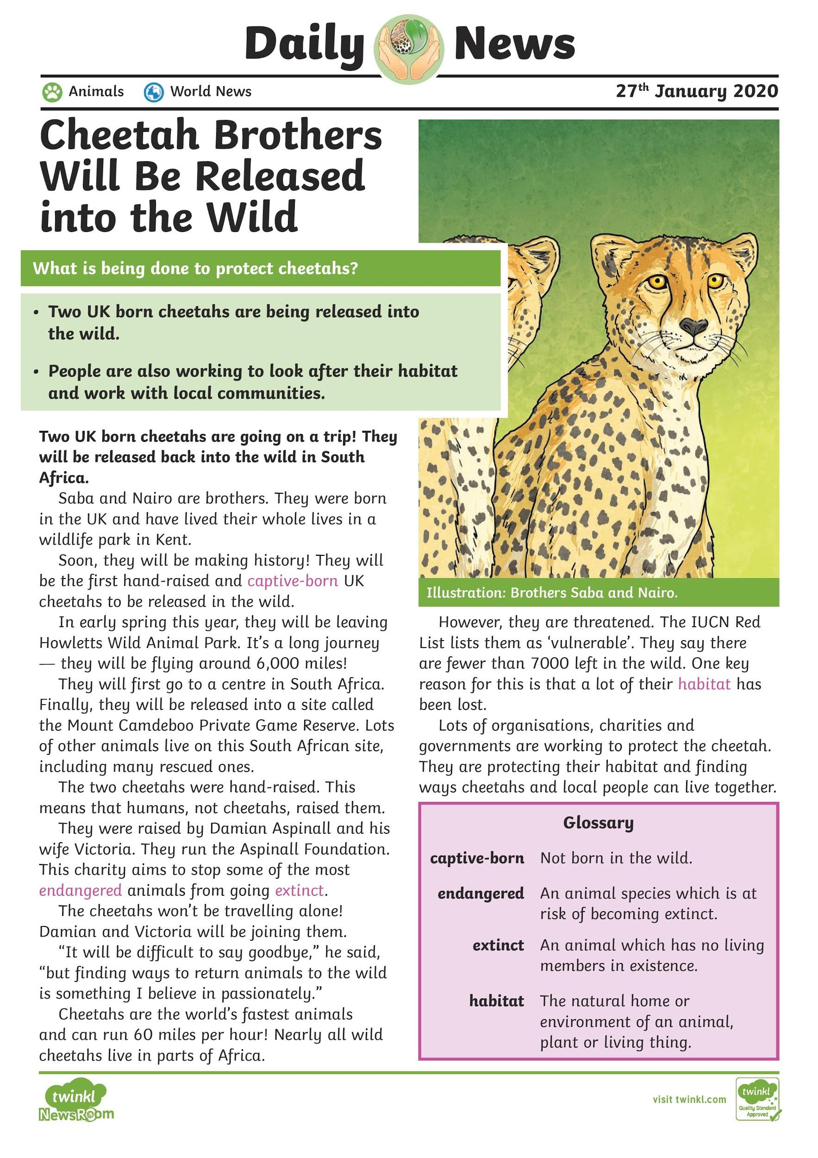

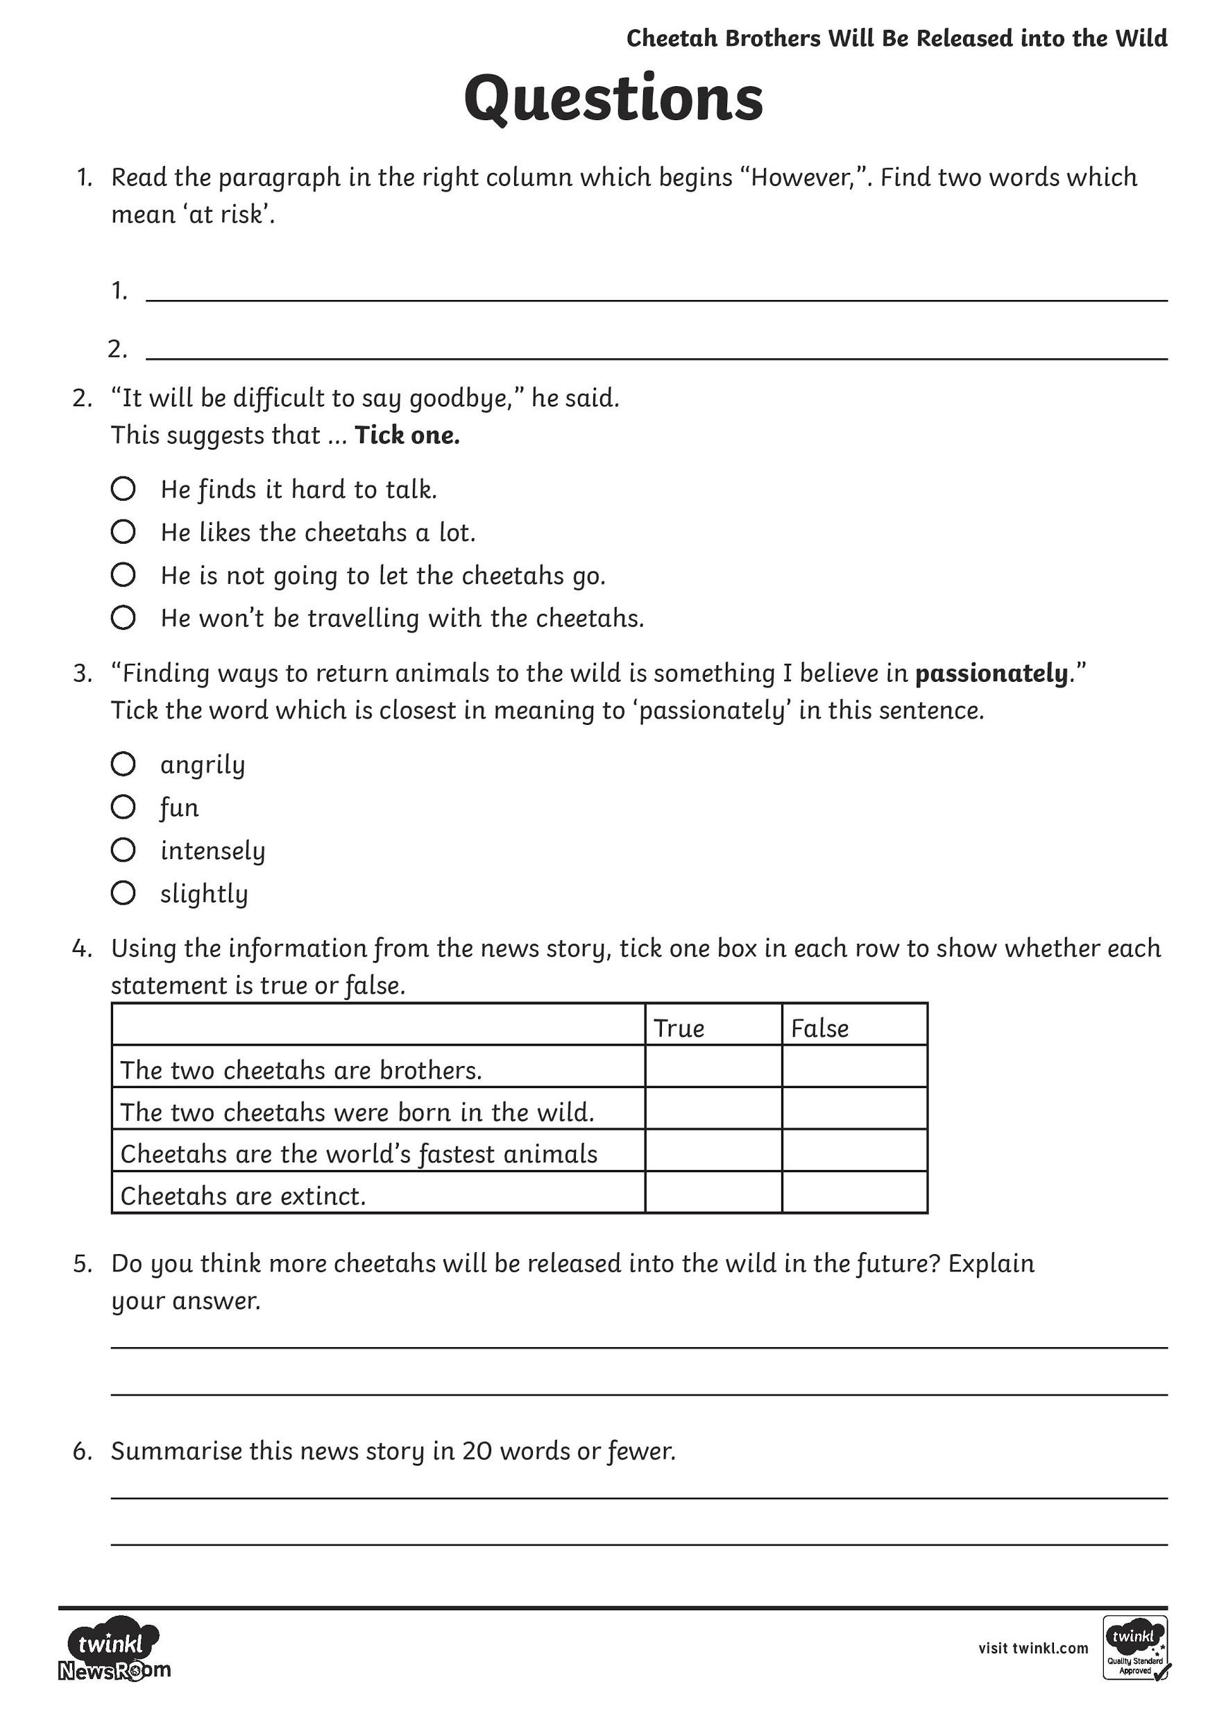

Creative Writing - Choose an African Animal, write a story from their perspective use this planner to help structure your story.

