Friday:
Test: Test yourself on your spellings from the week. (Maybe 10 spellings and 10-15 sums). If you don’t have anyone to help you could test yourself - or why not make a wordsearch or crossword with all of your spellings!

Test yourself on Big Maths Beat that too, see if you can beat your score from the start of the week!

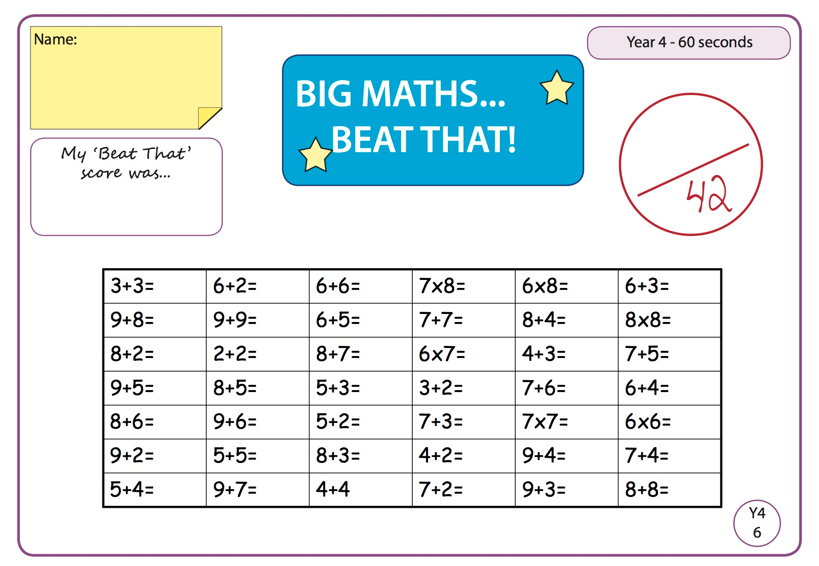

Maths

Complete the activity set on Seesaw for today.

Art
Complete the activity set on Seesaw for today.

English

Complete the activity set on Seesaw for today.

