Wednesday:
Daily Activities
​Morning Meeting
Spellings: Learn spellings daily.
Writing: Set a timer for 5 minutes
and do some "free writing" or "free typing" on a topic of
your choice.
Reading: Try to read for at least 15
minutes (or more if you can)!
Maths: Daily 10 Mental Maths Questions. Try level 1 or 2.
Skip counting: in 10s. (10, 20, 30, 40, 50,
60, 70, 80, 90. 100)
Tables: Practice 9+ tables.
Whole-school event: Go to the Well-being Fortnight page for today’s activity.

1. English:
Spellings.
- Learn your last 3 spellings - second, must, stuck.
Remember: “Look, Say, Cover, Write, Check”
*Challenge. Silly sentence! Write one sentence using as many <ti> words as you can!
Here is one I wrote last week with <ear> words;
I swear I did not see a bear wear or tear his underwear while he ate a pear.

Writing.
Today we will practice some cursive writing.
- Watch the video called ‘Cursive i’ in the resource list.
- Practice cursive writing in a copy.
- Rule your page as Amy has done in the video; one red line, 2 blue lines, one red line. Continue this pattern down the page.
- Write 2 lines of the letter ‘i’.
- Practice writing words that have the letter ‘i’ in them. There are some examples in the video.
*Challenge. Write a short story in your best handwriting.

2.Maths:

- We are looking at place value again today.
- Can you think of how many units are in 1 ten? No need to write in down, just say it in your head.
- Now try the following in your copy or a piece of paper. How many tens and how many units are in each of the numbers below?
35
42
67
55
87
- Now we will look at hundred, tens and units. For example:
125 has 1 hundreth, 2 tens and 5 units.
144 has 1 hundreth, 4 tens and 4 units.
- Now, complete the worksheet below on tens and units and at the bottom we have an activity which we have to look at hundredths too.
*Challenge- Open the resource titled ‘Maths challenge 1’ and complete Wednesday
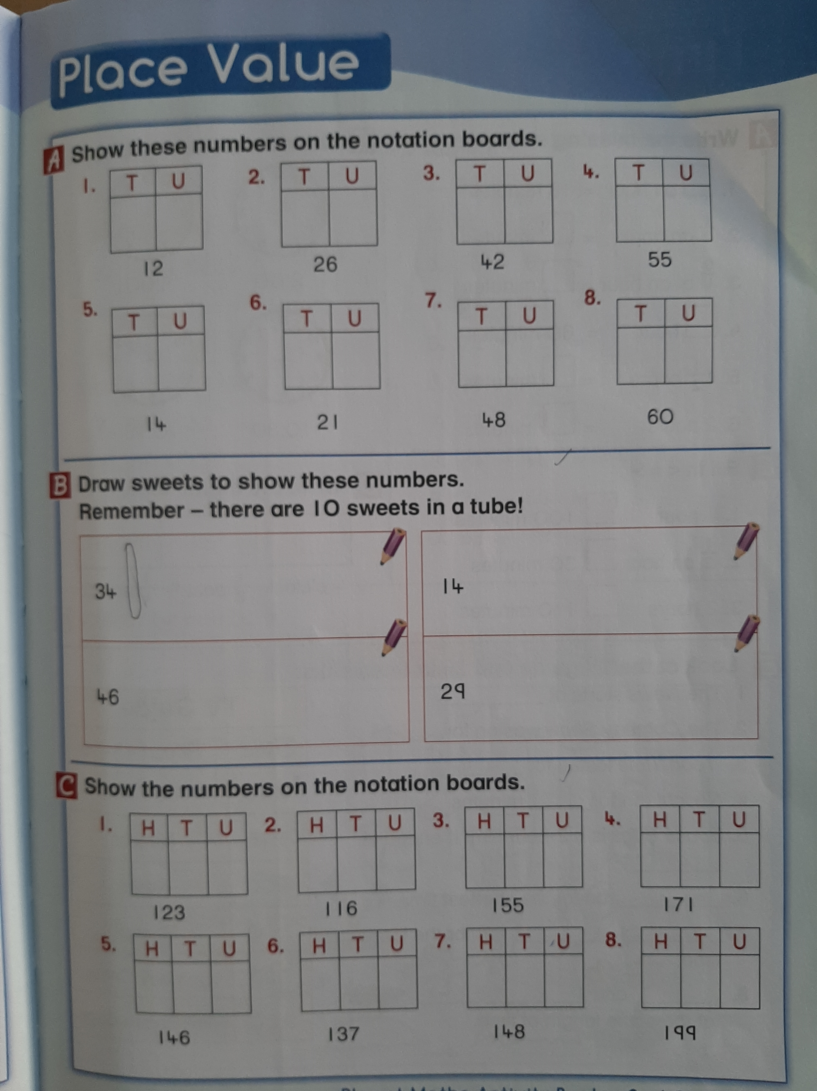

4. Science: The Burren.
Here are some more interesting facts about the Burren, I hope that you enjoy it!

The Burren is located in North West Clare. In Irish, Burren translates to Boireann which means great rock. Some of the Burren is protected by the Burren National Park. Three quarters of Ireland's plant species can be found in the Burren. In the summertime, average temperatures are about 15 degrees and are about 6 degrees in winter. The Ailwee Caves are located in the Burren.

Click here to learn about the Burren.
- Write the answers to these questions:
- What type of plants grow in the Burren?
- How do Arctic Alpine plants survive in the Burren ?
- How do Mediterranean plants survive in the Burren?
- List 5 animals that live in the Burren.
- How many species of birds have been recorded in the Burren?
- Write a list of 5 birds that are found there.
Please use full sentences when writing your answers and check for capital letters, finger spaces and full stops.

