Tuesday:
Daily Activities
Morning Meeting: Check out Seesaw each morning!
​Spellings: Learn spellings daily.
Writing: Set a timer for 5 minutes and do some "free writing" or "free typing" on a topic of your choice.
Reading: Try to read for at least 15 minutes (or more if you can)!
Maths: Daily 10 Mental Maths Questions. Try level 1 or 2.
.Skip counting: in 2s backwards from 30. (30, 28, 26, 24, 22, 20, 18, 16, 14, 12, 10, 8, 6, 4, 2, 0)
Tables: Practice 10+ tables.
Whole-school event: Go to the Mother Language and Multi-Language Fortnight page for today’s activity.

1. English:
Spellings
- Learn the next 3 spellings - revision, invasion, explosion.
Remember your spelling strategy: “Look, Say, Cover, Write, Check”

Writing
- Complete the worksheet below. Don’t worry if you don’t have a printer at home. You can copy and complete the work on a piece of paper or in a copy.
-Part 1. Write some <si> words on the television. Can you think of any more that are not on your spelling list? Write them on the television too.
-Part 2. Choose a word from your spelling list to fit each sentence. Practice writing the words fraction and estimate.
-Part 3. Last week we learned about contractions. A contraction is the shortened form of 2 words. Remember we write an apostrophe to replace missing letters. Eg. ‘I won’t go outside’. Write the correct contraction on each line.

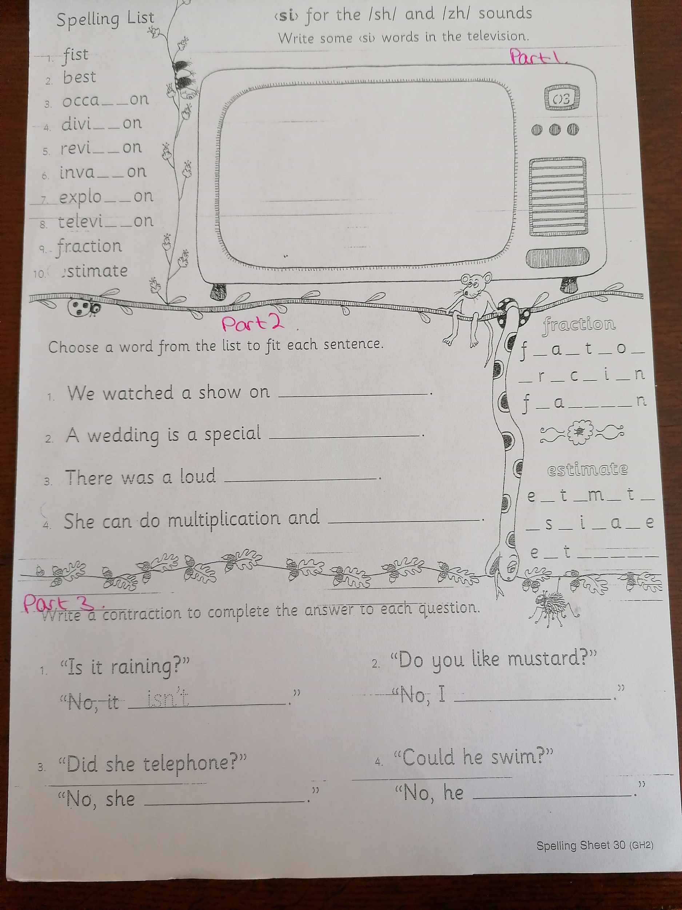

2. Maths: Area

- Today we are looking at the topic of Area.
- Remember, area is a measure of how much space there is on a flat surface.
- Yesterday, we compared the area of many different objects that we find in our classroom. It was fun!
- When we think of our school, it can help us understand surface area. Take a look at the questions below and write the answers in your copy or a piece of paper.
- Which has a greater surface area, our classroom or the sports hall?
- Which has a greater surface area, the sportshall or the 2 basketball courts?
- Which has a greater surface area, the library or the sports hall?
- Which has a greater surface area, Amy's classroom or Shane’s classroom ? Or are the 2 classrooms of equal area?
- Which has a greater surface area, the library or our yard space?

- Complete the worksheet below on area
*Challenge- Open the resource titled ‘Maths challenge 1’ and complete Tuesday

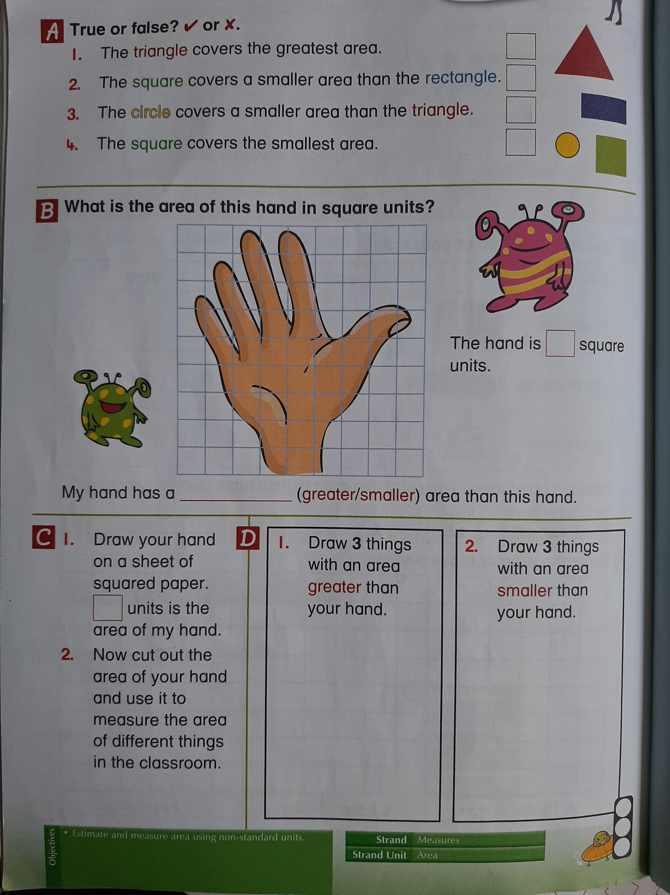

3. SESE:

- We are going to look at Sharks this week. I know so many of you will find this very interesting and fun!
- Open the resource titled “Sharks” on the homepage.
- Read the comprehension below about Sharks and answer the questions, the questions are based on the powerpoint and the comprehension. Have fun!

There are more than 500 different species of shark, including the great white shark, grey reef shark, hammerhead shark and tiger shark. Sharks can be found in every ocean, including off the coast of Ireland. The sharks that are found in Ireland are called Basking sharks. There are many sharks in the oceans around Australia, South Africa, America and Brazil. What sharks eat depends on its species and where it is. Most sharks are meat eaters so they like to eat fish and other sharks. Some larger sharks eat dolphins, sea lions and small whales. Smaller sharks eat small aquatic life like clams and crabs. A group of sharks is called a shoal or school.

Answer the following questions in your copy or a piece of paper.

- How many different species of shark are there?
- Which countries can sharks be found in?
- What do sharks like to eat?
- What is the name of the shark that can live for 400 years?
- How do scientists estimate the age of sharks?

