Monday:
Daily Activities
Morning Meeting: Check out Seesaw each morning!
​Spellings: Learn spellings daily.
Writing: Set a timer for 5 minutes and do some "free writing" or "free typing" on a topic of your choice.
Reading: Try to read for at least 15 minutes (or more if you can)!
Maths: Daily 10 Mental Maths Questions. Try level 1 or 2.
.Skip counting: in 3s backwards from 30. (30, 27, 24, 21, 18, 15, 12, 9, 6, 3, 0)
Tables: Practice -5 tables.
Whole-school event: Go to the Mother Language and Multi-Language Fortnight page for today’s activity.
1. English:
(These activities are also available to complete on Seesaw today)
Spellings.
Find the list below.
This week most of your spellings make an /ai/ sound.
- Underline the /ai/ sound in 6 of these words.
- They are spelt with <ei> or <eigh>.
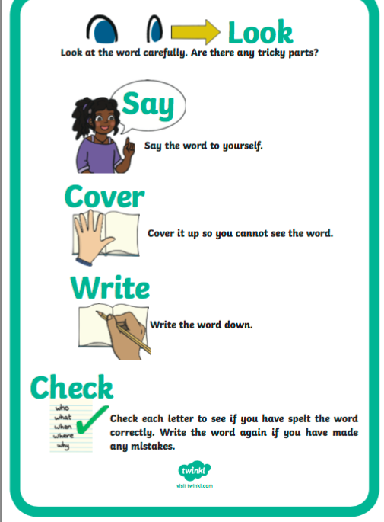
- Learn the first 3 spellings (neighbour, reindeer, weigh). Have a look at the “Look, Say, Cover, Write, Check” poster here.

Spelling List:
neighbour
reindeer
weigh
eight
eighty
eighteen
child
children
grub
slug

Writing.
Choose 6 words from the spelling list and write them in an interesting sentence. You will have 6 sentences in total.
-Check each sentence. Make sure that it makes sense and that you have a capital letter, finger spaces and full stops.

2. Gaeilge- Ag siopadóireacht.
Find a video for today’s activity on Seesaw.
- Do page 97 in your workbook.
- Draw a picture of your favourite animal on a separate page.
- Use https://www.focloir.ie/ to find what this animal is called in Irish. (This is an online dictionary. Type your animal into the search bar and click search. This will then give you the gaeilge word.)

3. Maths
- Today we are looking at the topic of Addition
- Addition is adding something to something else.
- For example
- If you have 20 apples and you buy 3 more, you have 23 in total.
- If you have 35 marbles and get 20 more, you have 55 in total.
- If you have 33 tennis balls and you add 7 more, you have 40 in total.

- Try these additions in your head just to get you warmed up for today's tasks, no need to write them down!
- 17+7=
- 22+14=
- 36+11=
- 56+8=
- 64+13=
- Complete the worksheet below on addition. Remember, when we have more than 10 in our unit column, we bring ten across and add it to our tens column!
- No need to print the worksheet, just write the sums in your copy or a piece of paper.

*Challenge- Open the resource titled ‘Maths challenge 1’ and complete Monday.
