Monday:
Daily Activities
Morning Meeting: Check out Seesaw each morning!
​Spellings: Learn spellings daily.
Writing: Set a timer for 5 minutes and do some "free writing" or "free typing" on a topic of your choice.
Reading: Try to read for at least 15 minutes (or more if you can)!
Maths: Daily 10 Mental Maths Questions. Try level 1 or 2.
.Skip counting: in 10s backwards from 100. (100, 90, 80, 70, 60, 50, 40, 30, 20, 10, 0).
Tables: Practice -8 tables.
Whole-school event: *Find the link for Active Fortnight on the home page

Find a message and an activity from your 3rd Class Teacher on Seesaw!

English.
(These activities are also available to complete on Seesaw)
Spellings.
This week most of the spellings make an /ee/ sound, spelled with <ie>.
- Underline the /ee/ sound in 6 of these words.
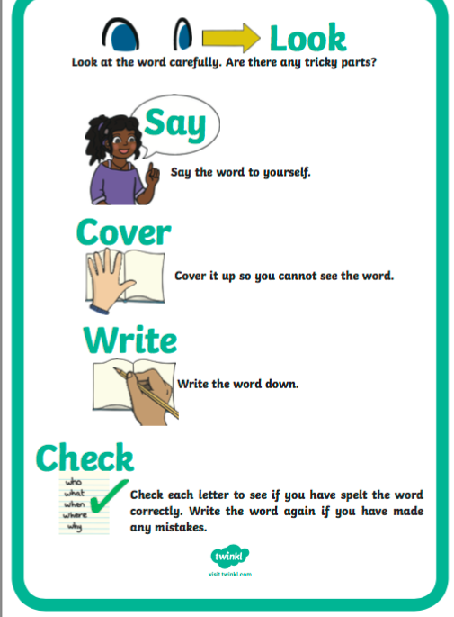
- Learn the first 4 spellings (quit, sweet, field, piece).
- Remember to use the “Look, Say, Cover, Write, Check” method. See poster here.
Spelling List:
quit
sweet
field
piece
chief
thief
shield
belief
library
computer

Writing.
(Also available on Seesaw)
- Choose 6 words from the spelling list and write them in an interesting sentence. You will have 6 sentences in total.
Check each sentence. Make sure that it makes sense and that you have a capital letter, finger spaces and full stops.

Maths

- Today we are looking at the topic of Data.
- Data is how we represent information.
- For example, we can say who had an apple, who had an orange and who had a banana for lunch! Once we know this information, that is the data we need.
- A pictogram is a chart that uses pictures to represent data.
- Pictograms are set out in the same way as bar charts, but instead of bars they use columns of pictures to show the numbers involved.
- See page 147 in your maths book for a pictogram and complete the tasks on the page.

