Monday:
Daily Activities
Morning Meeting: Check out Seesaw each morning!
​Spellings: Learn spellings daily.
Writing: Set a timer for 5 minutes and do some "free writing" or "free typing" on a topic of your choice.
Reading: Try to read for at least 15 minutes (or more if you can)!
Maths: Daily 10 Mental Maths Questions. Try level 1 or 2.
Skip counting: in 5s backwards from 50. (50, 45, 40, 35, 30, 25, 20, 15, 10, 5, 0)
Tables: Practice -7 tables
Whole-school event: *Find the link for Diversity Fortnight on the home page

English.
(These activities are also available to complete on Seesaw)
Spellings.
This week most of the spellings are <ture> words. They make a /chur/ sound.
- Underline the /chur/ sound in 6 of these words.
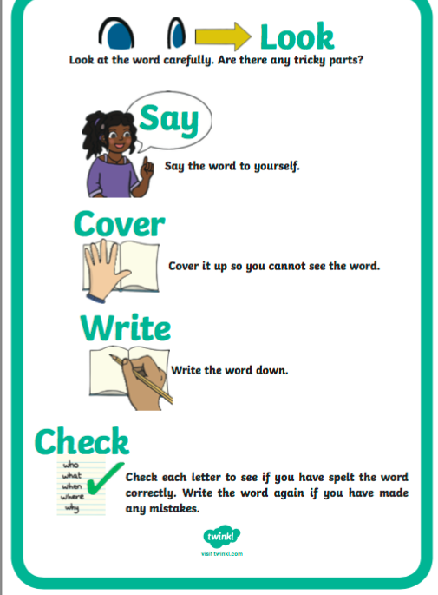
- Learn the first 4 spellings (sound, often, picture, future).
- Remember to use the “Look, Say, Cover, Write, Check” method. See poster here.
Spelling List:
sound
often
picture
future
nature
creature
fracture
adventure
mouse
mice

Writing.

- Choose 6 words from the spelling list and write them in an interesting sentence. You will have 6 sentences in total.
Check each sentence. Make sure that it makes sense and that you have a capital letter, finger spaces and full stops.

Gaeilge
- Log in to Seesaw to find instructions on today’s activity.
- Complete page 132 and 133 in Bua na Cainte.

Maths

- Today we are looking at the topic of Capacity.
- Capacity is the maximum amount that something can contain.
- Here are some examples of capacity that may help you understand.
1. A water bottle has LESS capacity than a swimming pool.
2. A swimming pool has MORE capacity than a cup.
3. A cup has LESS capacity than a bucket.
4. A bucket has MORE capacity than an egg cup.
- Open the resource titled “Which holds more” and play the Capacity game.
- Complete page 132 in your maths book. You might not have the measuring resources at home so don't worry and just do your best!
Remember to ask an adult for help when measuring capacity.
*Challenge- Open the resource titled ‘Maths challenge 1’ and complete Monday

